MicroAge’s analysis of Saint-Gobain’s Firewalls and Network.

The following documentation contains security issues related to the Checkpoint Firewalls and network throughout Saint-Gobain Corporation. MicroAge determined these issues after a general analysis of SGC firewalls and network configuration performed October 25 through November 2, 2000.

The SGC network contains a total of eight Checkpoint Firewalls installed, which are distributed in the different locations.

Firewall Naming Convention:

fw-Auburn
fw-BFG
fw-Calmar
fw-Stow
fw-Valley-Forge
fw-Vetro
fw-Wayne
fw-Worcester

See the Firewall distribution map on next page.

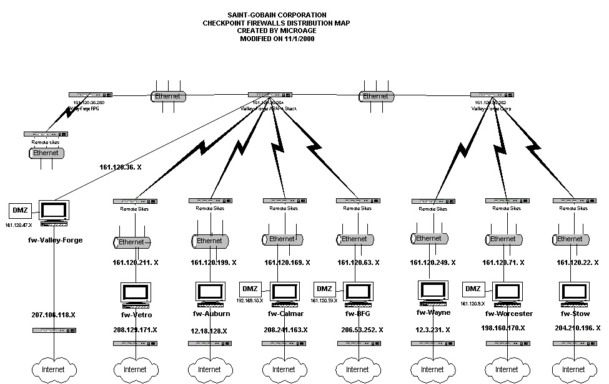

1. Firewall Rules General Configuration Issues:

1.1 Stealth Rule:
The security policy, (or rule base) defines access control by specifying and enforcing what goes in and out of an organization's network. The stealth rule is important to overall security policy as it masks the firewall from the outside world. Without a stealth rule, an intruder can attempt to connect to the firewall, which creates a major security flaw. Currently some of firewalls in the SGC network do not have a stealth rule.

Solution: Add one for each firewall, using the policy editor, with the following parameters;
"Stealth Rule: Source Any, Destination Firewall, Service Any, Action Drop, Installed On Gateways"

1.2 Cleanup Rule:
The cleanup rule is necessary for the firewall to dump any activity that may get past your other rules.
Currently almost all the firewalls in the SGC network do not have a cleanup rule. This creates a risk for the policy rule base.

Solution: Add a cleanup rule as the last rule in each rule base in each firewall using the policy editor, with the following parameters;
“Cleanup Rule: Any Source, Any Destination, Any Service, Action Drop/reject Installed On Gateways"

1.3 One Firewall named “fw-Wayne” Lost Configuration:
One firewall: fw-Wayne lost some configuration which make it can’t synchronize with the management server. We couldn’t read these firewall interface configurations.

Solution: Load newest Checkpoint Patches. Then check and test network connection, make sure no system modification affected them

1.4 VPN Access:
There are some sites with VPN access separated with Checkpoint Firewall, which administrators have to use different management tools to set them up. This configuration causes some potential security risks.

Solution: Consolidated Checkpoint firewall products. Migrate other VPN products to the checkpoint firewall native VPN products.

2. Firewall Rules Specific Critical Issues:

2.1 Critical Issues 1:

fw-BFG firewall Rule 7

The following rule allows ANY type of sources to access ANY service on the all firewall interfaces. This setting is critical problem to the entire network system and poses a big security threat.

:rule (
:src (
: Any
)
:dst (
: Firewall_Interfaces
)
:services (
: Any
)
:action (
: (accept
:type (accept)
:color ("Dark green")
:macro (RECORD_CONN)
:icon-name (icon-accept)
:text-rid (61463)
:windows-color (green)
)
)
:track (
: Long
)
:install (
: (Gateways
:type (gateways)
:color ("Navy Blue")
:icon-name (icon-gateways)
)
)
:time (
: Any

Solution: change Accepts action to Drop action

2.2 Critical Issue 2:

fw-Stow firewall Rule 7

The following rule allows ANY type of source to access some services on the fw-Stow firewall . This setting poses a major security threat.

:rule (
:src (
: Any
)
:dst (
: fw-Stow
)
:services (
: smtp
: ("smtp->Stow_mail"
:resource Stow_mail
:service smtp
:color (firebrick)
:icon (smtp)
:type (Tcp)
:"#oldname" (
:type (refobj)
:refname ("#_smtp->Stow_mail")
)
)
: lotus
)
:action (
: (accept
:type (accept)
:color ("Dark green")
:macro (RECORD_CONN)
:icon-name (icon-accept)
:text-rid (61463)
:windows-color (green)
)
:track (
: Long
)
:install (
: (Gateways
:type (gateways)
:color ("Navy Blue")
:icon-name (icon-gateways)
)
:time (
: Any

Solution: We recommend deleting this rule.

2.3 Critical Issue 3

fw-Valley-Forge Rule 12

The following rule allows both super-user and Berlin-Project groups to access ANY type of service on the ANY destination. This setting is too broad and poses a security threat. This maybe is good for super-user but is not good for some project group.

:rule (
:src (
: Super_User
: Berlin-Project
)
:dst (
: Any
)
:services (
: Any
)
:action (
: (accept
:type (accept)
:color ("Dark green")
:macro (RECORD_CONN)
:icon-name (icon-accept)
:text-rid (61463)
:windows-color (green)
)
)
:track (
: Long
)
:install (
: (Gateways
:type (gateways)
:color ("Navy Blue")
:icon-name (icon-gateways)
)
)
:time (
: Any
)
)

Solution: We recommended setting up another rule with specific destination and services for Berlin-Project Group.

3. Hardware Configuration Issues

One Cisco Catalyst 2924 Switch named “SGC_Internet_VF” configured with two VLANs. The switch has 24 ports totally. Ports 1-8 assign to Vlan1; Ports 9-24 assign to Vlan2. The cables had been connected to the switch as the following picture below.

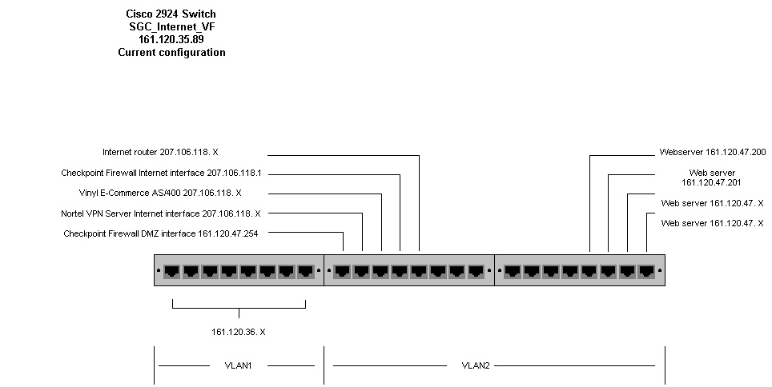

The problems with this connection are:

- Two different networks mix each other: one is 207.106.118.X; another is 161.120.47.X.
- If some body configures IP addresses using 161.120.47.X on the internet anywhere, they can bypass firewall and directly to enter into the DMZ network because it have physical connection(same switch) and logical connection(same VLAN)available, which causes a serious security problem.
- After the intruder gets into the DMZ, they can spoof the system and get into the intranet system because we don’t have anti-spoof rules on the firewall.
- One AS400 that has name: “Vinyl E-commerce” and IP address 207.106.118.X is connected to the switch. That host is on an unprotected network, which exposes possible attacks from the internet also.

Solution 1: split Vlan2 into two Vlans: Vlan2 and Vlan3. One for 207.106.118.x subnet; one for 161.120.47.x subnet, which is the DMZ for the system.

Solution 2: Reconfigure the AS400 with IP address 161.120.47.X and move the AS400 machine to DMZ subnet (161.120.47.x)

Details see the picture below:

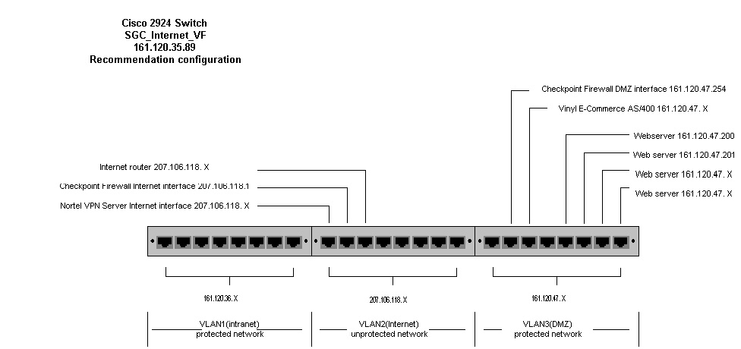

4. Checkpoint Service Patches Issues

4.1 Checkpoint Firewall Current Configurations

8 Checkpoint Firewalls, Version 4.0, Service Pack 1 (Build number 4031)
Windows NT 4.0 (Service Pack 4)
Management Console and GUI installed on firewall at Valley Forge

4.2 Potential Security Issues with current Service Patch

1. SMTP Security Server Denial of Service
A rapid stream of invalid SMTP commands to the SMTP Security Server would raise CPU load on the firewall, disabling mail delivery (although other traffic continued to pass).
Who is affected: Installations employing the SMTP security server for inbound email.
Changed in Service Packs: The SMTP Security Server in the new Service Packs drops SMTP connections after a configurable number of invalid commands.

2. IP Fragmentation Denial of Service
The mechanism used to log invalid IP fragments consumed a large amount of CPU resources during an IP fragmentation attack.
Who is affected: All versions.
Immediate Workaround: Refer to IP Fragement-droven Denial of Service Vulnerability for information on disabling the invalid fragment logging.
Changed in Service Packs: The logging mechanism has been refined so that it consumes minimal CPU cycles.

3. One-way Connection Enforcement Bypass
It was possible to bypass FireWall-1's normal directionality check by using specially fragmented TCP connection requests -or by closing and reopening one-way TCP connections- in conjunction with certain complex multi-connection protocols.
Who is affected: Sites allowing protocols employing unidirectional data flow connections (such as FTP and RSH STDERR). NOTE: The directionality check is an additional layer of security, which VPN-1/FireWall-1 adds to these protocols. An attack, which bypasses this check, is not in itself a security risk, however this check would otherwise substantially minimize the effects of items such as (4) below.
Changed in Service Packs: Directionality checks are much more strict in the new Service Packs, and will prevent surreptitious back-channel communication.

4. Improper stderr Handling for RSH/REXEC
Specially formatted RSH/REXEC connection requests could cause an unauthorized connection to be opened from an external RSH/REXEC server to an internal (protected) RSH/REXEC client. This applied only if the FireWall-1 administrator specifically enabled the RSH/REXEC setting in the Properties window.
Who is affected: Only those sites which have specifically enabled the VPN-1/FireWall-1 RSH/REXEC property.
Immediate Workaround: Disable RSH/REXEC if not needed.
Changed in Service Packs: The new Service Packs feature tighter control of STDERR connections plus the directionality checks noted in item (3), to prevent misuse of the error channel. NOTE: RSH/REXEC, like other protocol properties, should not be enabled if not needed.

5. FTP Connection Enforcement Bypass
Specially formatted FTP connections could be redirected from the FTP server to a system other than the FTP client.
Who is affected: Installations allowing inbound write access to those FTP servers which are vulnerable to "FTP Bounce" attacks.
Immediate Workaround: Configure VPN-1/FireWall-1 to allow FTP Read only, if feasible. Verify that your FTP server software is not susceptible to an FTP Bounce attack (the majority are not vulnerable; consult your FTP server vendor for verification).
Changed in Service Packs: VPN-1/FireWall-1's validity checking of FTP commands is much more strict in the new Service Packs, protecting the few FTP servers which are vulnerable to this type of attack.

6. Retransmission of Encapsulated Packets
The payload of specially encapsulated FWZ packets, which passed normal rule-base checks, would be retransmitted even if the packet did not originate from an FWZ client.
Who is affected: All versions. NOTE: This is not vulnerability in itself, although it may be used to facilitate an attack.
Immediate Workaround: Correct configuration of IP Spoofing protection will reduce exposure to attack. If SecuRemote with FWZ Encapsulation is not being used, IP Protocol 94 may be blocked at an external router.
Changed in Service Packs: FWZ encapsulation is disabled unless explicitly enabled by the firewall administrator. Additionally, only packets from authenticated FWZ VPN users will be decapsulated.

7. Inter-module Communications Bypass
Inter-module authentication mechanism (fwa1) was vulnerable to certain attacks, although the encryption used for data exchange was not. This allowed theoretical denial of service attacks.
Who is affected: Installations with rules allowing control connections from locations other than known management stations. NOTE: There is no known risk to customers because of this issue.
Immediate Workaround: For version 4.0 sites not using SecuRemote and version 4.1 sites, allow VPN-1/FireWall-1 control connections only from known management stations in the rule base.
Changed in Service Packs: The authentication mechanism in FWA1 has been strengthened in the new Service Packs. SSL is available in version 4.1 SP2 as an option for inter-module communication, although FWA1 remains the recommended inter-module authentication and encryption protocol for all VPN-1/FireWall-1 versions

8. OPSEC Authentication Vulnerability
The authentication mechanism used by OPSEC communications (fwn1) can be spoofed.
Who is affected: Sites which have not constrained OPSEC communication to specific source/destinations pairs via the rule base. NOTE: Check Point does not recommend or support the use of FWN1 for inter-module authentication.
Immediate Workaround: Ensure that OPSEC communications are allowed only between specific source/destination pairs in the rule base and that IP Spoofing protection is properly configured.
Changed in Service Packs: The authentication mechanism in FWN1 has been strengthened in the new Service Packs.

9. One-time (s/key) Password Authentication
Inter-module authentication for non-VPN software version 3.0 and 4.0 systems was susceptible to a brute-force
attack.
Who is affected: Only installations using S/Key for inter-module authentication.
Immediate Workaround: For VPN-1/FireWall-1 version 4.0 users with an encryption license and all version 4.1 users, use FWA1 rather than S/Key for inter-module authentication and encryption. For version 4.0 users without an encryption license, modify the rule base to ensure that FW-1 control connections are allowed only from the management station. Also verify that IP Spoofing protection is properly configured.
Changed in Service Packs: While the S/Key seed generation mechanism has been strengthened in the new Service Packs, Check Point recommends that all version 4.0 and 4.1 sites use FWA1 for inter-module authentication and encryption. NOTE: With the new Service Packs, FWA1 is now available for all version 4.0 users, regardless of encryption capability.

10. Getkey Buffer Overflow
Inadequate protocol checking in inter-module communication could be exploited, causing the firewall daemon to terminate. However, policy enforcement continued.
Changed in Service Packs: Protocol checking in the new Service Packs has been strengthened in all areas of the software, preventing malformed instructions from impairing the firewall.

Solutions:
Install Service Pack 7 for VPN-1/Firewall-1 Version 4.0 SP1 or higher.
- Resolve Potential Security Issues inVPN-1/FireWall-1
- This service pack can be applied to VPN-1/FireWall-1 Version 4.0 SP1 or higher.
- Non-VPN and VPN users should install the DES edition. No new license is required.
- Supported Platforms: Windows NT 4.0 (SP4, SP5, SP6a) — Intel and compatibles only

.

5. Microsoft NT Server Service Pack Issues

Service packs are the means by which Windows NT 4.0 product updates are distributed. Service packs
keep the product current, and extend and update the product's functionality so you'll never have to worry about becoming out of date. Service packs include updates and may include additional components. All are conveniently bundled for easy downloading If you are not experiencing a problem with Windows NT 4.0, you do not need to download and install the latest service pack. However, if you are experiencing a problem and the Microsoft Knowledge base states it is fixed in the latest service pack, please download and install the appropriate service pack.
All machines with Checkpoint firewall installed on the SGC Network are Window NT 4.0 with SP4.

Recommendation Solution:
Install Windows NT 4.0 latest service pack, SP6a.
- Supported by Checkpoint SP7
- Implement if experiencing Windows NT issues.
- Brings Windows NT 4.0 to current release.

6. Management Server Issues

The Security Policy is defined using the GUI and saved on the Management Server. The Management Server
maintains the FireWall-1 databases, including network object definitions, user definitions, the Security Policy,
and log files for any number of Firewalled enforcement points. The GUI and the Management Server can be
deployed on the same machine or in a Client/Server configuration.
However SGC Firewall system place GUI, Management Server and Firewall Module into the same machine.

Recommendation Solution:

Remove Management Console and GUI from firewall and run on separate units
- To improve performance and stability on unit running Firewall Module.

7. User with Static IP Assignment Issues

Currently SGC Firewall system use static IP address assignment method to associate user PC with IP, which cause the system administrator headache to manage system security issues.

Recommendation Solution Implementation of META-IP, to convert from static IP environment to dynamic.

- Automate the IP address process and manage all DNS and DHCP services across large
multi-site networks.

IP Address Management
Providing IP addresses to every device on the network is a necessity for reliable communications in today’s e-business world. As the unique identifiers that allow network traffic to be routed correctly to its destination, it is imperative to effectively track them and properly assign them. However, IP addresses often are managed manually in an Excel spreadsheet - resulting in wasted time, duplicate or erroneous IP addresses, and an unreliable network. Even if an organization moves to the Dynamic Host Configuration Protocol, it still faces the problem of controlling multiple sites centrally and holding users accountable for network usage. Check Point Meta IP builds a reliable IP address and name space for the enterprise by automating the IP address process and managing all DNS and DHCP services across large, multi-site networks, promoting greater network reliability and control. Meta IP provides enterprises with centralized management, an integrated LDAP data store, standards-based DNS and DHCP services, as well as the unique ability to match employees to dynamic IP addresses. By integrating all IP address and name information – as well as user information – enterprises can create a solid foundation for network connectivity

Automated, Fault Tolerant IP Addressing and Naming
- Automate IP addressing and eliminate duplicate IP address errors with DHCP
- Reduce IP administration costs by 80%
- Provide IP addressing fail over with replicated DHCP
- Implement latest standards, including BIND 8.2.2 pl6, for increased stability and security
- Increase DNS efficiency with IXFR
- Support Dynamic Update – required by Windows 2000 – with standards-based Dynamic DNS
- Control IP address assignment with DHCP Programmable Lease Filtering

Centralized Management of Network Services
- Centrally administer the whole system, or delegate specified tasks to others on the network
- Control IP services on multiple platforms, including Windows NT and Unix
- Administer remotely or in local mode with Win32 or Java interface
- Simplify DNS and DHCP configuration with GUI and configuration wizards
- Delegate administrative tasks with granular access controls

Comprehensive User-Based Auditing and Tracking
- Accurately track and audit IP address assignments by MAC address and device name
- Correlate IP addresses with login names, through User-to-Address Mapping
- View address assignments, names and other status information in real-time displays
- Integrate with FireWall-1 and VPN-1 for transparent, user-based security

8. Run Firewall HealthCHECK

MicroAge performed system security analysis and found some system security problems, but
This is still a potential for an issue being missed. Fortunately, Checkpoint and its partners released software, which can, in-depth, do the system security check. One of the software is called “Firewall Health Check”.

We strongly recommend running “FIREWALL HealthCHECK”, to retrieve an in-depth analysis of the rule base in the SGC Network, which can tests the security policy of FireWall-1® installations.

Following are some details about this product.

Date Certified: August, 1999
Product Version Certified: 1.5 for Windows NT
Certified for use with: Check Point VPN-1/FireWall-1

Product Description
Firewall HealthCHECK tests the security policy of FireWall-1® installations and is the only software program available to test key areas of security and performance of FireWall-1®. With nine major areas of analysis, Firewall HealthCHECK can remotely examine the logistics of the firewall, review security policies for vulnerabilities and make recommendations for ensured security.
The Company
Verisign is the leading provider of Internet trust services - including authentication, validation and payment - needed by Web sites, enterprises, and e-commerce service providers to conduct trusted and secure electronic commerce and communications over IP networks.

Key Features and Benefits
Firewall HealthCHECK is a client/server application. The server application runs in the background on your firewall gathering key security and performance data. On the client side, the server's information is relayed via a secured connection to the client application and can be retrieved from remote locations. The product performs the thorough test and displays the results along with recommendations for optimizing performance and security. The nine key areas of analysis are presented using familiar tabs with easy to understand icons. FireWall HealthCHECK 1.5 now tracks changes in FireWall-1 security policy. This product allows you to test any firewall installation to ensure it has been setup correctly and is functioning properly. This test can be executed at any time, from anywhere. It is a comprehensive program that allows you to keep track of your firewall's functionality through key performance statistics. Firewall HealthCHECK uses the OMI component of the OPSEC SDK. This functionality allows the product to gather information about such things as the FireWall-1 rule base.

9. Upgrade Check Point Issues

Upgrade to Checkpoint 2000

- Check Point 2000 is the latest edition of Check Point’s version 4.1 Enterprise CD. It is
also known as service pack 1 (SP1) of version 4.1.
- Improved Security and Software Enhancements.

Why is Check Point 2000 Important?

Check Point 2000 will soon becomes the default-shipping version for VPN-1, FireWall-1, and most other CheckPoint products. All Check Point customers with valid software subscription will be upgraded to the Check Point 2000 edition.

What products are included on the CheckPoint 2000 CD?

The CP 2000 CD will include version 4.1 of all Check Point software products, except:

- Provider-1
- MultiGate
- Compression Module
- VPN-1 Certificate Manager

Product Overview

The remainder of this document details the following products and capabilities included with Check Point 2000:

- FireWall-1
- VPN-1 Gateway
- VPN-1 SecuRemote
- VPN-1 SecureClient
- High Availability Module

FireWall-1

Malicious Activity Detection
Centrally analyzes VPN-1 and FireWall-1 log records to detect eight (8) well-known network attack- and suspicious activity-profiles:
- SYN attack
- Successive Alerts
- Port Scanning
- Successive Login Failures
- Successive Multiple Connections
- LANd Attack
- Blocked connection port scanning
- Address spoofing
Upon successfully identifying one of these profiles in the logs, security managers are alerted. Threshold settings enable security managers to adjust alerting sensitivity. Because Malicious Activity Detection is based on log file analysis and is not performed in real-time, it compliments network-based intrusion detection.
Benefit: Saves security managers’ time by automatically analyzing log files for signs of malicious activity.

CVP Manager
FireWall-1 includes the new CVP Manager to enable the deployment of multiple CVP or UFP servers. With a pool of
content security servers available to FireWall-1, the CVP Manager can deliver high availability for content security
operations, and provide chaining capability so that multiple successive operations (virus scanning, Java/ActiveX
screening, etc.) can be performed on a single connection request.
Benefits:
- High availability for content security guarantees security and network availability in the event of a content security server failure
- Chaining of content security servers enables a comprehensive check of traffic before it is passed into the corporate network

Visual Policy Editor
Provides a comprehensive picture of enterprise security deployment by drawing a map of security objects — firewalls, VPNs, servers, networks, routers, etc. — and the relationships between them. The Visual Policy Editor illustrates the effect of individual security policy rules by color-coding relevant elements in the map to indicate source, destination and encryption method. Other powerful policy editing capabilities include the ability to visually locate objects in the topology, edit object parameters and define groups of objects in the Visual Policy Editor.

Benefits:
- Increasing security managers’ understanding and control of Internet security
- Validates the intent and integrity of the security policy
- Object-oriented interactions make the process of managing a security policy more
efficient.

NOTES: (1) A Visual Policy Editor preview is provided on the Check Point 2000 CD and operates in a “read-only” mode (i.e., objects can be read into the Policy Editor, mapped and edited, but cannot be saved). Interested Check Point 2000 users can register for the Visual Policy Editor Beta Test Program, which will allow them to use the Visual Policy Editor for their day-to-day policy management. (2) The Visual Policy Editor is not intended as a replacement for the current Policy Editor, but as a complement to it. (3) The ship date and pricing for the Visual Policy Editor have not yet been determined.

VPN-1 Gateway (Includes all FireWall-1 enhancements)

Hybrid Mode Authentication
Check Point’s Hybrid Mode Authentication for IPSec enables the use of widely deployed (“legacy”) authentication techniques such as token cards, RADIUS and TACACS+ within IPSec VPNs. The hybrid mode authentication technology is currently an IETF draft, making Check Point the only vendor with a solution being considered for inclusion into the IPSec standard.

Benefits:
- Strong security through the IPSec standard and the technologies it supports, such as the Internet Key Exchange (IKE) and Triple DES encryption
- Standards-based interoperability that does not require the deployment of new authentication technologies such as X.509 certificates

VPN-1 SecuRemote

Secure Authentication API (SAA)
The Secure Authentication API (or SAA) enables innovative new authentication products to be used with Check Point’s VPN client solutions, VPN-1 SecuRemote and VPN-1 SecureClient. With SAA, new types of hardware-based authentication schemes (e.g., biometrics, proximity, etc.) can be used to authenticate a user when requesting a VPN connection. SAA passes authentication information from the VPN-1 client through the Gateway and on to an authentication server like RADIUS. The authentication server then tells the Gateway whether or not the user has been authenticated.

Benefits:
- Provides additional flexibility in choosing best-of-breed technologies to meet specific needs
- Extends the open SVN architecture by enabling third-party products, in this case authentication solutions, to interoperate with VPN-1 solutions

Secure Domain Login
Secure Domain Login enables Windows NT users whose primary login is to the network (as opposed to local desktop) to have their login take place AFTER the VPN-1 tunnel has been established, so that the login information is encrypted. Previous releases of VPN-1 clients did not start in time to allow the NT Primary Domain Controller (PDC) login to take place over the VPN tunnel.

Benefit:
- Improves security by enabling mobile users to securely perform PDC logins when coming in via external VPN connections

Automatic Topology Update
Automatic Topology Updates enable VPN-1 administrators to configure the VPN-1 clients to automatically fetch network topology (i.e. the site information) on a periodic basis. This functionality requires Version 4.1 SP1 of VPN-1 Gateway.

Benefits:
- Adds further user transparency to ongoing configuration maintenance of VPN-1 clients
- Increases management efficiency and reduces end user training/support

Partial Topology Configuration
VPN-1 Clients can be pre-configured with a partial site topology. This feature is useful when users download their VPN-1 SecuRemote installations from a publicly accessible site and enables the system administrator to include minimal site topology information (only the site’s IP address) in the downloadable userc.C file. The first time the user connects to the site, the full topology is downloaded automatically (after the user is authenticated).

Benefit:
- Enhances security by reducing the exposure of potentially sensitive network topology information

Automatic Version Checking
Administrators can define/set a policy to control the required version of VPN-1 SecuRemote/SecureClient software on clients connecting to VPN-1 gateways. When their software is out of date, the VPN-1 clients can now pop up a dialog box with a launchable URL (e.g., pointing to an intranet software distribution server). This functionality requires Version 4.1 SP1 of VPN-1 Gateway.

Benefit:
- Aids administrators in managing software distribution of VPN-1 clients

VPN-1 SecureClient (Includes all VPN-1 SecuRemote enhancements)

Desktop Policy Verification
Policy Servers now maintain open “stateful” connections with VPN-1 SecureClients and are immediately notified when a client is reconfigured. The administrator can specify that the Desktop configuration be verified, and the action to take if the configuration is incorrect.

Benefit:
- Strengthens security of the extended enterprise network by continuously ensuring client machines are configured correctly
Additive licensing
A single Policy Server/Desktop Manager can use multiple license strings – licenses are no longer “up to n users.” E.g. A customer with 600 users can purchase a 500 user license + 100 user license, not a 1000-user license.

Benefit:
- Enables more flexible licensing scenarios

High Availability Module

The High Availability Module is an optional add on for mission critical VPN-1 and FireWall-1 deployments. It delivers seamless fail-over by allowing customers to create clusters of redundant gateways. In the event that a primary gateway fails, all connections are re-directed to a designated backup.

The module leverages VPN-1's enhanced state table synchronization, which includes
IPSec/IKE key exchange information, to ensure that all VPN connections are maintained in the event of a fail-over. In addition, it is tightly integrated with Check Point management tools. Finally, a programmable health check feature enables detection and response to a range of user definable system health problems.

Benefits:
- Fault tolerance for mission critical VPN and FireWall-1 deployments
- Completely seamless end user experience during a VPN failover (no need to re-
authenticate)
- Simple to deploy and maintain

