New feature:
- Running eye test with several dc gain.
End user able to choose 3 option
- Auto: This option will run the eye test with dc gain from 0 to -6
- Auto_Quick: This mode will only run for 0,-3 and -6 dB.
- Manual: End user will run one of the dc gain for eye test.
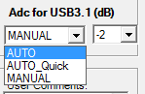

End user able to choose the number of UI required for the eye test. The selection was under the configure tab.
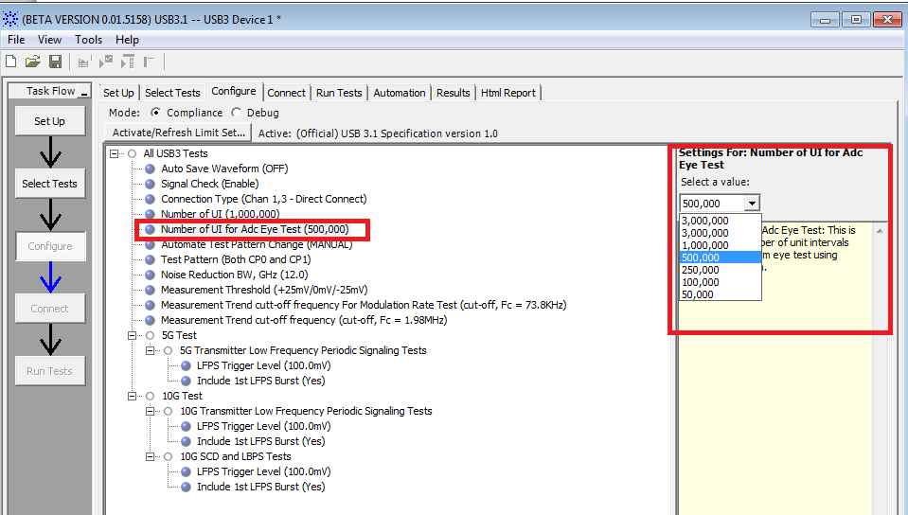

- SDA test.
USBIF sigtest still not available.
Please turn on the SDA mode to run the RJDJ test.
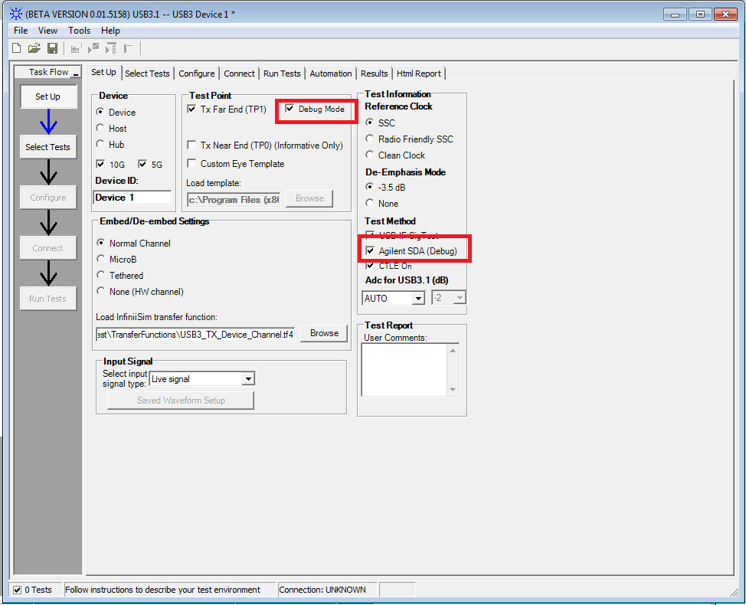
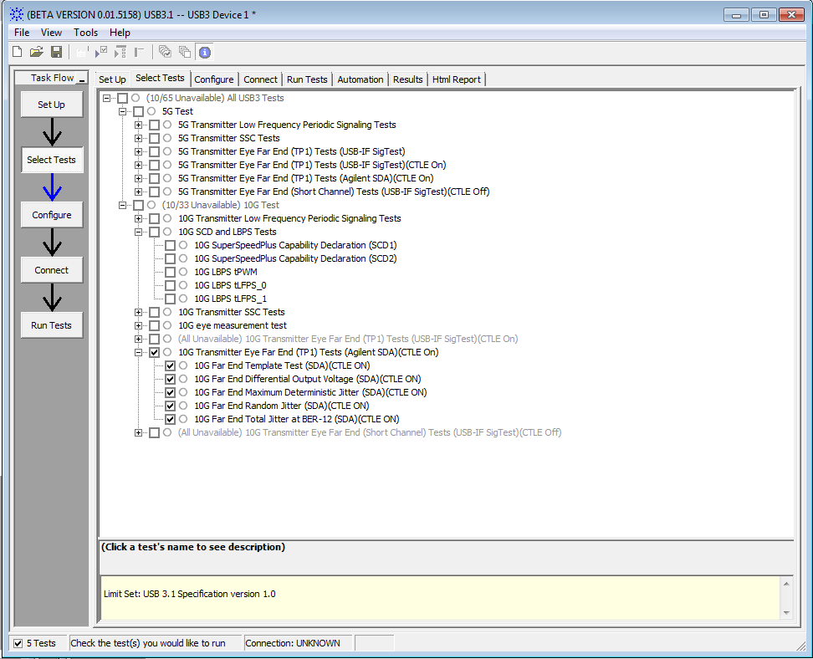

Setup Instrument for LFPS test.
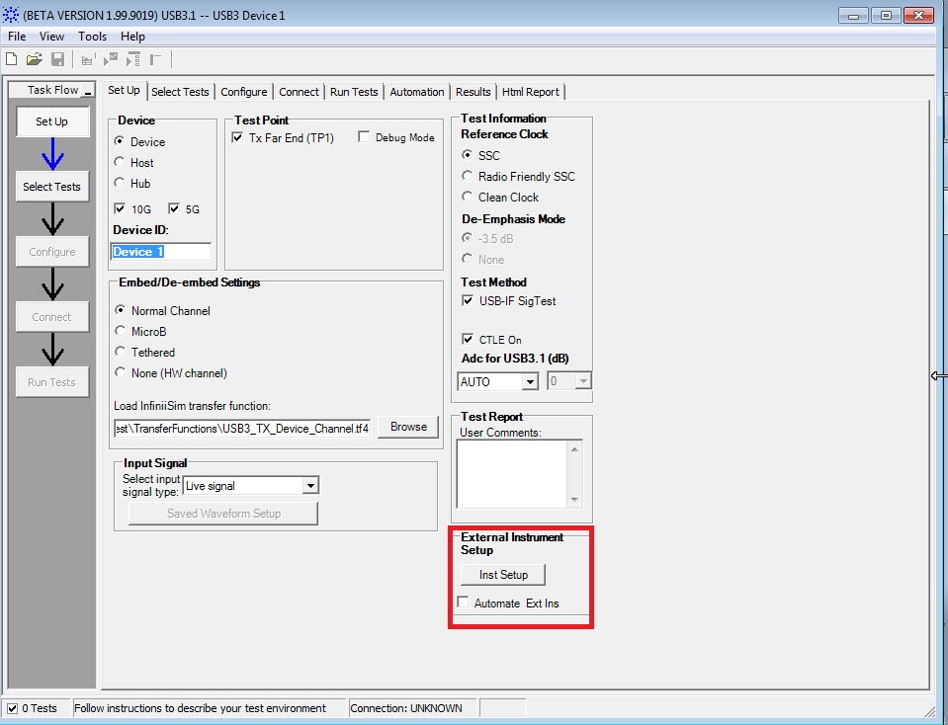
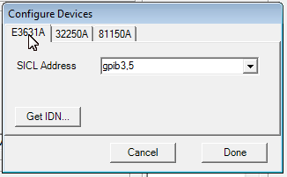

CP9/CP10 Auto toggle
3 option had been added, choose the required option and configure the instrument if you are using 81150A or 33250A
- DC(default)
- 81150A
- 33250A

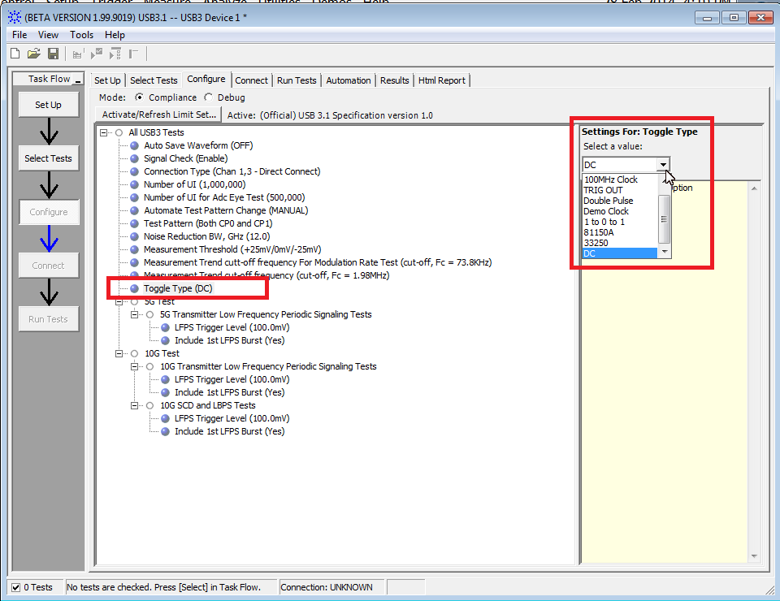

Choose Automated Test pattern, in this mode, the test will continue if the correct pattern was found.
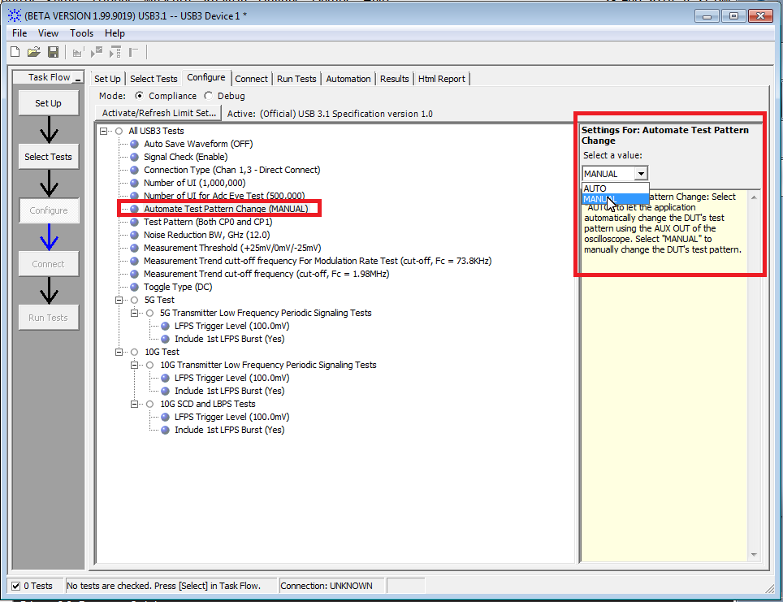

User can choose the number of attempt for the toggling and the toggle mode.
