Software External Reference Specification

Document Information:
Filename | AgilentDataSource_SilentInstall.docx
Current Owner | Raju Wagh
Product Identifier | Remote Advisor A.02.09 SP1
Project Identifier | CrewChief

Table of Contents

Table of Contents 1
1. Overview 1
2. Installer updates 1
2.1 Command 1
2.2 Prerequisites 1
3. Steps to run the installer 2
4. Appendix A. Glossary 2

Overview
This document details the information about the silent installation for data source.

Installer updates
We can make the existing installer to run silently. Installshield provides command for running the installer silently. We have to use those commands.

Command
To run the installer in silent mode we need to pass the following command to installer.
AgilentDataSource.exe /s /sms /v"/qn ISSILENT=1"
Command details:
- /s –To specify the values of public properties for a silent Basic MSI installation. This tells the installer that we are running in silent mode.
- /sms – Automatically waits for the installation to finish before exiting.
- /v - Use the /v option to pass command-line options and values of public properties through to Msiexec.exe
- /qn - Sets the UI level. No UI in this case.
- ISSILENT – we have defined this property in data source installer which we use in custom actions (installer concept) to do some customization. We need to set this to 1 so that custom action will specific action accordingly.

Prerequisites
Prerequisite will be part of same installer. We will not be having the separate msi for installing the prerequisite. When we run this installer with above mentioned command following Prerequisite will run silently
- Uninstall previous version of DS (if installed).
- Search Data Source Setup Basic Requirements
- Search DataSource Dependency
- Log Parser 2.2
- Microsoft XML

Steps to run the installer
- Open command prompt. (cmd)
- Run following command [PathToInstaller]\AgilentDataSource.exe /s /sms /v”/qn ISSILENT=1”. Note that the quotes are important.
- Press enter.
- DS should get installed silently without any user interaction and any pop-up messages.
- If DS is installed on machine then above command will first uninstall the DS and will continue to install the latest DS (A.02.09 SP1) without restarting the machine. i.e. Installer will be upgrading the DS silently without restarting the machine. (In normal mode installation machine will be restarted when un-installation is done while upgrading the DS)
- Once installation is done, DSSM will be displayed.
- IQT will also run silently, IQT report will be available at “[installLocation]\DataSource\IQT.

Note that you can monitor that the install is running by observing this directory on disc. The directory will shows changes as the install runs.
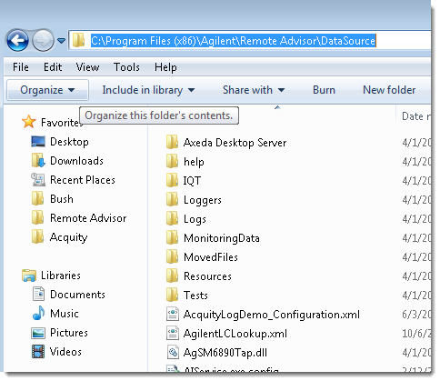

Appendix A. Glossary
Use this section to define terms and acronyms used in this document that would typically be unfamiliar to management and/or technical staff on other projects.

Term / Acronym | Definition
DS | Data source
UI | User interface
IQT | Installation Qualification Tool

