Every time before running the program,
1. Please preset the power meter. (do not connect power sensor)
2. Then connect power sensor to power meter.
3. Query the below SCPI command make sure the sensor return a valid data :
a) Serv:sens:type?
b) Serv:sens:snum?
c) Serv:sens:cdate?
d) Serv:sens:cplace?
4. Now execute the .vxe program, follow the instruction below :

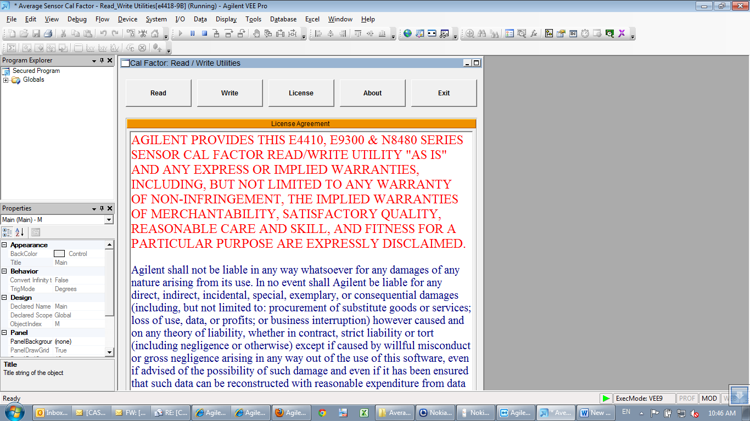Click Read Button
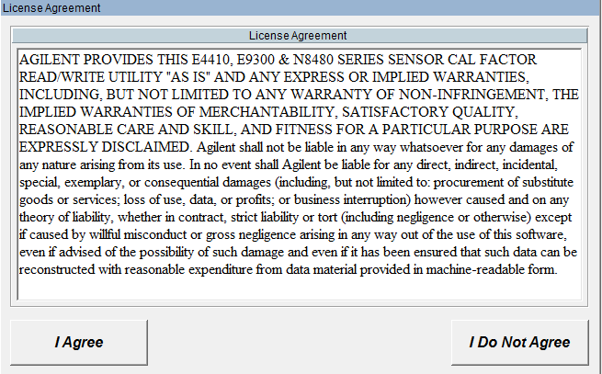Click “I Agree”
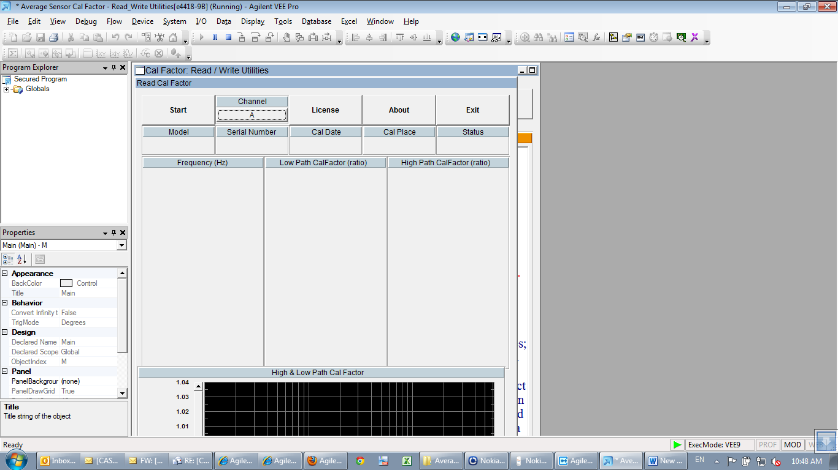Click Start

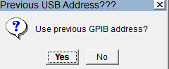Click No
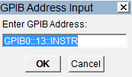Key In E4418B GPIB address
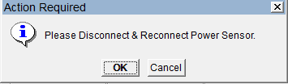Do not disconnect the power sensor, just click OK.
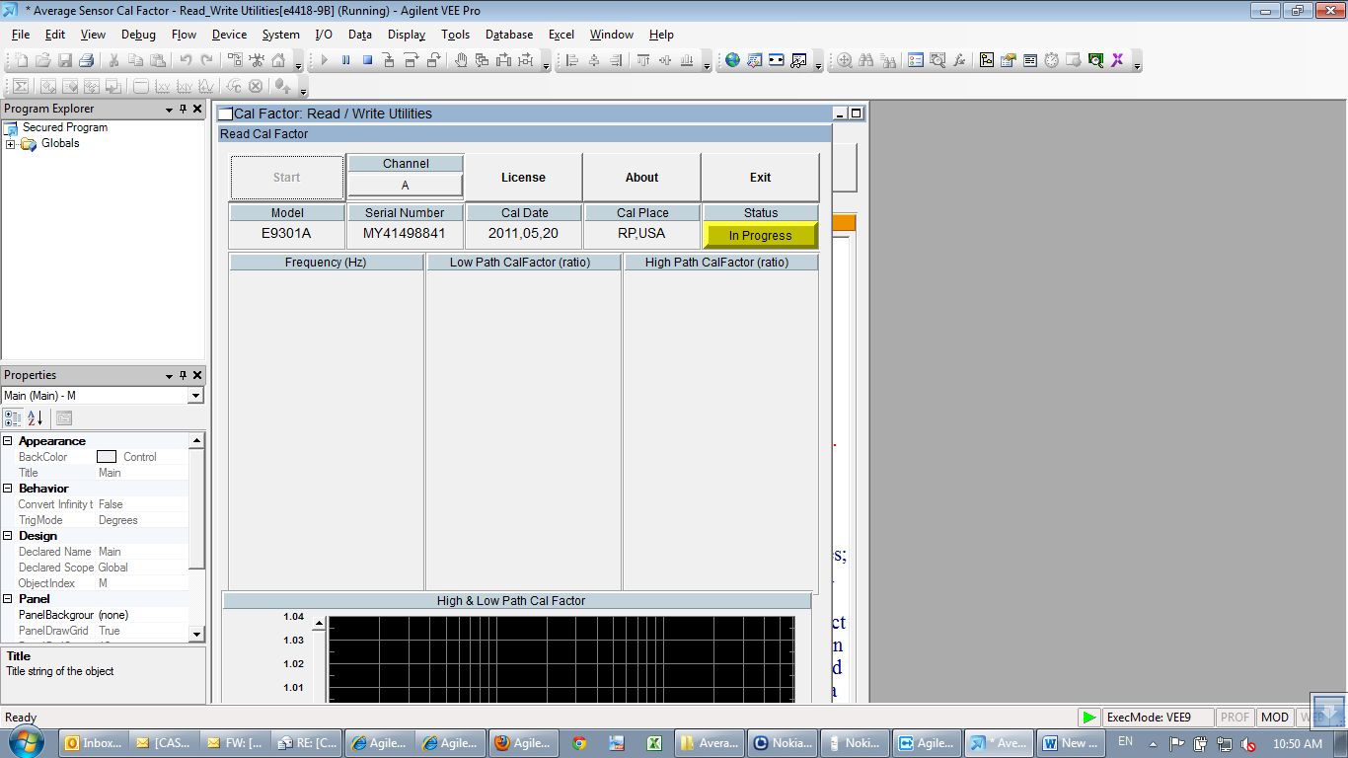 Detected power sensor model and showing status “In Progress”
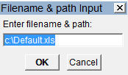key in the path, click ok(make sure user have the write authority on the path)
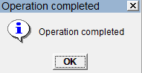click ok
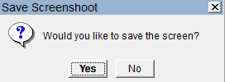click ok
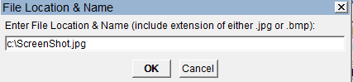 key in the path, click ok(make sure user have the write authority on the path)

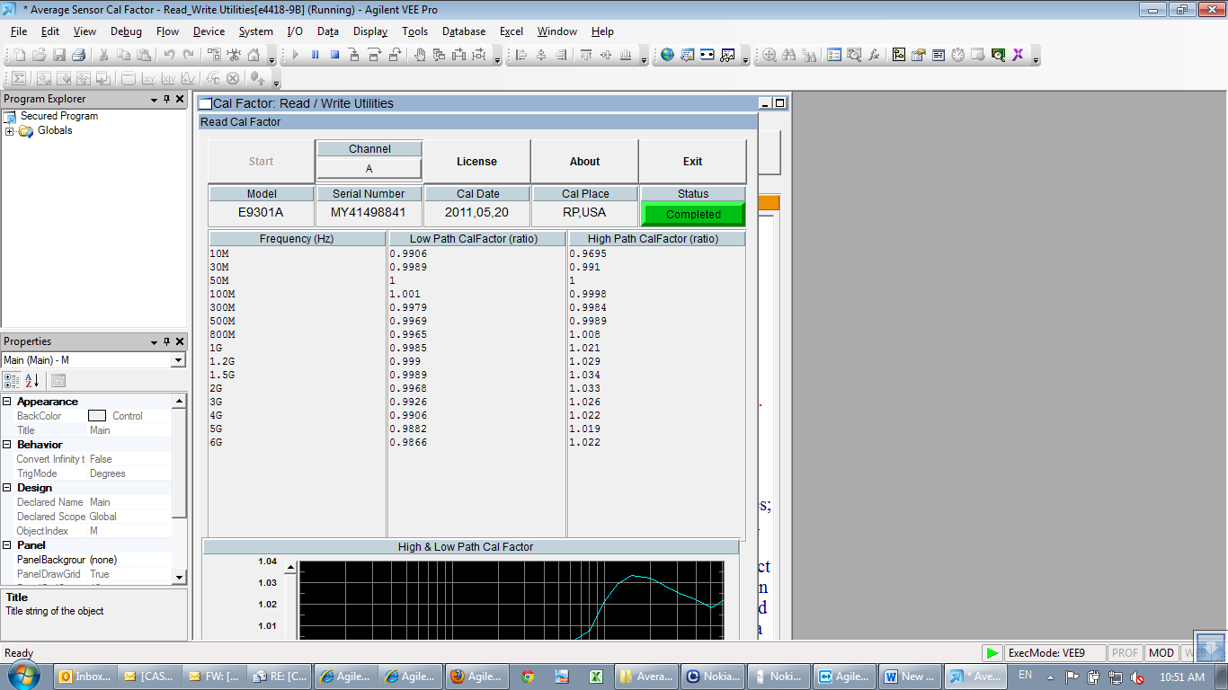status show completed

