Agilent Technologies, Inc.

DDS
PCIe3 Protocol Solutions Competitive Landscape
Last Update: November 9, 2011
Rob Vezina

What’s covered in this Document?
The primary purpose of this paper is to provide the field with a comprehensive, single source, overview of the PCIe3 Protocol Solutions available today from Tektronix and LeCroy. Agilent products will not be discussed in as much depth since that material is already well understood by the reader but there is a side-by-side comparison including Agilent capabilities provided toward the end of the document. The final section will be a Frequently Asked Questions (FAQs) section addressing some of the more common PCIe 3.0 Analyzer questions asked.

Table of Contents
LeCroy and Tektronix Pictorial Overview
Industry Gen3 Protocol Solution Side-by-Side Comparison
LeCroy PCI Express Gen3 Product Overview
- LeCroy Summit T3-16 Analyzer
- CATC Trace™ Analysis Software (GUI)
  - GUI Features
- Probe systems
  - Gen3 Active Slot Interposer Probe
  - Gen3 MidBus Probe
- LeCroy Summit Z3-16 Exerciser
Tektronix PCI Express Gen3 Product Overview
- Tektronix TLA7AS00 Logic Protocol Analyzer
- Logic Protocol Analyzer Software GUI
- Probing Solutions
- Exerciser Solution
U4301A PCIe Gen3 FAQ


LeCroy Summit T3-8 Analyzer
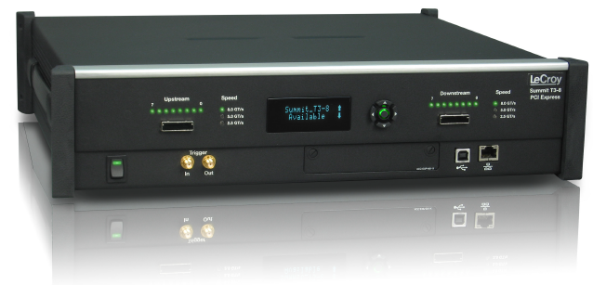
LeCroy Summit Z3-16 Exerciser PCIe3 Slot Interposer Card
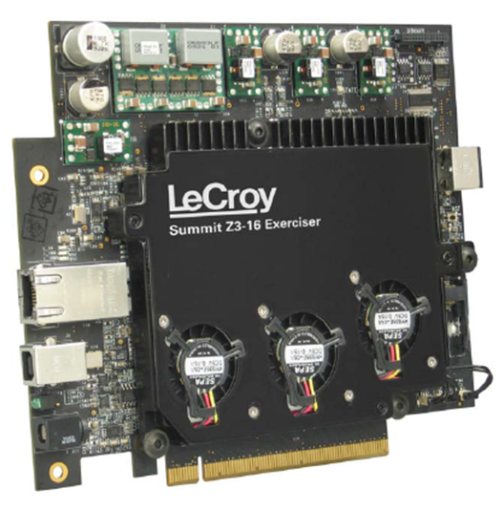 | 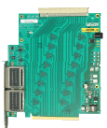

Summit T3-16 Interposer Set Up Summit T3-16 MidBus Set Up
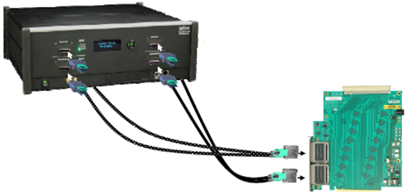 | 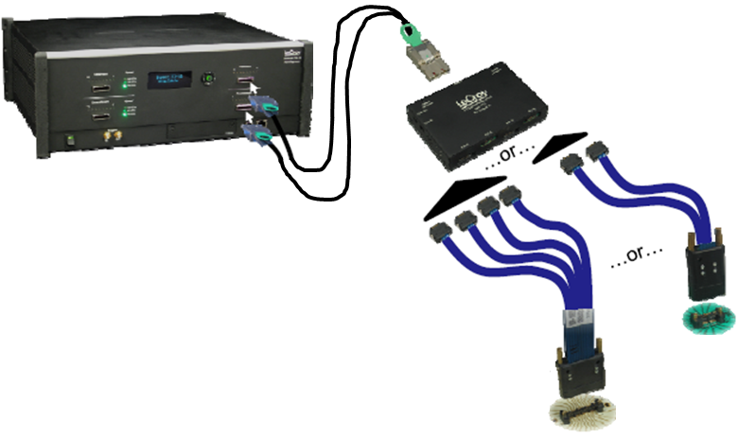

Tektronix TLA7AS00 x16 Logic Protocol Analyzer
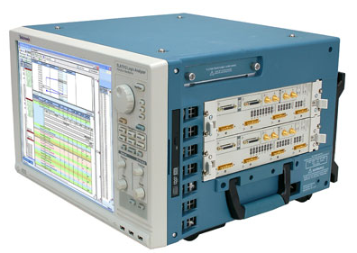 | 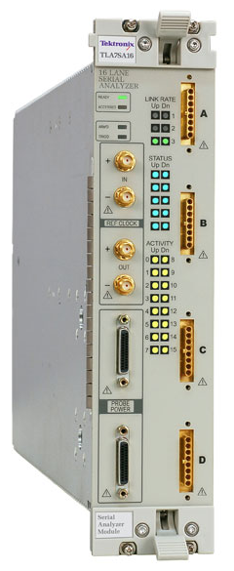

Tektronix TLA7AS00 Probing Solutions
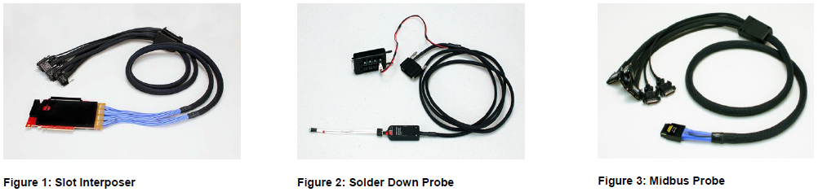

TLA7AS00 Logic Protocol Analyzer Solution Set
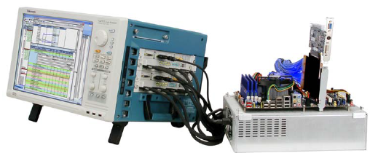
Industry Gen3 Protocol Solution Side-by-Side Comparison
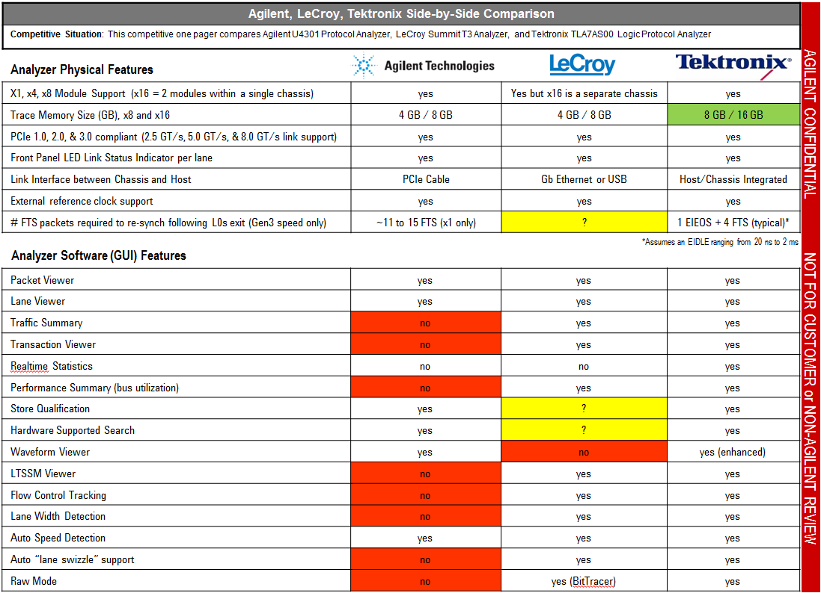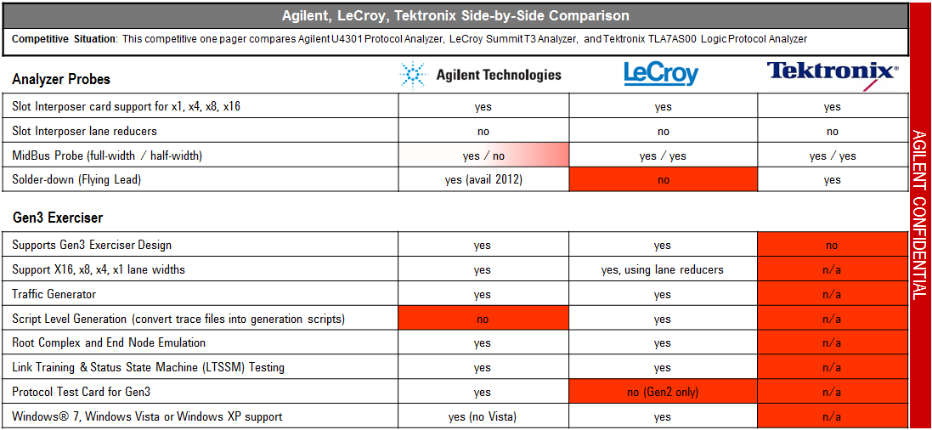

LeCroy PCI Express Gen3 Product Overview
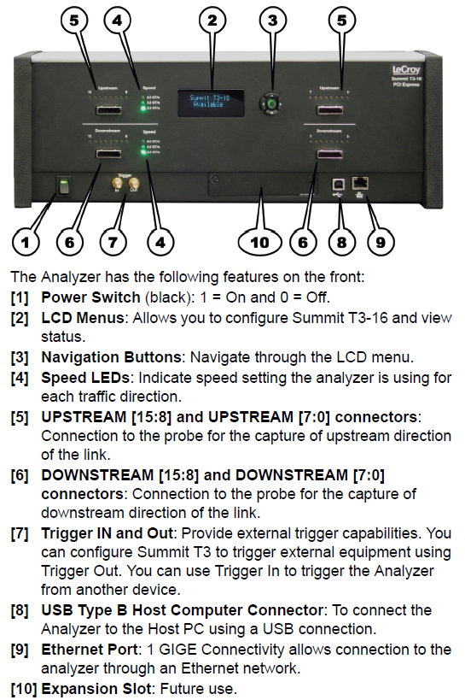
Summit T3 Analyzer
The Summit T3 Analyzer is offered in two chassis options, x8 and x16. Both platforms will support data rates of 2.5 GT/s, 5 GT/s and 8 GT/s; full data capture on bidirectional lane widths of x1, x2, x4, x8 and x16; and 8 GB of trace memory (4 GB for x8; 2 GB in each direction). The x16 chassis license will support all lane width trace capture up to x16. The front LCD panel displays system serial number, current network configuration, or Available if no host connected.
CATC Trace™ Analysis Software
Using the same CATC Trace™ Analysis Software as was used on the Summit T2 (PCIe2), LeCroy can decode Transaction Layer Packets (TLP), Data Link Layer Packets (DLLP), and all PCI Express Primitives. The CATC Trace™ GUI viewing provides Packet level, Link & Split Transaction levels, and collapsible/expandable headers. The view packets, TLP transactions, and DLLPs are viewable in both packet mode and raw mode. They also provide an external interface for enable cross triggering with other test instruments. The software supports Microsoft Windows 7, Windows XP, or Windows Vista.
CATC Trace™ Decodes
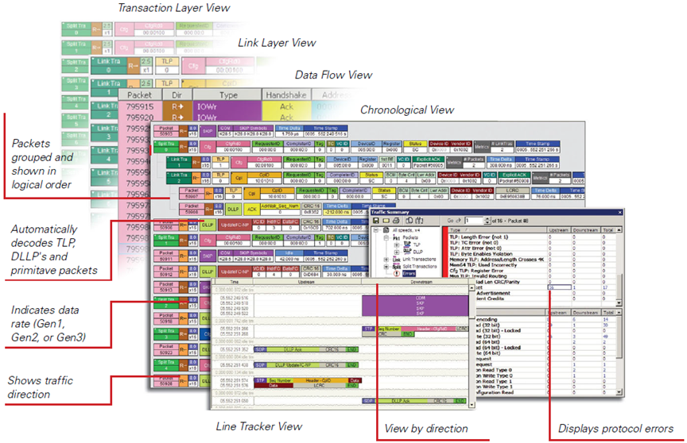
Summit T3 GUI Features Summit T3 Analyzer GUI Feature List:
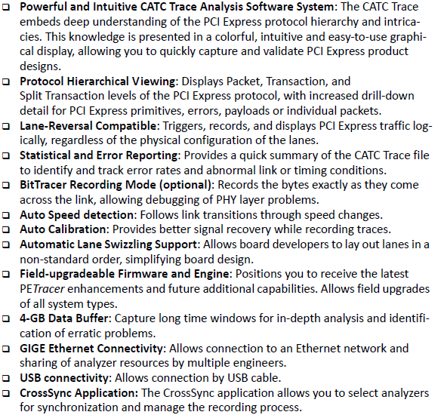
The Summit T3 Features list also supports automatic “lane swizzling,” which allows a board developer to lay out a mid‐bus probe pad with lanes in non‐standard order. Internally, the Summit T3‐8 then maps the lanes back into their correct order. Trace upload to the host is offered in both USB and Gigabit Ethernet (GbE). By connecting over the GbE interface, the system can be operated remotely.
Probe systems
The Summit T3 Probe systems include active interposer and MidBus (both full- and half- size) probes; there is no flying lead probe option. LeCroy offers the largest probe offerings for Gen3 than both Agilent and Tektronix.
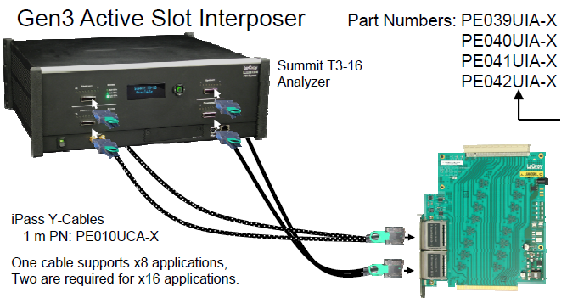
Gen3 Active Slot Interposer
The Gen3 Active Slot Interposer shown on the left supports lane widths x1 to x16. These cards CANNOT be used with card reducer edge adaptors (likely a tuning issue with Gen3). Similarly, Agilent does not allow the use of card reducer edge adaptors. For lane widths up to x8, one iPass Y-cable is required. For x16, two iPass Y-cables are required.
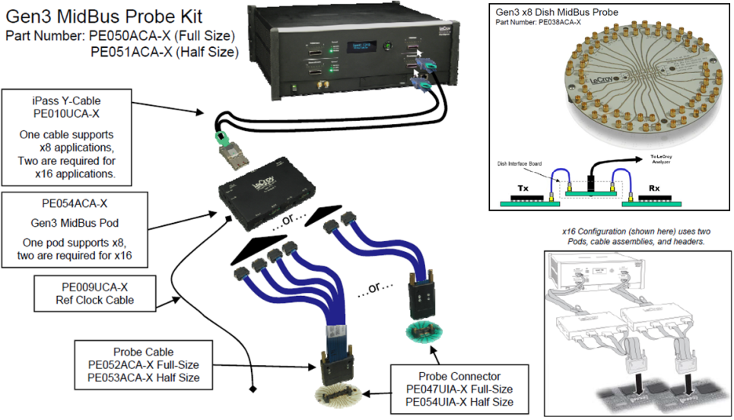
Gen3 MidBus Probe
The LeCroy Gen3 MidBus probe supports lane widths from x1 to x16 at data rates of 2.5 GT/s, 5 GT/s and 8 GT/s. The MidBus probe attaches from a MidBus footprint pad to a Gen3 Probe Pod and a reference clock cable also connects from the PCB to the pod. The pod then attaches to the Summit analyzer using an iPass Y-cable. For x16, use two Pods and two cable assemblies are required.
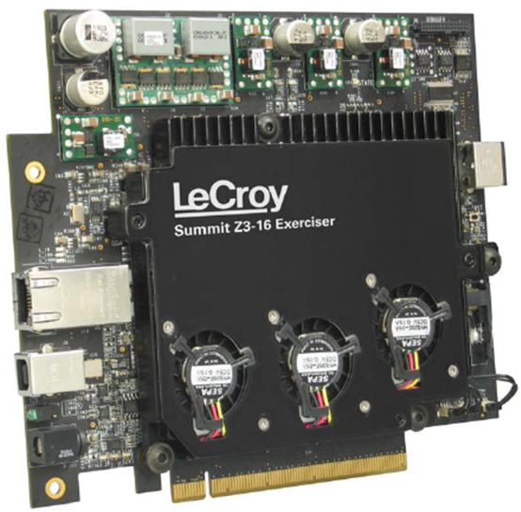
The Summit Z3 Exerciser
The LeCroy Summit Z3 Exerciser (traffic generator) comes in one physical x16 PCIe Edge Connector configuration and can emulate both the root complex and an end-node. The x16 PCIe edge connector can be adapted to x8, x4, or x1 slots through use of Card Reducer Edge Adapters. The Exerciser provides Script Level Traffic Generation and can convert trace files into generation scripts. The script memory size is 2 GB and is also used for device memory emulation, timing and control information. The Z3 also supports Link Training & Status State Machine (LTSSM) Testing by invoking LTSSM state transitions. The host software supports Windows® 7, Windows Vista or Windows XP. LeCroy does not support a PCIe 3.0 Protocol Test Card option.

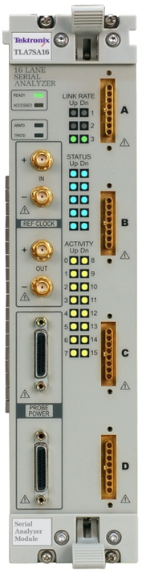
Tektronix PCI Express Gen3 Product Overview
Tektronix TLA7AS00 Logic Protocol Analyzer
Tektronix Logic Protocol Analyzer supports PCI Express Gen3, Gen2, and Gen1 Protocol architecture (8.0 GTs, 5GTs, and 2.5GTs acquisition rates respectively) at Link Widths from x1 through x16. The analyzer will automatically configure link width (Dynamic Link Width) and link training speed. The Front-panel LEDs provide Status Information such as Link Speed, Symbol Lock, and Link Activity. Capable of 8 GB Trace capture memory depth at x8 lane width configuration within a single module (16 GB at x16; 2 module configuration). The trigger state machine supports 8 states, 8 packet recognizers, 4 symbol sequence recognizers, 4 counter/timers, 4 event flags, and real-time filtering.

Logic Protocol Analyzer Software GUI
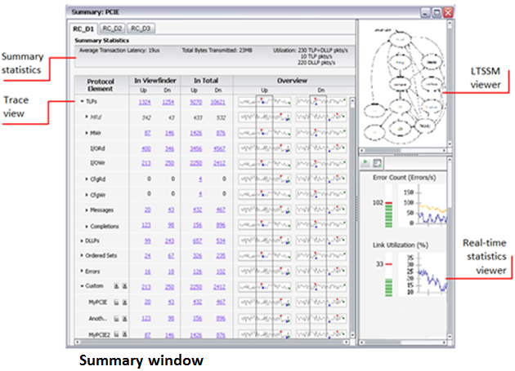
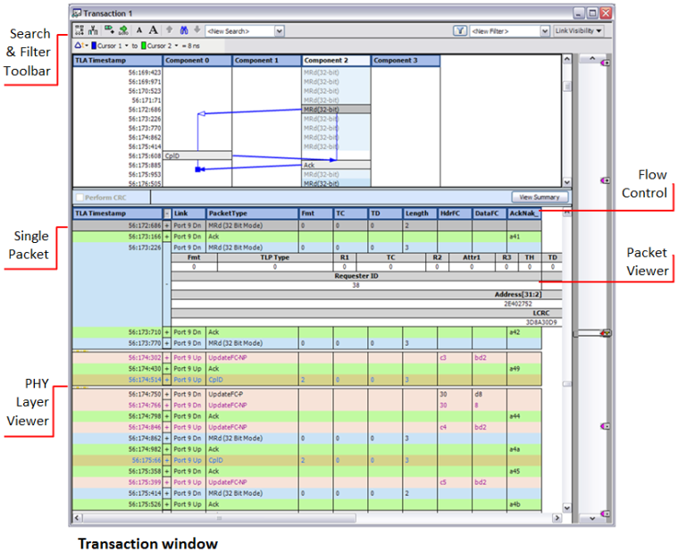
Protocol information can be viewed at the packet and transaction level interspersed with physical layer activity, expanded and collapsed as needed. The GUI supports real-time statistical summary and identifies errors, specific transactions, ordered sets, etc. Summary statistics include average transaction latency; total bytes transmitted, and bus utilization. A Transaction Stitching feature shows packets participating in a completed transaction or incomplete transactions as errors in a diagrammatic representation. Additional capabilities, including color coding of the packets, cursor locking across multiple data windows, LTSSM viewer, and flow control. The GUI also provides lane-by-lane symbol decode and a waveform viewer.
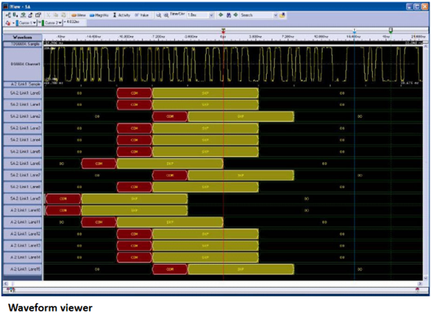

Probing Solutions
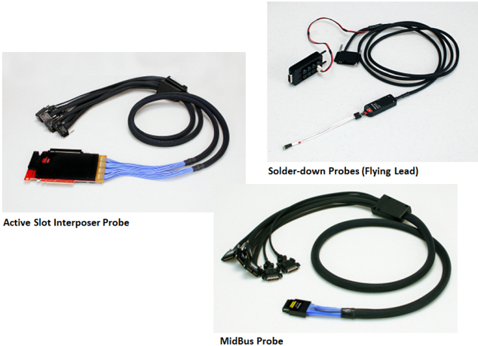
The Tektronix TLA7AS00 probe solutions include MidBus, slot interposer and solder-down probes. The slot interposer probe is available in x1, x4, x8, and x16. Tektronix dropped the use of lane reducers on their PCIe3 slot interposer The MidBus is available in x4 and x8 (2 for x16). The solder-down probe is available only as a single a single differential pair but can be shared with the leadsets used on their oscilloscopes.

Tektronix Exerciser
Tektronix does produce an Exerciser card.

U4301A PCIe Gen3 FAQ
Q: Will there be a method to combine two U4301A modules into a single module, so as to occupy a single backplane resource?
A: No. The architecture prohibits that configuration. As long as one module (when used up to x8 bi-directional) is one resource then two modules will always be two resources. There is no way to change this.
Q: Can we get a single downloadable installer or ZIP file (one each for 32 and 64-bit Windows) to install the TCL tools needed for tuning?

A: Unfortunately no. The license agreements prevent us from distributing the TCL SW. As far as the scripts go, they are already installed with the SW and we are working on a future release that will integrate the TCL scripts into the GUI (e.g. – no separate TCL scripts would be required).

Q: If, due to bit errors, I get a trigger on a packet, but the trigger occurred during logical idle, why don’t I see the erroneous packet in the packet viewer (making it appear to have false triggered) – why are the display and trigger different?

A: Response from technical support: I believe if we trigger due to a bit error, the analyzer shows them in the GUI. For example: Bit error results in channel bonding loss can be seen in the GUI. The bit error results in a red packet, the analyzer triggered on it as showed it as RED packet. Please provide an example of the error field you’re referring to.

Q: What is the use model on the Gen 3 Exerciser for an add-in card vendor (IHV – Independent Hardware Vendor) to test SRIOV? How should this be sold? It is clear for a system vendor but not an add-in card vendor.

A: There is no SR-IOV use model for the IHV. When the exerciser is plugged into an IHV card, the exerciser is emulating the RC. Under the definition of SR-IOV, Single Root IOV, there is nothing the RC needs to do to support SR-IOV within the IHV card. SR-IOV is not a feature to be sold to the IHVs, only system vendors.

Q: When will tuning be integrated into the main GUI and not require the TCL installation?

A: TCL integration will likely be available in release 5.40 (April 2012)

Q: What is the status on raw mode capture? Last I heard it was not going to be implemented, if this is the case, take it out of the GUI.

A: Raw mode may still land in release 5.50. Raw mode is not impossible on U4301A, it’s just that it requires a lot of changes to the FPGA. The plan is to take a look at what is needed to implement raw mode after major feature completion.

Q: According to a 2008 press release, the SRIOV and MRIOV capabilities are free for analyzer and exerciser. This is not the case for Gen 3 but the press release is misleading and is still on the website.

A: The referenced press release states “is available free of charge to all Agilent E2960B customers”.

Q: When will the A.com software download page for Gen 2 and Gen 3 be useable?

A: The PME will get with the Webmaster and get this page fixed.

Q: If the Gen 3 analyzer loses lock, what conditions does it need to get the lock again? Does it need to see a link training? A reset of the software does not seem to help.

A: This issue has been fixed and the correction has been tested at IBM and Intel; the correction will be in release 5.30. Only Training Sequences (TS) or Skip Ordered Sets (SOS) is needed to get lock again.

Q: When will definitive numbers on the exit from L0s locking time be available for 2.5G/5G/8G and x1 – x16 be available (Gen 3 analyzer)?

A: This is being worked on now and it will be defined by release 5.30. It will be a best case number (not a minimum threshold) because recovery from L0s is highly dependent on the target signal integrity.

