U4611A USB Protocol Analysis
Demonstration Guide
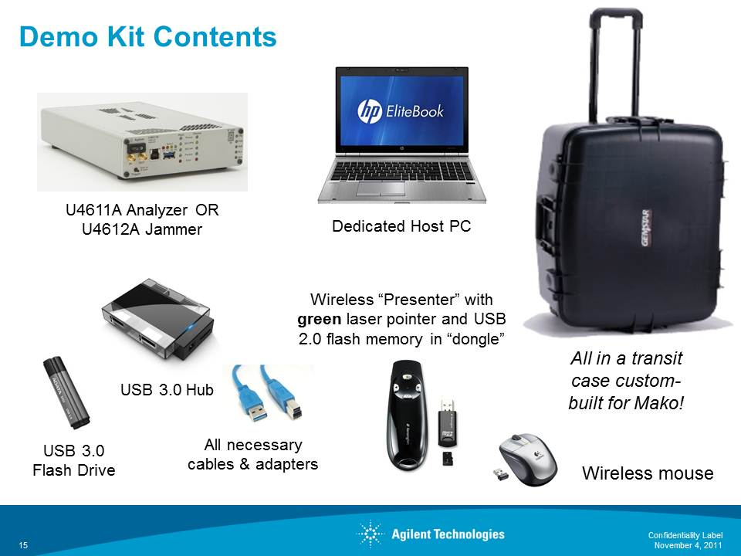
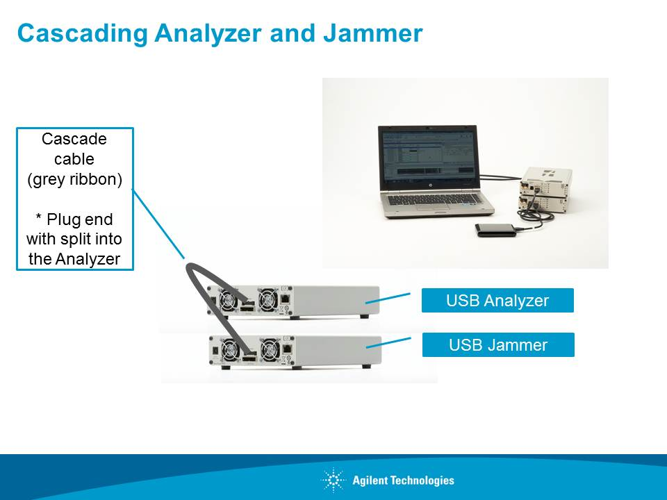
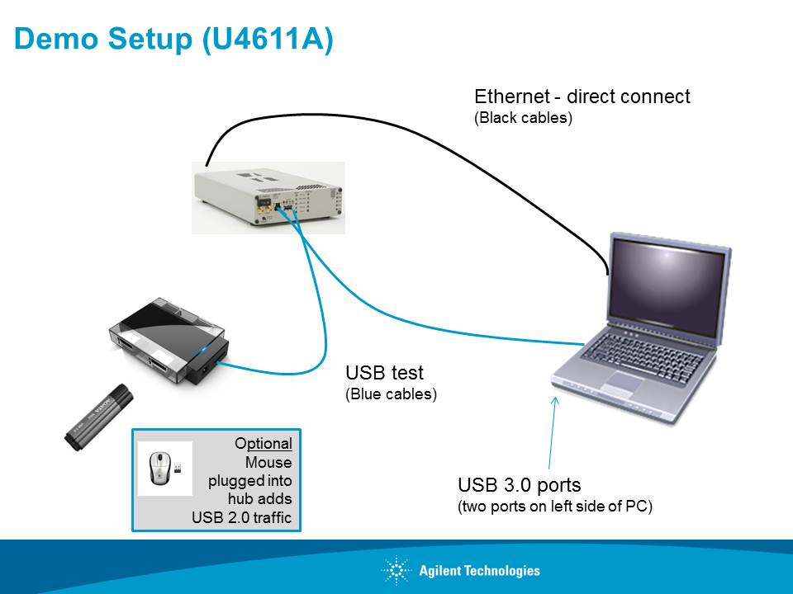
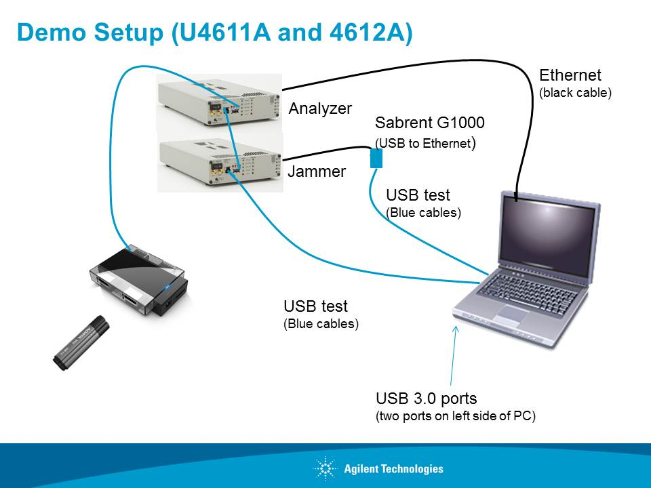

Demo Instructions
- Make sure to use “Mako Host PC” power supply for the host PC; Mako itself needs the larger 90W p/s.
- Connect Mako to the host pc via GbE; GbE light on Mako should light up pretty much as soon as the box and the PC are powered up, even if the BusXpert software isn’t running yet.
- Connect host PC to Mako’s USB input via the blue cable; output to the hub with the hub’s black cable. Hub and devices will draw more than spec allows, but Mako can supply it (the current draw is measured and displayed by the software).
- I included a 2.0 Sandisk drive and a 3.0 Transcend drive; they have batch files on their root that will create traffic back and forth between themselves and the host. “ABCs.txt” is a very small (62 bytes) file, Pisa and Duomo are ~4MB images, and “trace” is a 74MB captured trace file. Double click on whichever “MoveXXXX” batch files you want to create traffic with as you see fit. ☺
- I also included a wired mouse if you want to create LS traffic (which will become split transactions on the other side of the hub, of course). I’m a fan of split transactions, so I usually have a LS device hanging off the hub when I do demos.
- Launch BusXpert; “Capture Control” window will come up – hopefully an instrument will show up with a green “I” symbol. Click OK.
- You can click through the “Device,” “Filter,” “Trigger” and “Status” menus to show them trigger positioning, segmented memory buffers, filters (these are “storage qualifiers,” i.e., if it isn’t checked, the analyzer won’t store it), the triggering, etc. Status is where the current monitoring shows up. All settings should be retained from when I set it up; if not, you can “File/Open Capture Settings” from c:\mako\demo\settings\demo settings.btcs.
- Hit “Start Capture” and let it go. Assuming there is traffic, the 3.0 dial should fill up in about 7.5 seconds (90% of the trace buffer is dedicated to 3.0 and 10% to 2.0 by default). Since there won’t be any devices being enumerated, it won’t trigger, so at some point you can hit the manual trigger button on the front panel.
- It will then launch the trace viewer window. If it puts up a Sync Flow Fifo Error message, close it down quickly and tell them that’s a bug we’re fixing. ☺ It tends to only show up when doing concurrent 3.0 and 2.0; it’s a bug in the FPGA that SerialTek is working on a fix for. I like to immediately jump into “Hide”ing Idles, Skips, LCRD, LGOOD, etc. so that they can see that the trace is immediately usable.
- The workspace will be set up with a trace view in “spreadsheet view” at top left, the packet detail view at top right, and the histogram at the bottom. You can switch between the spreadsheet and transaction views and the histogram and data views (data will show the packet contents of whatever packet you have selected in the trace view). I have the histrogram set up to show data packets and 3.0 handshaking. You can add or remove histogram buckets, as well as renaming them (e.g., you can have it only show ACKs from host to device and rename it “Host ACKs”, etc.).
- When it’s in transaction view and it’s having to do a lot of processing, occasionally you’ll see a “Loading . . . Click to Cancel” clock symbol come up. If it lasts long at all, you can click on it to show that it is immediately responsive to canceling (you know how some/most programs don’t actually cancel when you tell them to? ☺).

