USB Protocol Tutorial
Load file: Sony Device Startup.ccusb
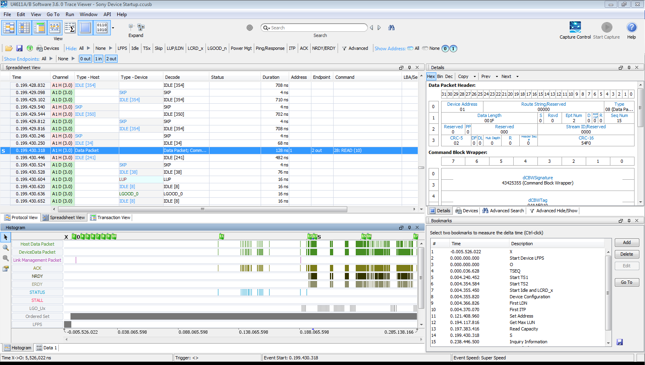

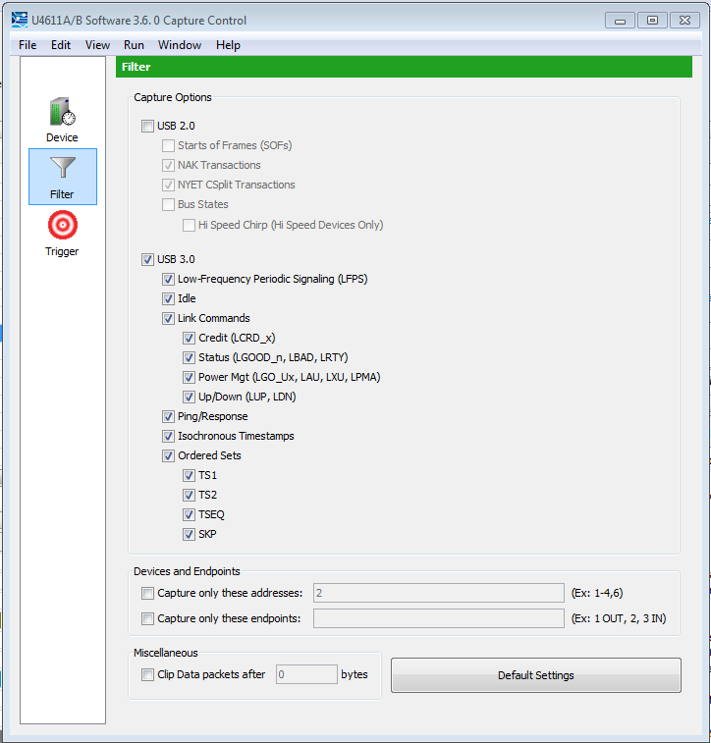
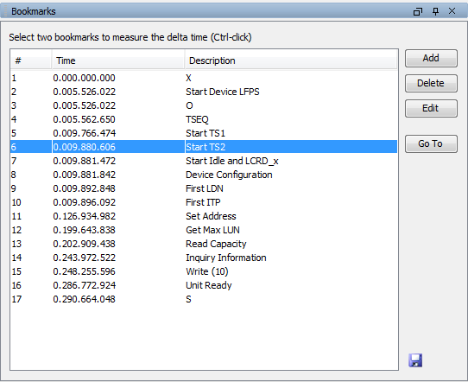

This file uses a Sony 8GB flash drive, and traces the entire process from device connection to file transfer.

The capture included all information from the link. Nothing was filtered out.
The entire sequence for the device configuration took at total of 290 msecs. Generating a capture buffer of 347MB.
LeCroy point: To upload and analyze a file of this size on the Advisor or Voyager products would take more than 10 minutes. From stop capture until data is loaded and ready.

The remainder of this tutorial will point to a bookmark and then mention some of the key points regarding the protocol operation.
Open the bookmarks tab and double click on a bookmark to jump to that location in the buffer.
Bookmark – X
This is the start of the capture buffer. As soon as the host detected that termination was present, it began send LFPS signals to the device to begin the connection process. Right-click on the timestamp and select “Set Origin Here”, to gain a quick view of the time reference of all the events. Setting the timestamp effects not only the decode window, but all of the bookmarks as well.
Bookmark – Start Device LFPS
Note that this is also the “O” bookmark. By setting “X”, we can get a quick look at the time difference between X -> 0 in the lower right of the screen.
The Device begins sending LFPS to the Host. The LFPS (Low Frequency Periodic Signal) is a 10MHz to 50MHz signal used to signal initialization and power management information.
Bookmark – TSEQ
LFPS signaling is present for 36usec before the host begins send TSEQ. This is the beginning of the training sequence for the equalizers. Note the “Raw data” error, as the signal changes from LFPS to a 5GHz signal. Our front end is the best in the industry. LeCroy is blind for a period when transitions happen. You can also see that it takes a while before the device is sees the 5 GHz signal and start replying with TSEQ. TSEQ is sent 65,536 ordered sets – or groups of 8.
A TSEQ is a special pattern to help with the equalization process, to see the pattern; go to Protocol view and expand one of the TSEQ. If you expand one from both sides you will see the exact signaling that occurred relative to each side of the link.
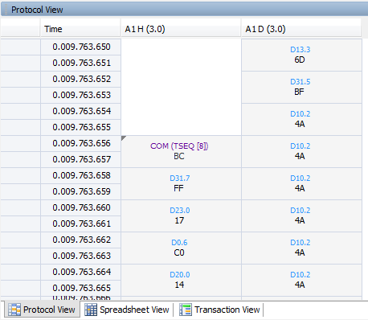

Bookmark – Start TS1
Bookmark – Start TS2
Now each side must receive 16 uninterrupted TS1s and then 8 uninterrupted TS2s to complete the training. Note that there are some SKPs in the middle. According to the spec, this is not to occur in the middle of the consecutive 8 for the training.
A deep capture buffer and a high performance front-end is critical to capture this type of information.
Bookmark – Start Idle and LCRD_x
Now that the link is synchronized, the link level communicates the status of the receive buffers. Whenever a link syncs, it first send a LGOOD_7 as the sequence numbering of messages. The LGOOD_x messages are to indicate the success of receiving a packet from the other end.
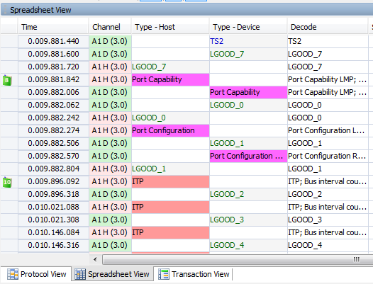
If you adjust the filters to see only the packets and the LGOOD_x messages, you can see that everytime a packet is received, the other end sends an LGOOD with the number sequence incrementing.
Any LGOOD_x messages that are not sent in order will cause the link to go into recovery.
The LCRD_x messages indicated an available buffer to receive a packet. Each end has 4 buffers available, and indicates when they are available.

Bookmark – Device Configuration
Multiple steps are involved in the device enumeration. It starts with the Port configuration, and then continues further down the with the Set_Address, Get Descriptor, etc.
Use the Quick Search to find these messages. Type “Device” in the quick search field to get a list of device commands that you can find “instantly”.
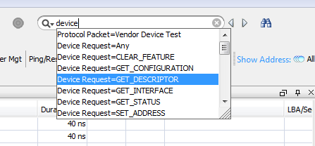

Bookmark – First LDN
Whenever the Device or the Host does not have any data to send, they send one of these message every 10 usec to indicate to the other end that they are in the U0 data transfer state.
LDN is sent by the host, and LUP is sent by the device.

Bookmark – ITP
The Isochronous Timestamp protocol message is sent every 125 usec to maintain timing sync with all isochronous devices.
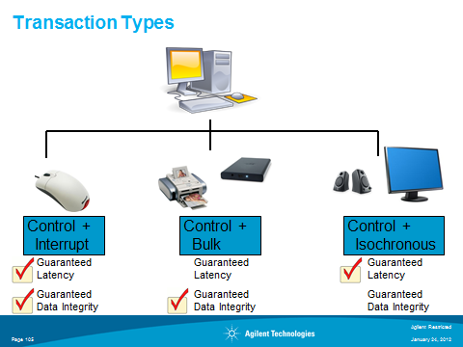

Bookmark – Get Max LUN
Now it is best to switch to the transaction view.
Most of the USB Link level messages will now be filtered out of the display. Transactions are grouped to show the overall success or failure of the commands.
I find it best to move the columns to make sure I can easily see the Duration, Transfer size, and Status of each command.
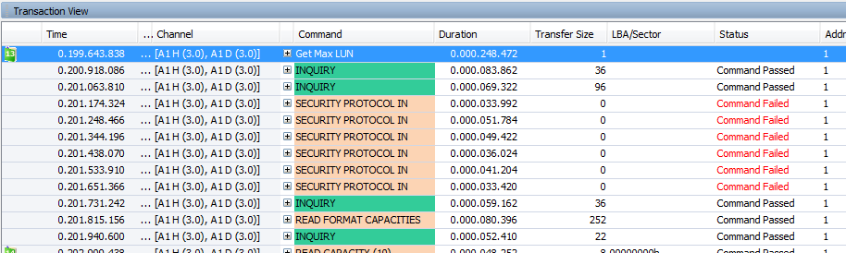
For looking at the detail of the command keep in mind that there are multiple message to look at.
For example.
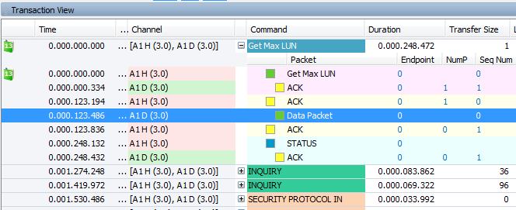
The sequence here is that the Host asks the device for the “MAX_LUN”, that packet is acknowledged by the USB level, but the device sends the response in the 4th packet and it takes 123 usecs to get the answer.
Security Protocol messages are failing in this link. The Host wants to secure the communication, but this device rejects the commands. “Command Failed”

Bookmark – Read Capacity
In the read Capacity command you will see that the device sends a “NRDY” response. (Not Ready) It is asking the host to wait until it gets the information requested to send the response.
The device then notified the host when is ready with an ERDY (Endpoint Ready) and waits for an ACK before sending the data.
Bookmark – Inquiry
Be sure to look at the Data Packet from the Device in this sequence. Now examine the “Details” pane to see all of the device information.
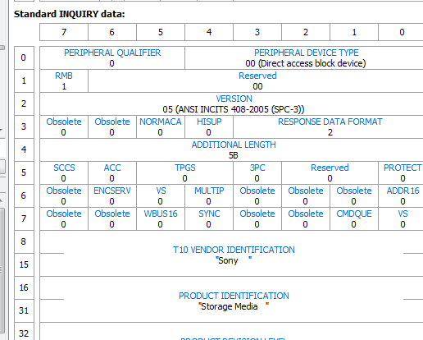
When looking at this level it is important to note the address and endpoints that are communicating. The Transaction display will automatically group the transaction using the correct addresses and endpoints, but when you move from one transaction to the next, you should always check that you are looking at the correct devices. For a complex trace it can be useful to use the Device and endpoint Filters.
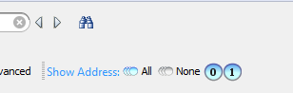
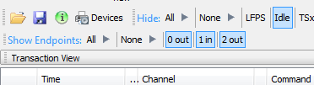

Transaction Decode window
In the Transaction decode window there is a second row of headers to label the fields of the individual packets.
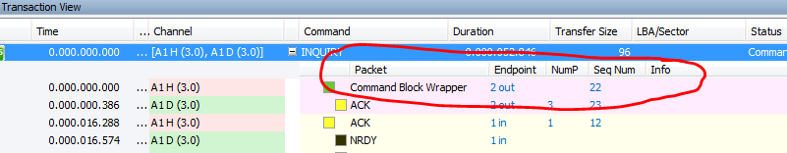
These can be turned off by right-click on a header turn “Table view” on or off.
Bookmark – Write (10)
Even though the max size of a USB packet is 1K, the write command is much bigger. It is just in multiple packets.
Note that it took just 43 usec to transfer the data, but then the device sent NRDY, then 400 usec later the device sent ERDY and the close of the command.

