U4611A USB 3.0/2.0 Protocol Analyzer

Demo guide – Data decode

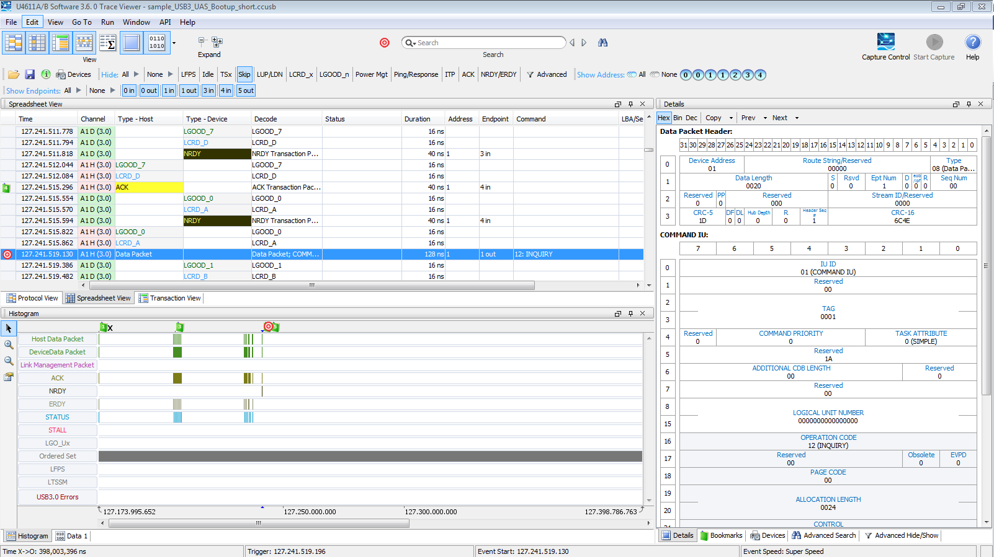
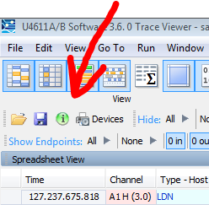
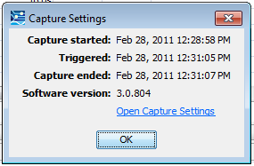
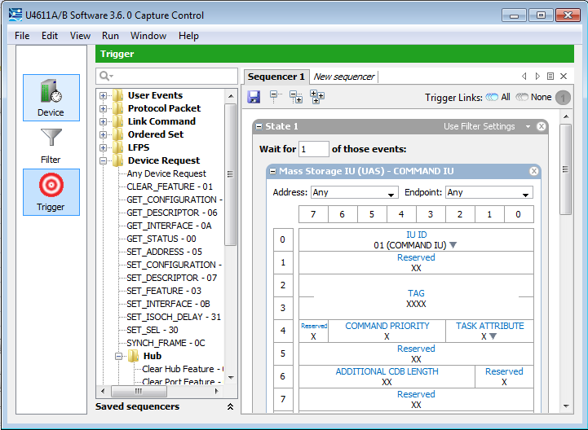

Open trace file:
(The following trace file is included in the software installation.) C:\Users\<User>\Documents\Agilent\ProtocolTester\Traces\sample_USB3_UAS_Bootup_short.ccusb
This file focusses on the operation of UAS (USB Attached SCSI) storage device from “SYMWAVE”
The first step is to get the display like you want. The layout configuration is “sticky” so it might not look like the display on the right, but will need to be adjusted.
To get to a default layout, select “Window”, “Reset Layout”. You will need to select the Histogram tab on the bottom window.
(See Help topic “Dockable Windows” for tips on adjusting the windows in the application.)

When examining a display it is good to know what was captured. Click the green icon, to see the capture settings. Then click on the “Open Capture Settings” Link to see the details of the filters and trigger conditions of the capture.

This capture used a simple trigger on a mass storage IU command. When the file is opened you are automatically placed at the point where the trigger condition happened. In the spreadsheet decode window you see a data packet is selected in the details window you see the mass storage packet that triggered the capture decoded.

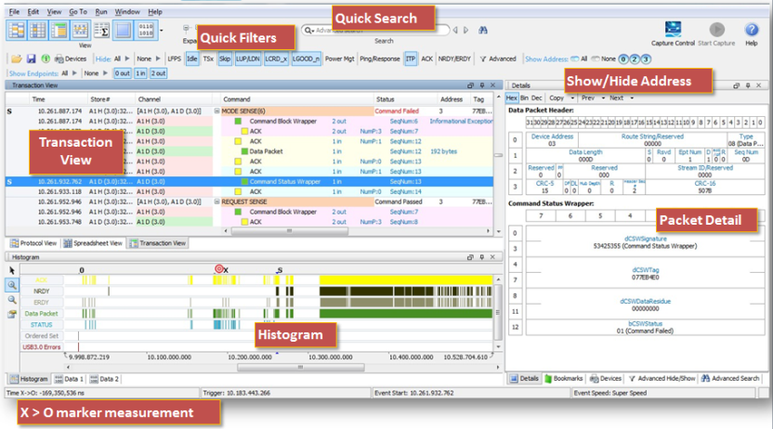

Quick Decode Filters
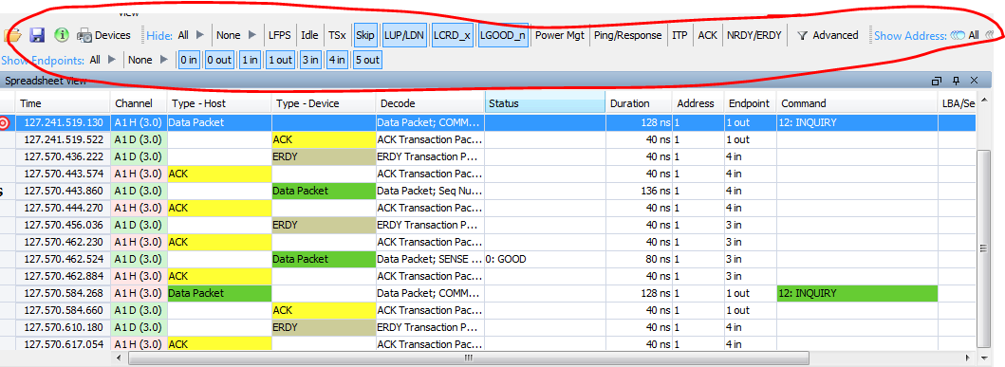

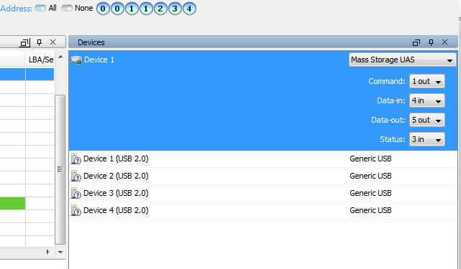

There are two levels of filtering USB analyzer to capture filters are separate from the decode filters. The quick filters do not change the data but simply remove the viewing of certain types of information. In this view to remove the skips for example which are abbreviated SKP in our decode click on the skip icon by the quick filters.
The quick filters also work on addresses and endpoints. To see what addresses and endpoints are in the system click on the devices icon right at the start of the quick filters.
This immediately opens up the devices window where we see a list of all the devices that were discovered on this link and automatically categorized. Configuration of any of these devices can be changed to enhance decode of information. The reason there are two device one devices this one is on USB 3.0 the other on USB 2.0.
To understand the USB is important to realize that every device is assigned an address by the host when it is connected to the link. Within the device there are always multiple endpoints. On control end point and 1 or more data end points to send and receive data.

Selection buttons

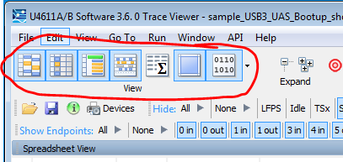

The 7 large buttons in the upper left are to turn the different views on/off.
Hover over any button and it provides a tool tip to indicate what will be displayed.
The 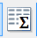 button is for statistics. It will open a window that is mostly blank. This is a future feature that will provide utilization as well as device level statistics.

Decode Window
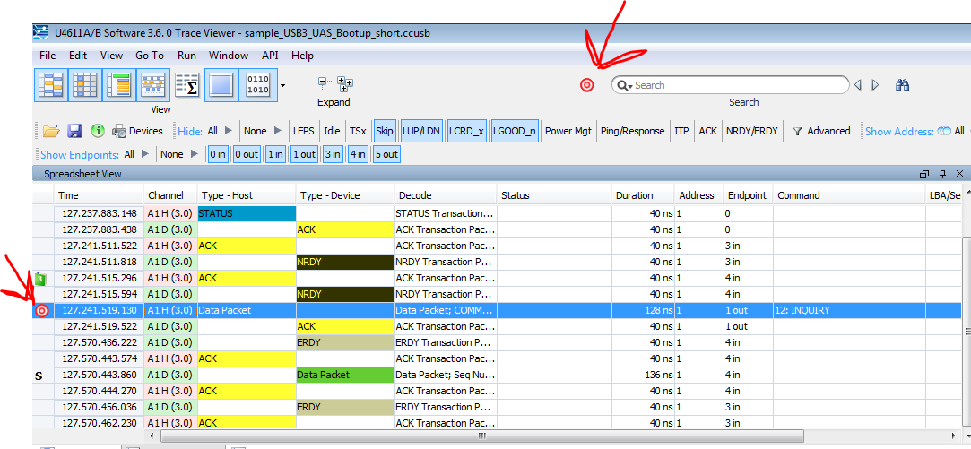
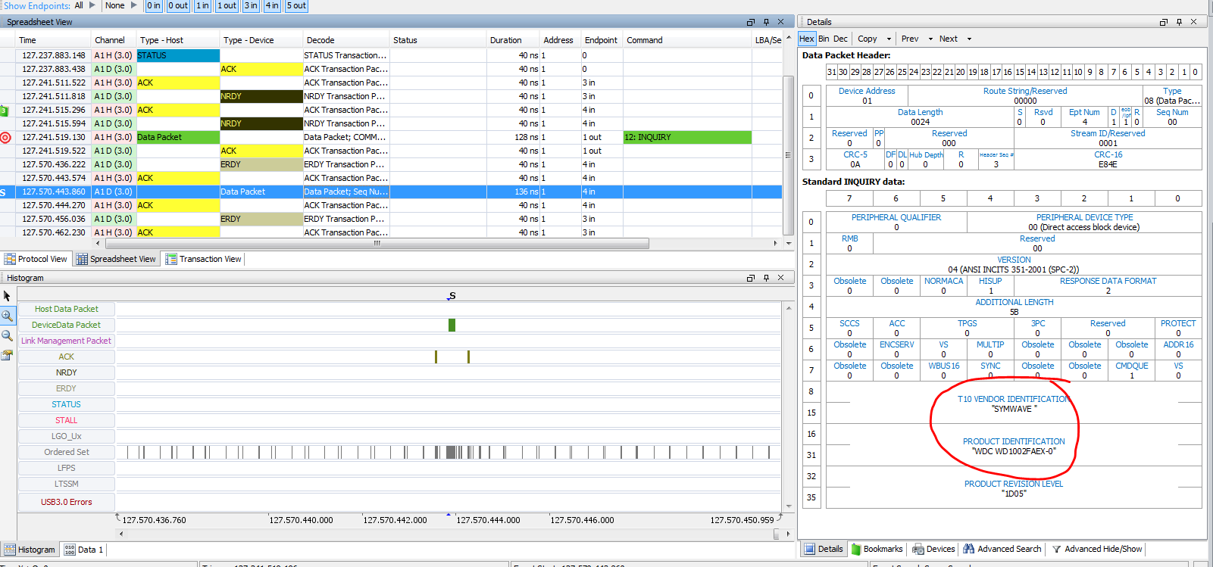

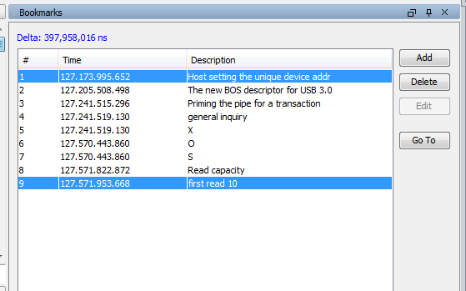

Now let's configure the spreadsheet decode window like the display on the left. Click on the target icon to immediately move the decode to the trigger frame. What we can see is the data packet if we look on there to the right it says it's an inquiry this is the UAS protocol asking the device for additional information. If you now click on the next data packet, this is the reply information from the device.

Now you see the information about the device as being from vendor SYMWAVE and the product identification information.

Now at the bottom of the detailed display click on the tab that says bookmarks. This information has been stored with the trace file and gives us easy access to key bits of information. Double-click on any bookmark and it instantly takes you to that reference point. To make a timing measurement between toolbar bookmarks simply select one then control click on the other end at the top it gives you the time difference between those events.
To see the device setup time we take the difference between the “Set_Address” command to the first read(10); we can see that the delta time is 398 msecs.
To add a bookmark right-click on any packet in the display and select “Add Bookmark”, a full text field is available.

Histogram
The Histogram is a very powerful tool that enables the user to review the data traffic flow very quickly.
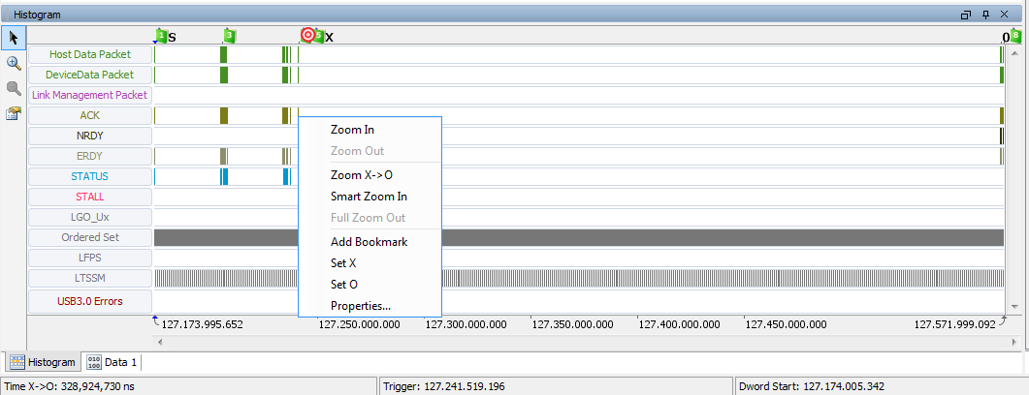

Configure the Histogram
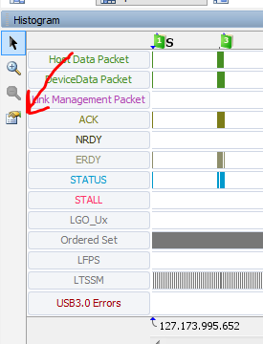
** WARNING **
LTSSM state information is not fully functional in release 3.5.7.
Use with great caution!
*****
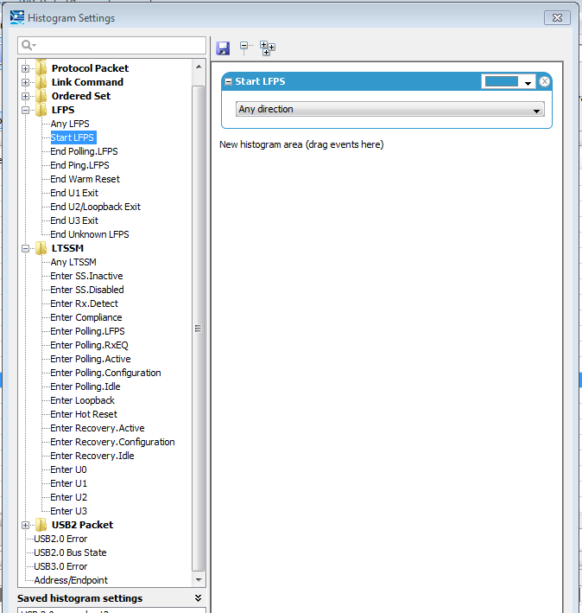
The histogram to provides a linear time-based view of the entire capture buffer (up to 18 GB) in one quick view. As data is captured we used to FPGAs to flag the types of data in real time as it is captured. There are over 300 different types of flags being generated for the data. When you configure the histogram you are simply setting which flags should be displayed.
To see the types of flags are being integrated on the data simply click on the configuration icon. In the next section we will cover how to configure common configurations for the histogram.
Notice across the top of locations of the target trigger condition as well as all bookmarks are highlighted. By simply clicking on the tick mark indicating a frame of a certain type it automatically synchronizes the other views to that point in the capture buffer. Also by right clicking you can add bookmarks set X. and O.

The histogram configuration is not maintained in a separate file or with the data file. It is a set of configurations that are stored in the analyzer operation. I recommend that you have the following four configurations stored in your analyzer to be recalled at any point in time.
- USB 3.0 general
- USB 2.0 general
- USB 2.0/3.0 general
- Link Synchronization
- Default Histogram
After you configure each one click the save button at the top get the appropriate name and then create the next one.

The histogram settings are saved to:
For Windows7:
\Users\<someones_user_name>\AppData\Roaming\Agilent\ProtocolTester
WindowsXP
Documents and Settings\<someones_user_name>\MyDocuments\Agilent\ProtocolTester

Files include included in – ProtocolTester.zip
- histogram_0.xml (Default Histogram)
- histogram_1.xml (Link Synchronization)
- histogram_2.xml (USB 3.0/2.0 general set)
- histogram_3.xml (USB 2.0 general set)
- histogram_4.xml (USB 3.0 general set)

USB 3.0 General
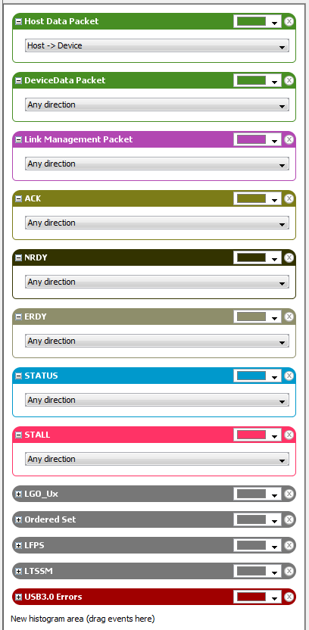

USB 2.0 General
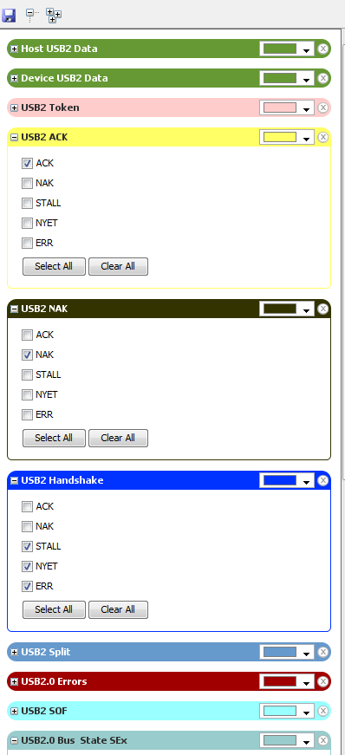
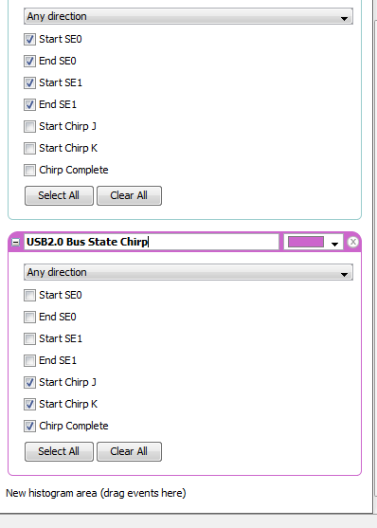

Time based view – histogram
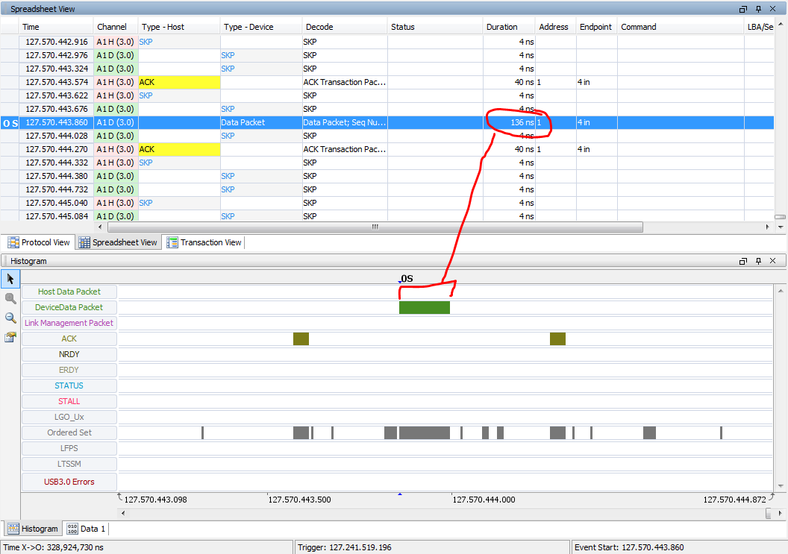

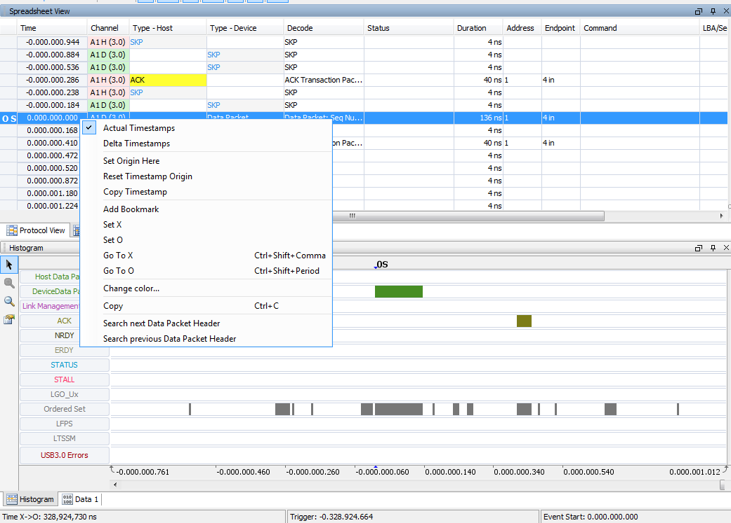

The histogram provides a view of the duration of the events that occur in the decode windows.
Zoom in on the “O” marker and you can easily see the length of time (136 nsec) that the data packet lasted versus the 4 nsec SKP messages (shown in the ordered sets of the histogram).

Right click on the timestamp in the data decode and set the timestamp origin. Note that the Histogram now displays the same relative time stamps.

Uses of the different Protocol views

Spreadsheet
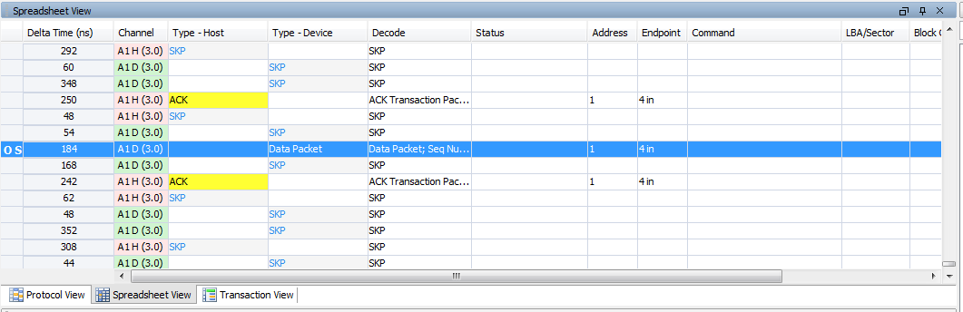
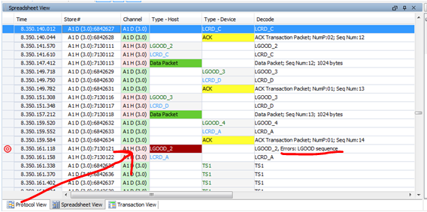

Transaction view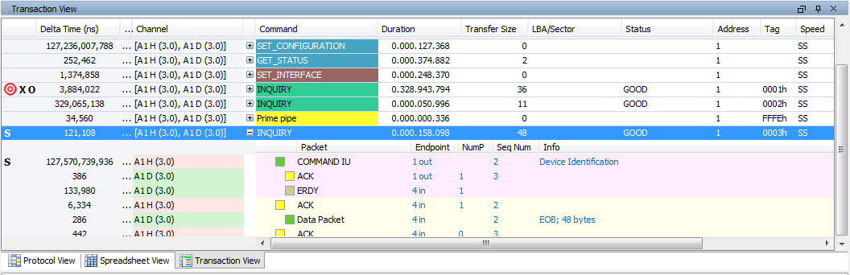
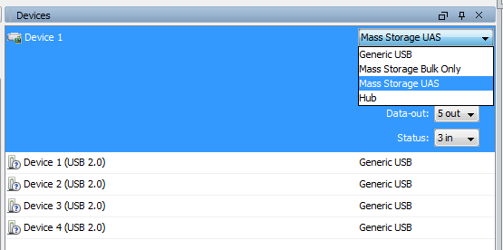

Use the Expand and Contract links in all Transaction View
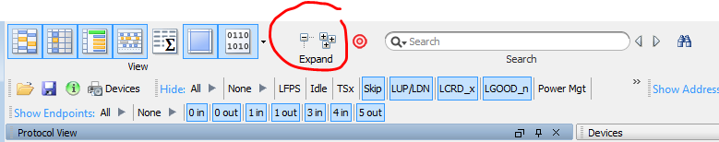
The spreadsheet view is the most commonly used view.
The key of this view is that each packet is displayed in a one line with multiple columns. Each packet is in exact time chronological order (LeCroy doesn’t do this). Column can be turned on and off and dragged in any order desired.
Quick filters are extremely visible in this area. The filters are so fast because they use the same flags (saved in an analysis index) that we use to draw the histogram. Also used by the search function to find packets in the capture buffer. (LeCroy uses software that must reprocess the data every time you change the filters or search for new information.)
Errors in protocol operation are highlighted in red for easy identification. Also available through the “quick search.

Transaction view is moving up the protocol hierarchy to decode the device information. The decode of information usually takes the tracking of more than one packet. All of the packets are grouped together to provide the transaction result. The transactions may be interleaved, but in this display all packets for a specific transaction will be in order.
**NOTE IF TRANSACTIONS ARE NOT DECODING CORRECTLY**
Go to the “Devices” menu and check the configuration. If the device enumeration was missed, you may need to manually set the device type for the decode to display correct.

Protocol View
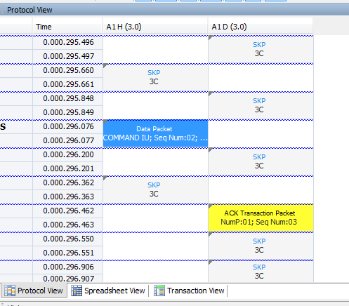
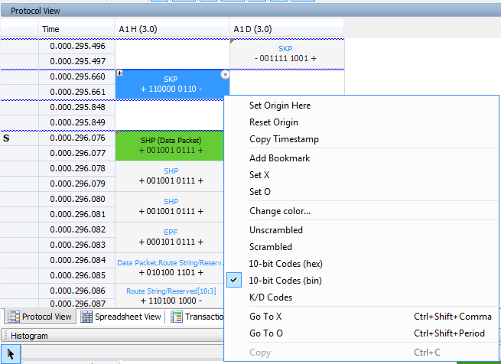

Use the Expand and Contract links in all Protocol View
The Protocol decode is a byte by byte display of the information that was sent over the cable. The analyzer actually captures the bits from the wire and can the exact information in in binary, D/K codes, scrambled or unscrambled form.

Each link (USB 2.0 and USB 3.0) has a Host column and a device column. Multiplexed links also have 'a' and 'b' columns. Links are shown side-by-side so you can see what happened at the same time. The blue wavy lines indicate gaps in time.

Details Decode
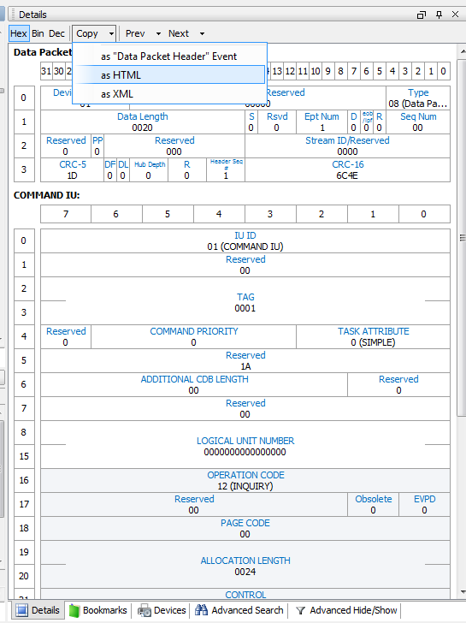

Data display
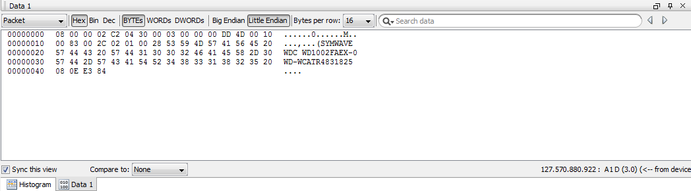

The Details decode displays the packet in the same format as the specification. All of the values are displayed directly in the fields as appropriate for the decode.
A very useful feature is that this information can be copied in HTML format for easy pasting into documentation. The pasted information will look just exactly as it does in the analyzer.
Also useful is to copy as XML. All of the single packet decode information is done by XML files. Past this information into an XML editor, and you are most of the way on configuring a new Protocol decode for the analyzer. (See the Help topic “Custom Decodes” for a full explanation.)
XML files are also used for custom filters, custom trigger conditions, custom Jammer sequences, and adding new types of analysis to the Histogram.

Additionally all of the information can be displayed in the raw data form. Either the payload or the entire packet.

Data Export
Export of information has been very important to many customers and is seen as a significant feature.
Under “File”, “Export”
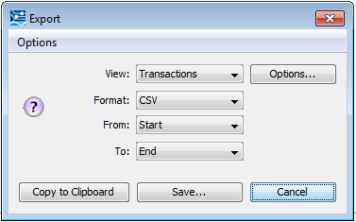
The most common use has been to export the data for analysis and comparison to original source data.
The way to do this is to filter the data first with the advanced filters. Show only the data frames.
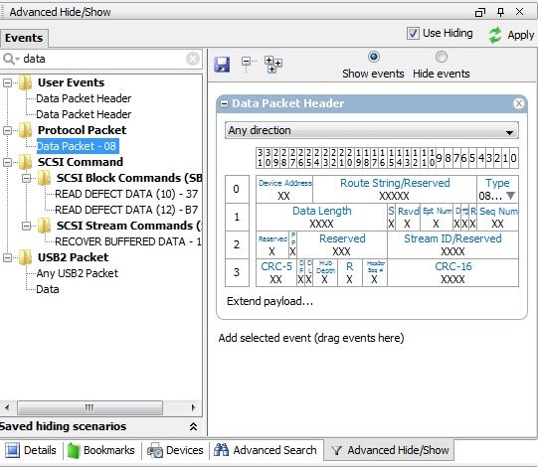

Then export into a spreadsheet, and include the payload data. This allows them to maintain other files (i.e. timestamp) that may be useful.
Make sure to “Use Hiding” to get only the data packets. You can choose the X -> O markers for an export range.
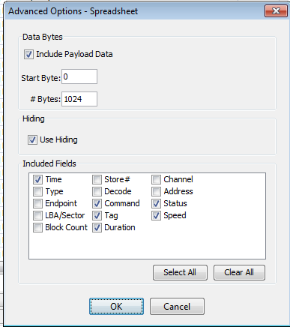

Advanced Search
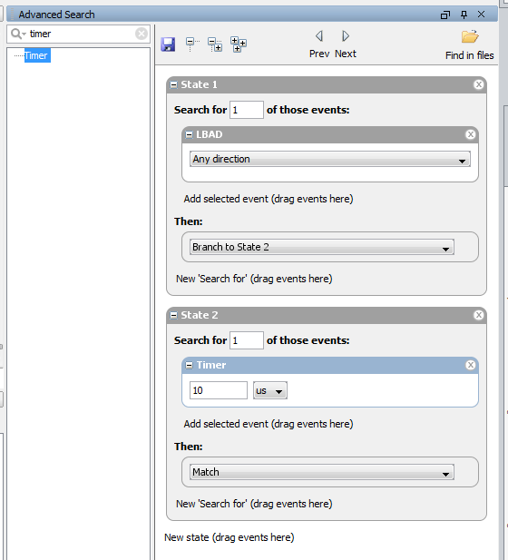

Advanced Hide/Show
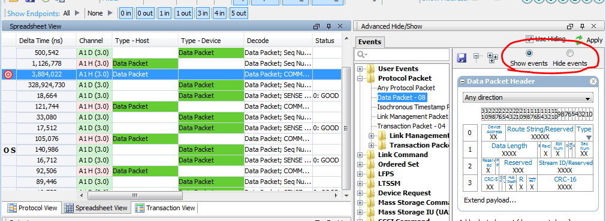

Advanced search adds the ability to state based searching in the data, including looking for a timeout value based on the captured information.

The advanced Hide/Show menu is very useful for displaying only one type of information. For example, Show the Data only.
*** WARNING ***
If the “Use Hiding” checkbox is unchecked, all of the filters are disabled, including the quick filters.
***

