MIMO Programming Guide (preliminary)

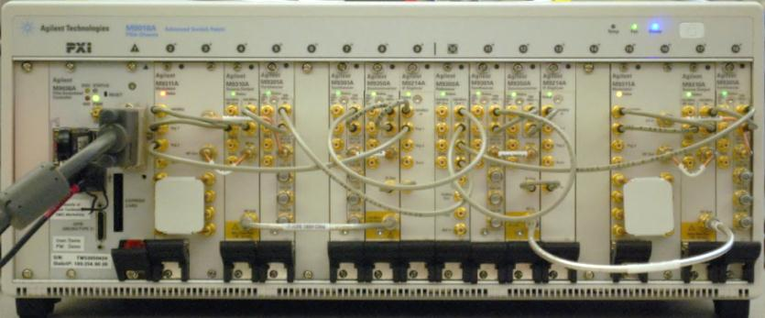
This document details the programming of the M9381A and M9391A MIMO. All examples will be for a 2x2 setup, as described in the MIMO Demo Configuration and Demo Guides. The M9391 is entirely controlled via the 89600 VSA software. The 89600 can be programmatically controlled via SCPI and .NET interfaces. The 89600 documentation can be consulted for details.
Note: The M9381A is synchronized via external trigger. We use backplane external trigger, generated by M9300A.
Note: The M9300A module must be in slot 10 of the PXI chassis.
Note: The cables from M9300A to M9301A modules for 100 MHz reference must be of equal length.

Software Configuration
The software should be installed in the following order:
- 89600 version 16.2 or greater
- M9391 version 1.1.228.0 or greater.
- M938x version 1.3.105 or greater.
- Connect to each of the instrument SFP’s in turn, perform self test, and verify FPGA firmware is fully updated.
Note: If your M9381A VSG spans a chassis trigger bus segment, it will be necessary to route the triggers on the chassis prior to running self test. See the trigger routing discussion below.
- Create N-channel M9391A configuration in 89600. Include the M9300 module in channel 1, but not in subsequent channels. See below.
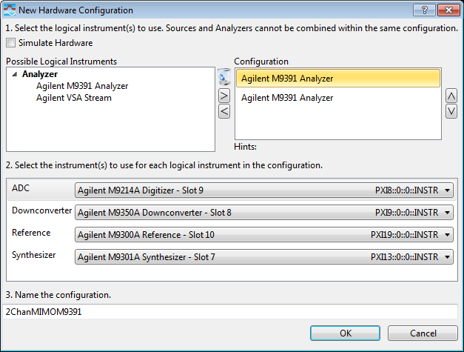
Channel 1 configuration

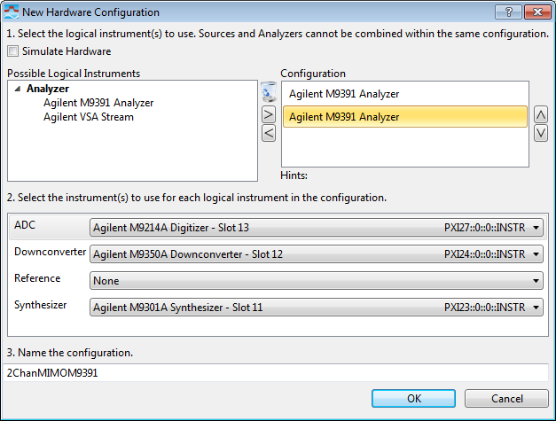
Channel 2 configuration

Note: Pay attention to the order in which you add your M9391 channels to the hardware configuration. You’ll need this later to determine which channel will be used to receive an external, software or magnitude trigger, and it will be needed for trigger allocation on the PXI backplane. The first (topmost) channel is the master, and will be used to receive triggers.

- Connect to the new hardware configuration.

- Exit the 89600 VSA software to ensure all settings are saved.

Driver Initialization
You’ll need to access the M9018A chassis for backplane trigger routing, the M9300A reference module for trigger generation, and the M938x driver for VSG setup and playback. Add references to these three IVI drivers. The following commands show an example of the references, and initializing the drivers for a 2-channel M938x setup in a C# Visual Studio program.
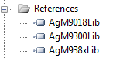
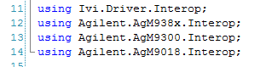
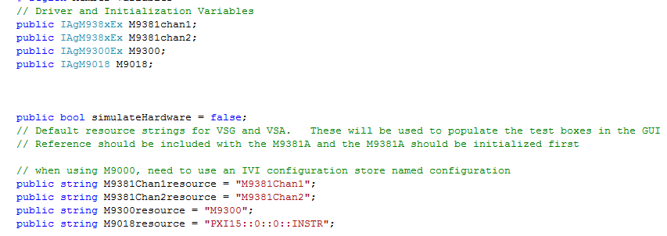
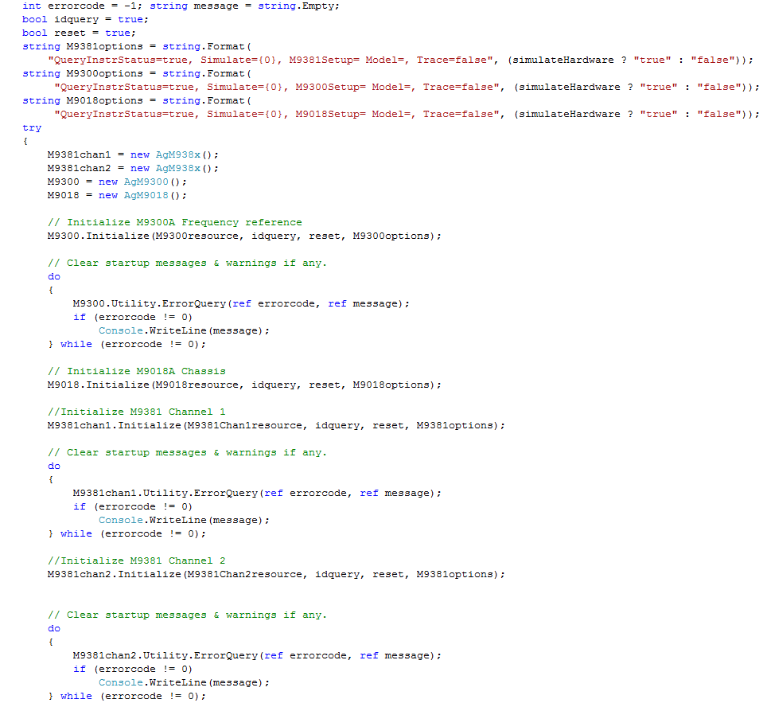

Trigger Routing

Before we can operate the MIMO VSG and VSA, we need to be concerned about proper backplane trigger assignment and routing on the M9018A chassis. There are 3 different types of triggers we will need to route:
- Predefined triggers for front panel external trigger and ALC Hold trigger within each M938x. The default triggers are PXI_TRIGGER7 for ALC Hold from M9311A to M9310A, and PXI_TRIGGER6 for front panel external trigger from M9301A to M9311A.
- Sync Ref 10 triggers for the M9391A. These are used to coordinate the capture alignment on the VSA. These are currently defaulted to PXI_TRIGGER1 from Master to last slave(master is topmost M9391 in 89600 hw config, last slave is bottom-most), PXI_TRIGGER2 from channel 2 M9391 to master, PXI_TRIGGER3 from channel 3 M9391 to master, and PXI_TRIGGER4 from channel 4 M9391 to master.
Note: In future, these trigger assignments may be configurable.
- Backplane external trigger routing from M9300A to M938x for playback synchronization of the VSG.
There are two requirements that must be met for each trigger that needs to be routed.
- The trigger must be able to propagate from the source to the destination. M9018A chassis trigger routing between bus segments may be required for this. Multi-chassis situations are more complex, and are not covered here.
- The trigger must not conflict with another trigger used on the same bus segment. It may be possible to reuse the same trigger line in one chassis, as long as there is isolation by a bus segment boundary. The triggers used by M938x can be reassigned if necessary. Currently the M9391 sync triggers are predefined, and cannot be reassigned.
For our 2-channel demo configuration, we need to route the external trigger from M9300A to our two M9311A modules, and route the sync triggers between the M9214A modules, but the default M938x external trigger and ALC hold assignments do not need to be changed. The following example demonstrates the commands required to achieve this:
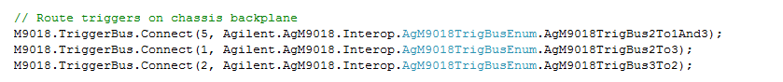
Since we are using PXI Trigger 5 for our external trigger, we need to define this:
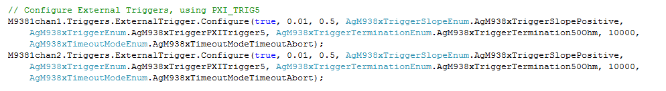
We also need to set up the M9300A reference module to generate a user-defined trigger on the PXI backplane trigger we’ve chosen:
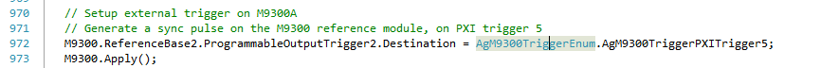
NOTE: The above setting must be performed every time we start playback, as it is possible for another process which is sharing the M9300A reference module to reset this setting.
A more complicated example is given here for a 4-channel M9381A and 4-channel M9391A in two chassis, which involves reassigning the triggers used for ALC hold and front panel external trigger, in addition to the backplane external trigger routing for M9300A to M9381A’s, and the backplane routings for SyncRef10 triggers for the M9391A’s.
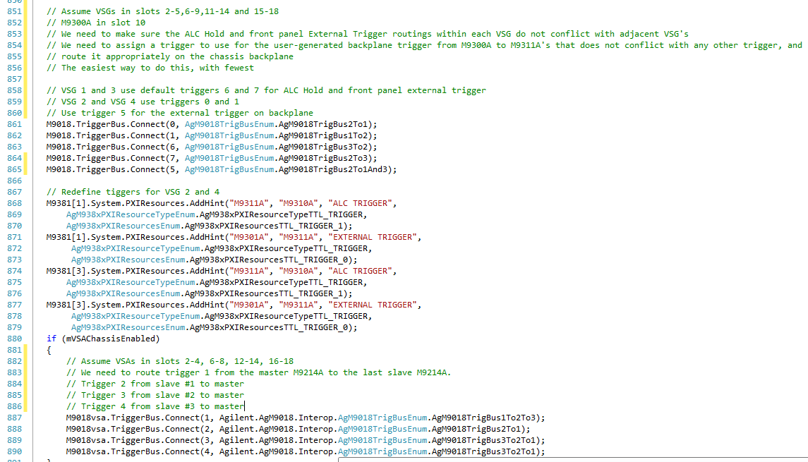

Setting up the M9381A VSGs
This section covers some of the basic settings needed to set up the M9381A VSGs, with WLAN Rx testing specifically in mind.
It is recommended to disable ALC for WLAN waveforms, to achieve the best residual EVM
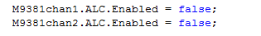
For receiver test, it is best to enable pulse blanking, for best off time rejection. This helps to avoid false packet detection during sensitivity testing. Note that if your waveform does not contain the pulse blanking markers, you will need to either define those markers using the M938x API, or disable pulse blanking.
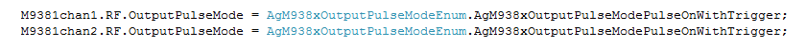
For optimal WLAN modulation performance, the PLL mode must be set to best wide offset.
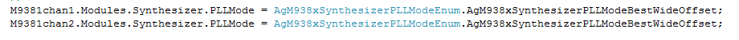

Starting Waveform playback on VSGs

We’ll look at two ways to playback waveforms – continuously, or as part of a sequence. We’ll also look at the best practice for achieving the most repeatable and accurate output power.
To play the waveform, we’ll first start the waveform in immediate trigger mode, optionally perform a power search to improve amplitude accuracy, optionally perform an IQ DC calibration if desired to improve carrier feedthrough, then restart the waveform in external trigger mode.
If turning the waveform on at this point would be problematic (Rx has already been started and is looking for packets), the power search and IQ cal steps could be performed as part of a calibration step that occurs before the start of the test. In this case, the power search results could be cached, and then recalled via the PowerSearch API.
Let’s look at how to perform the power search first, then how to play the waveform in either continuous mode or as a sequence.
Note that all of this assumes the desired waveform has already been loaded, and its reference name is stored in the string variable mWaveformHandle.

Power Search
First we play the in immediate mode, perform our power search, optionally cache this data, perform IQ cal, then stop modulation.
If you are recalling power search results from a previous session, you’ll call this method.
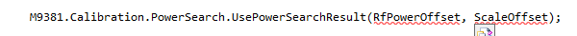
If you want to perform the power search right away, here is the recommended procedure:
- Play the desired waveform, or a waveform that is all 0 data, but with the same RMS factor and sample rate as the desired waveform, on all signal generators using immediate trigger mode.
- Perform the power search
- Stop playback
- Apply the power search offsets
First, create a zeros waveform with same RMS value and sample rate as the desired waveform. We’ll use this for power search, as well as putting it on the end of our sequence in order to turn off RF output in sequence mode. We use the ArbInformation method to get the RMS value and other parameters from our desired waveform:
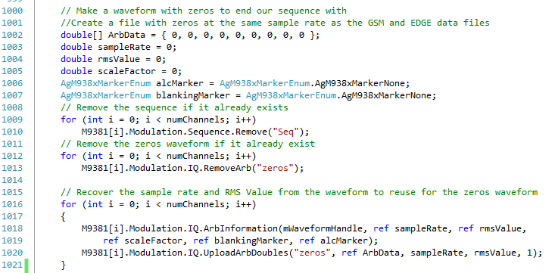
Next, play the zeros waveform in immediate trigger mode, and perform power search, first making sure to set the property to blank RF during power search, which will prevent any unwanted signal from coming out before we’re ready to play our desired waveform or sequence. Stop playback. Next, apply the power search values from the last step:
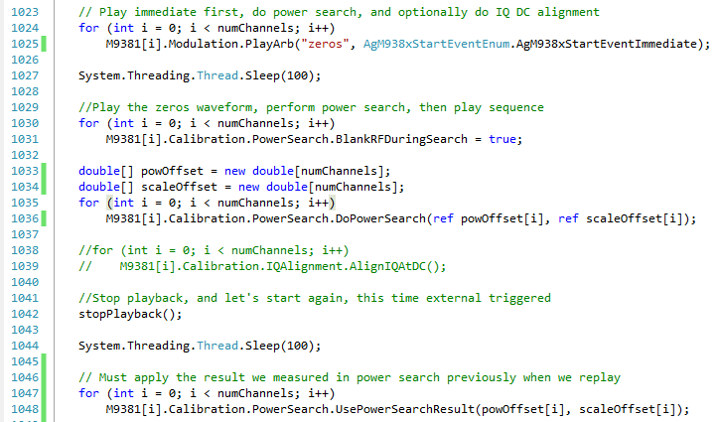
Here is all of the code we just discussed:
// Make a waveform with zeros to end our sequence with
//Create a file with zeros at the same sample rate as the GSM and EDGE data files
double[] ArbData = { 0, 0, 0, 0, 0, 0, 0, 0, 0 };
double sampleRate = 0;
double rmsValue = 0;
double scaleFactor = 0;
AgM938xMarkerEnum alcMarker = AgM938xMarkerEnum.AgM938xMarkerNone;
AgM938xMarkerEnum blankingMarker = AgM938xMarkerEnum.AgM938xMarkerNone;
// Remove the sequence if it already exists
for (int i = 0; i < numChannels; i++)
M9381[i].Modulation.Sequence.Remove("Seq");
// Remove the zeros waveform if it already exist
for (int i = 0; i < numChannels; i++)
M9381[i].Modulation.IQ.RemoveArb("zeros");

// Recover the sample rate and RMS Value from the waveform to reuse for the
// zeros waveform
for (int i = 0; i < numChannels; i++)
{
M9381[i].Modulation.IQ.ArbInformation(mWaveformHandle, ref sampleRate,
ref rmsValue, ref scaleFactor, ref blankingMarker, ref alcMarker);
M9381[i].Modulation.IQ.UploadArbDoubles("zeros", ref ArbData, sampleRate,
rmsValue, 1);
}

// Play immediate first, do power search, and optionally do IQ DC alignment
for (int i = 0; i < numChannels; i++)
M9381[i].Modulation.PlayArb("zeros",
AgM938xStartEventEnum.AgM938xStartEventImmediate);

System.Threading.Thread.Sleep(100);

//Play the zeros waveform, perform power search, then play sequence
for (int i = 0; i < numChannels; i++)
M9381[i].Calibration.PowerSearch.BlankRFDuringSearch = true;

double[] powOffset = new double[numChannels];
double[] scaleOffset = new double[numChannels];
for (int i = 0; i < numChannels; i++)
M9381[i].Calibration.PowerSearch.DoPowerSearch(ref powOffset[i],
ref scaleOffset[i]);

//for (int i = 0; i < numChannels; i++)
// M9381[i].Calibration.IQAlignment.AlignIQAtDC();

//Stop playback, and let's start again, this time external triggered
// Here is the code for stopPlayback()
//for (int i = 0; i < numChannels; i++)
// M9381[i].Modulation.Stop();

stopPlayback();

// Allow some time for all waveforms to stop playing
System.Threading.Thread.Sleep(100);

// Must apply the result we measured in power search previously when we replay
for (int i = 0; i < numChannels; i++)
M9381[i].Calibration.PowerSearch.UsePowerSearchResult(powOffset[i], scaleOffset[i]);

Trigger Routing
We also need to set up the M9300A reference module to generate a user-defined trigger on the PXI backplane trigger we’ve chosen:
NOTE: The above setting must be performed every time we start playback, as it is possible for another process which is sharing the M9300A reference module to reset this setting.
Here is the code:
// Setup external trigger on M9300A
// Generate a sync pulse on the M9300 reference module, on backplane trigger
M9300.ReferenceBase2.ProgrammableOutputTrigger2.Destination =
(AgM9300TriggerEnum)(triggerToSource + 2);
M9300.Apply();

Continuous Mode
Playing the waveform in continuous mode is simple: we start the waveform playback in external trigger mode, and generate our trigger on the backplane.
Here is the code needed to do this:
for (int i = 0; i < numChannels; i++)
M9381[i].Modulation.PlayArb(mWaveformHandle,
AgM938xStartEventEnum.AgM938xStartEventExternalTrigger);

System.Threading.Thread.Sleep(100);

// Generate a sync pulse on the M9300 reference module, on PXI trigger 5
M9300.ReferenceBase2.ProgrammableOutputTrigger2.GenerateTrigger();

Sequence Mode
To play the waveform in sequence mode, we first need to create the sequence. Let’s assume we want to play the same waveform a certain number of repetitions, then stop. To do this, we need to create a sequence that contains the waveform we would like to play as the first step, then a waveform that is composed of all zeros as the second step, which loops back on itself using the “Next Step” property. Note that the zeros waveform creation was described above in the section on power search. Here’s how to create the sequence and add our first step. Note that we MUST set RMS value during the sequence definition, or the power level will be in error:
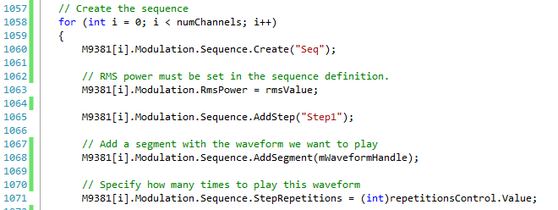
And now the second step, which contains the zeros waveform. This will have the effect of turning off the RF output. Note that we must set the scale factor in order to avoid problems with modulation quality.
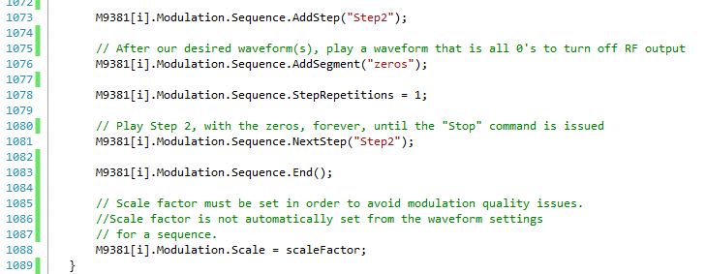

Lastly, we play the sequence and generate a trigger.
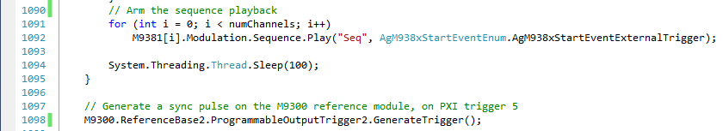
Here is all of the code needed:
// Create the sequence
for (int i = 0; i < numChannels; i++)
{
M9381[i].Modulation.Sequence.Create("Seq");

// RMS power must be set in the sequence definition.
M9381[i].Modulation.RmsPower = rmsValue;

M9381[i].Modulation.Sequence.AddStep("Step1");

// Add a segment with the waveform we want to play
M9381[i].Modulation.Sequence.AddSegment(mWaveformHandle);

// Specify how many times to play this waveform
M9381[i].Modulation.Sequence.StepRepetitions = (int)repetitionsControl.Value;

M9381[i].Modulation.Sequence.AddStep("Step2");

// After our desired waveform(s), play a waveform that is all 0's to turn off RF
//output
M9381[i].Modulation.Sequence.AddSegment("zeros");

M9381[i].Modulation.Sequence.StepRepetitions = 1;

// Play Step 2, with the zeros, forever, until the "Stop" command is issued
M9381[i].Modulation.Sequence.NextStep("Step2");

M9381[i].Modulation.Sequence.End();

// Scale factor must be set in order to avoid modulation quality issues.
//Scale factor is not automatically set from the waveform settings
// for a sequence.
M9381[i].Modulation.Scale = scaleFactor;
}
// Arm the sequence playback
for (int i = 0; i < numChannels; i++)
M9381[i].Modulation.Sequence.Play("Seq",
AgM938xStartEventEnum.AgM938xStartEventExternalTrigger);

System.Threading.Thread.Sleep(100);

// Generate a sync pulse on the M9300 reference module, on PXI trigger 5
M9300.ReferenceBase2.ProgrammableOutputTrigger2.GenerateTrigger();

89600 VSA settings for optimal WLAN demodulation
The Input->Extensions menu on the 89600 VSA contains several settings that are needed for optimizing WLAN EVM performance.
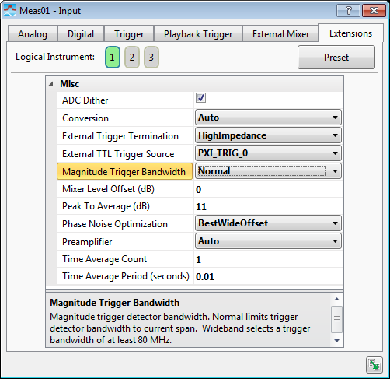

Phase Noise Optimization should always be set to BestWideOffset for WLAN demodulation. Peak to Average (dB) should be set as close as possible to the actual PAR of the signal, to optimize mixer drive level and IF attenuation. This should be used in conjunction with the Range setting in Analog settings. Additionally, the Mixer Level Offset (dB) can be used to provide additional adjustment to mixer drive level. Conversion mode should always be set to Auto or SingleHighSide or SingleLowSide for best WLAN EVM performance.
Note: The peak to average setting must be set for EACH channel, while the PLL mode is “shared” and will automatically be set on all channels when you change it for one.

