MIMO Demo Demo Guide
This document details describes how to demonstrate MIMO WLAN with the MIMO PXI VSG and VSA. For details of configuring the hardware and software, please refer to the MIMO Demo Configuration Guide.

Theory of Operation
Note: The following describes the current mode of operation of the MIMO Demo. There may be changes before the software is ready for shipment.
The system consists of two M9381A PXI VSGs and two M9391A VSAs, with one M9300A reference module in slot 10, the system timing slot. The M9300A is used to drive the 10 MHz reference on the backplane of the PXI chassis. This 10 MHz reference will be used to synchronize multiple VSGs baseband playback, and to synchronize multiple VSAs acquisition timing. All synchronization will be accomplished using the backplane of the PXI chassis.
It is possible to configure a 1x1, 3x3 or 4x4 demonstration system. In this case, 2 chassis must be used. The MIMO M9381A Demo Tool supports 1x1, 2x2, 3x3 and 4x4 configurations. The modules must be installed in the correct locations, and IVI aliases created appropriately. Additionally, the multi-chassis control must be set up. Please refer to the MIMO Demo Configuration Guide for details.
Note: In the current version, the VSGs are synchronized by an external trigger which is generated on the PXI backplane programmatically by the M9300A reference module. In future, the 10 MHz reference synchronization will be used.
Two pieces of software will be used:
- The 89600 VSA software will control the M9391A VSAs, and provide the measurement algorithms for the MIMO WLAN transmitter testing. This is the only supported software initially for making MIMO measurements with the M9391A VSAs. The M9391A IVI driver will not support this capability, nor will the M9391A SFP

- The MIMO M9381A Demo Tool can be found on the desktop in the MIMO VSG Demo folder. It will be used to control the M9381A VSGs, allowing you to play a number of included Signal Studio WLAN waveforms, play a user-defined waveform, control frequency and amplitude of the VSGs, and will also manage backplane trigger routing on the M9018A PXI chassis.

Getting Started

- First, run the MIMO M9381A Demo Tool.exe program. If you have followed the steps in the MIMO Demo Configuration Guide document, you should be able to press the “Init” button, and hardware will successfully initialize. If you have a 1x1, 3x3 or 4x4 configuration, first set the Number of Channels control appropriately, then press Init.
Note: It is important that this program be run before the 89600 VSA software is started and connected to hardware, so that backplane trigger routings are set appropriately.
- After initialization is complete, select the desired waveform from the Waveform Selection on the UI, and press the “Play Waveform Files” button. Note that you can also play a fixed number of repetitions of the waveform by selecting “Sequence” from the Sequencing settings. In this case, the specified number of repetitions of the waveform will play, and then the output will turn off.
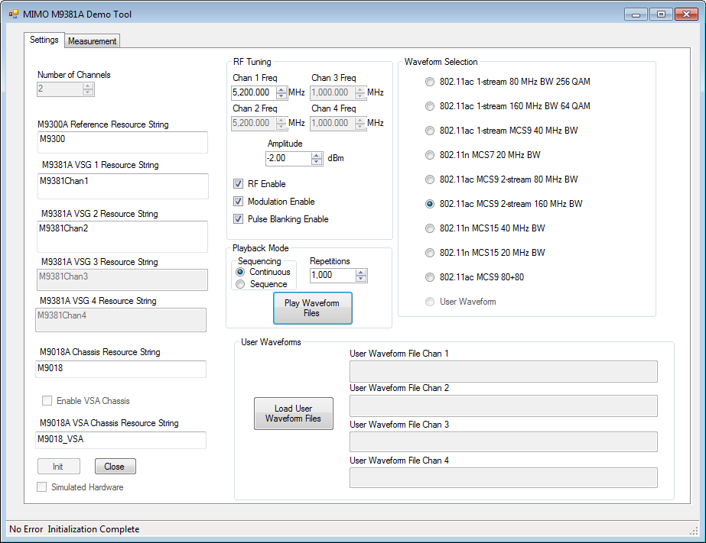

- Start the 89600 VSA software. After it is initialized, select the 2ChanMIMOM9391 hardware configuration, if it is not already selected. If you have a 1x1, 3x3 or 4x4 configuration, select the appropriate hardware configuration.

- Recall the appropriate 89600 setup file (e.g. 80211ac_MCS8_1SS_80MHzBW.setx) from the MIMO Demo waveform directories. There are four directories. All of the 89600 setup files you will need are in one of these four directories, which correspond to the 1x1, 2x2, 3x3 or 4x4 configurations. For example, all of the 2x2 setup files are in the “Dual Channel” directory. At this point we should be making a measurement with the two synchronized M9391A VSAs and M9381A VSGs.

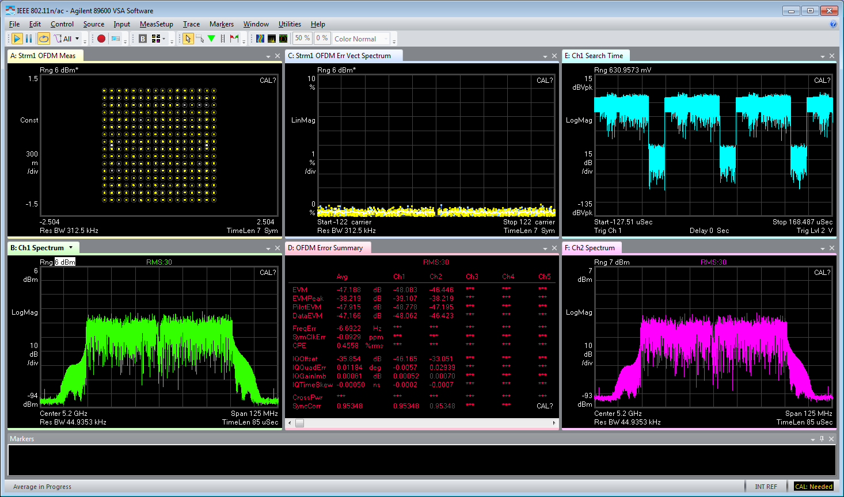

- Selecting any of the other built-in waveforms on the Demo Tool will stop playback. Press “Play Waveform Files” to initiate playback again. Each of these waveforms has a corresponding 89600 VSA setup file which you can recall to speed analysis. For all waveforms except the 802.11ac MCS9 80+80, and User waveforms, there is only one frequency control. Channels 1 and 2 will play back at the same frequency. For the 802.11ac MCS9 80+80, and User waveforms, the channel 2 frequency can be independently adjusted. It defaults to channel 1 frequency plus 300 MHz.
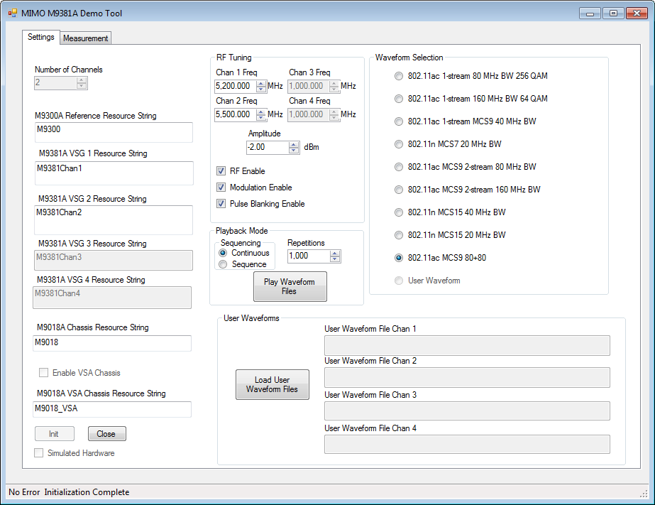

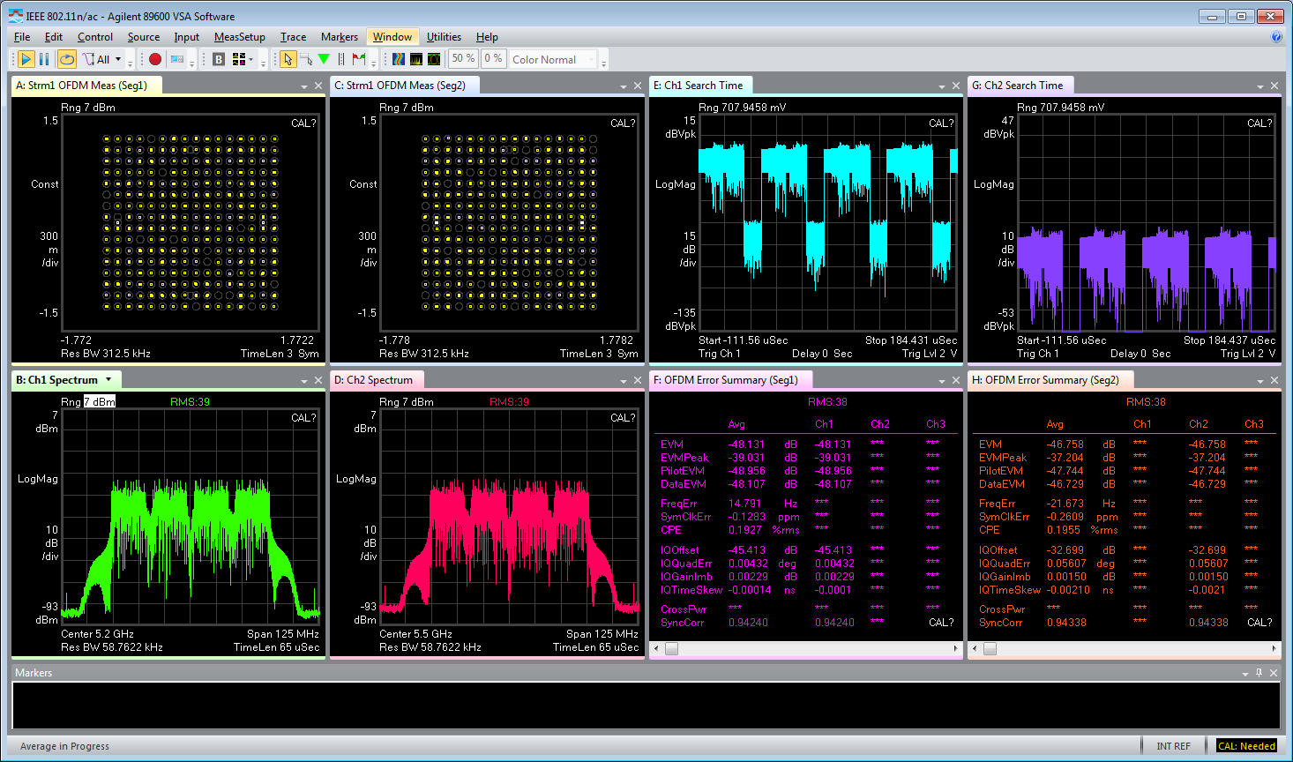

- To load user waveforms, press the Load Waveform button. This will bring up a dialog to select the waveform for channel 1, and then a second waveform for channel 2 (and channel 3 and channel 4 if they are present). Note that both of these waveforms must be the same length and sample rate for proper operation. Also note that if pulse blanking markers are not included in the waveforms, you may need to disable pulse blanking, or the waveform output will be suppressed.
After loading the waveforms, you must select the “user waveform” radio button, then press the “Play Waveform Files” button to begin playback.
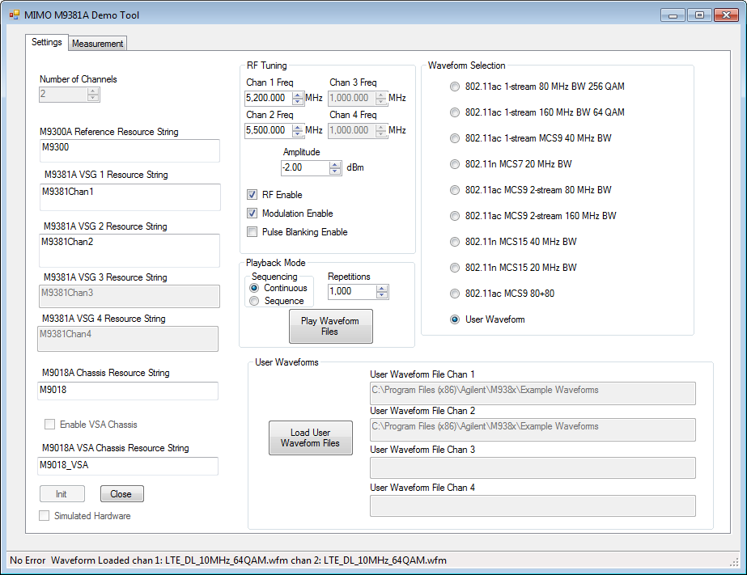

Recording Files
The MIMO VSG Demo directory includes recording files that can be used to demonstrate configurations beyond the hardware included in the demo configuration. There are some that were generated using 3 N5182B MXG VSGs with 3 M9391A VSAs, and others that were created using 4x4 M9381A and M9391A hardware. 89600 recording files are included, and setup files that can be used to demodulate. You will need to create a 3- or 4-channel simulated M9391A to be able to demodulate:
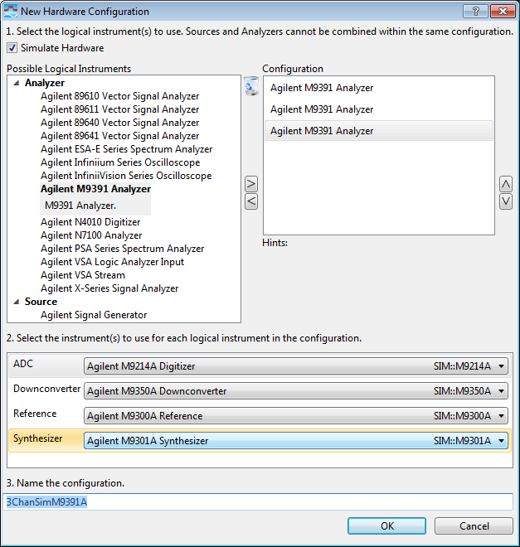

After enabling this configuration, recall the setup file, and the recording file to demodulate.
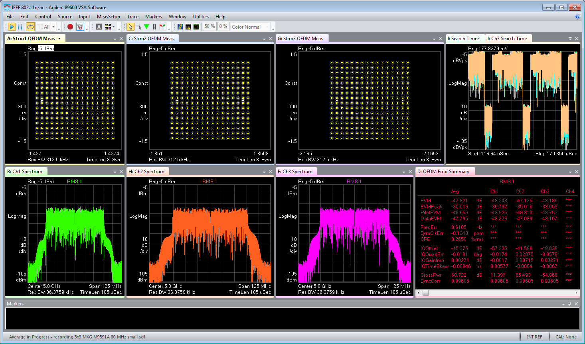
MXG to M9391A 80 MHz 802.11ac 3 spatial streams

