M938X SCPI Parser
Notes from: Scott C. Nevin, 13 January 2014

Overview
The M938x SCPI parser is implemented as a Windows Console application and is installed by the M938X Installer. It should create a “short-cut” that in which the properties can be edited to indicate the number of channels to control, the default is one.
The parser is built on the Aglient ACCL/HPP SCPI parser component. It can the “HiSLIP” protocol for communication which allows for multiple channels to be controlled over a single TCPIP port vis-à-vis the hislip device numbering scheme.
For example; hislip1 == channel 1, hislip2 == channel2, etc.
Alternatively the SCPI server can be started as a Socket or Telnet service. The first channel port number can be specified, subsequent channels would be on the next port number.

Creating the IVI Config Store Alias(es)
The first step is to use the M9380 or M9381 to create IVI aliases to the hardware. This is necessary because the parser will map hislip device onto an alias of the form M938XA-# where # is the channel number.
- Open either the M9380A or M9381A SFP depending whether the channel is a CW or modulated channel
- From the File > Save Connection… option
  - Name the connection and give it an optional description
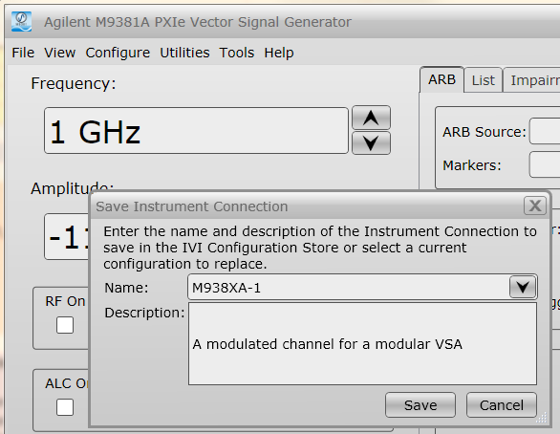

- Close the SFP

Starting the SCPI Parser
From the installation package there should be an “M938x SCPI Server” short-cut under the Agilent > M938X menu structure.
Here are the following command line options that can be supplied.
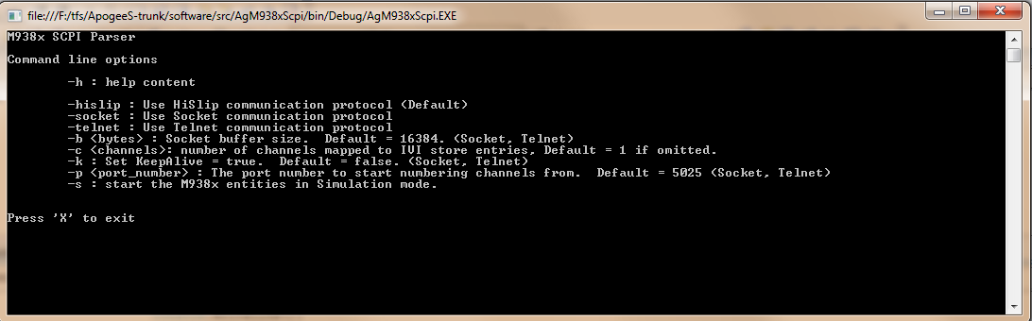
If you need have the SCPI server start with more than one channel
- Edit the properties of the short-cut and in the program
- Append on to the end of the Target of the short-cut “–c” with the number of options. Don’t include the quotes!

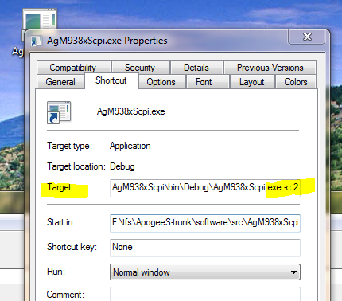

- Double-click on the short-cut and you should see a console dialog box open with a successful connection messages.
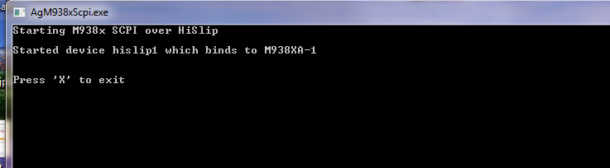

Sending Commands to the Parser
The Agilent IO package includes an “Interactive IO” application which makes for quick and easy testing. First connect to the channel you wish to send commands to. Look at the resource string below:
- It is using TCPIP!
- The 127.0.0.1 is the IP address of the loopback interface for a local connection, yes this will work remotely across the network.
- Note the end of the resource name which includes the hislip device name to connect to.
  - hislip1 is channel #1, hislip2 is channel #2, etc.
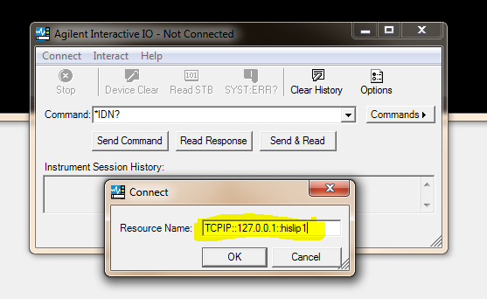

- At this point you can now start sending commands and reading responses.
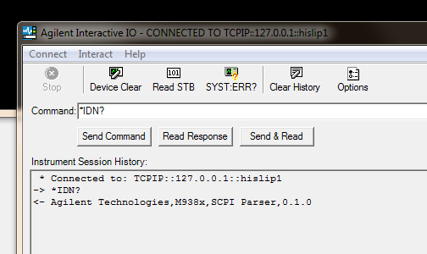

An Example Session

1) * Connected to: TCPIP::127.0.0.1::hislip1
2) -> *IDN?
3) <- Agilent Technologies,M938x,SCPI Parser,1.0.0.0
4) -> :MEM:COPY "F:\Waveforms\MXG Format\EDGE_BURST_WFM.WAVEFORM","edge1"
5) -> *WAI
6) -> *OPC?
7) <- 1
8) -> SYST:ERR?
9) <- 0,"No error"
10) -> :FREQ:CENT 1GHZ;:POW -10;:OUTP ON;:OUTP:MOD ON
11) -> SYST:ERR?
12) <- 0,"No error"
13) -> :RAD:ARB:WAV "edge1"
14) -> :RAD:ARB ON

Line 4 shows the copying of a file from some reachable file system to a named file in the Modulator DRAM (volatile memory)
Lines 5 and 6 show the use of *WAI and *OPC? on the :MEM:COPY command which is implemented as an overlapped command so that the parser doesn’t hang on a large upload. The client will have to wait for the completion of the previous command, and/or use the *OPC? to get a “1” that indicates the last command completed.
Line 10 shows the use of command chaining on one-line so that one and only one Apply would be issued against hardware. A hardware Apply is called at the end of a line of processing if one of the commands in the chain requires an Apply.
Line 13 shows the ARB being “armed” in the modulator
Line 14 shows the modulator being turned on to play the named ARB in line 13.

