NMRPipe

Sophisticated data processing tools have co-evolved with the development of NMR applications for biomolecules from the earliest days of modern biomolecular NMR. New NMR experiments such as multi-dimensional NMR have spurred computer hardware and software development for the last three decades. Both commercial and academic groups recognized the needs of the NMR community and responded with products and tools for analyzing NMR data. One of these responses was the development of NMRPipe by Frank Delaglio, first at NIH in association with the Ad Bax group, and then in continued development at NMR Science.

NMRPipe is the premier stand-alone processing software package used by most of the biomolecular NMR community. With VnmrJ 3.2, Agilent introduces the integration of NMRPipe into standard VnmrJ software. VnmrJ 3.2 provides a complete implementation of the widely-used NMRPipe system, specially augmented for use with spectral data from Agilent spectrometers.

For those users experienced with NMRPipe processing, all the familiar tools are available at the click of a button in the “expert” mode. For those not familiar with NMRPipe, the processing using NMRPipe is handled by VnmrJ macros, with data display and plotting performed by the standard VnmrJ commands and parameters (the “standard” mode).

Harnessing the power of NMRPipe
NMRPipe is a UNIX-based collection of programs and scripts for manipulating multidimensional NMR spectra. NMR structural biology uses a wide variety of methods, and is often practiced by those who might not be completely familiar with details of multidimensional signal processing. In response, the VnmrJ 3.2 implementation of NMRPipe provides an emphasis on automating the process of data processing with NMRPipe..

NMRPipe has become so widely employed for spectral processing of biomolecular NMR data that its use is noted in more than 50% of the NMR structures accepted into the Protein Data Bank (PDB) since 2000. Application examples include sophisticated 3/4D data processing schemes, multidimensional peak analysis, extracting rates from various NMR relaxation and kinetics data, calculating residual dipolar couplings, and extracting restraints for structure calculations, to name only a few. The key features of NMRPipe are summarized in Table 1. VnmrJ 3.2 software provides users with an interface that enables both new and advanced users access to the power of NMRPipe.

NMRPipe: the “Standard” mode.

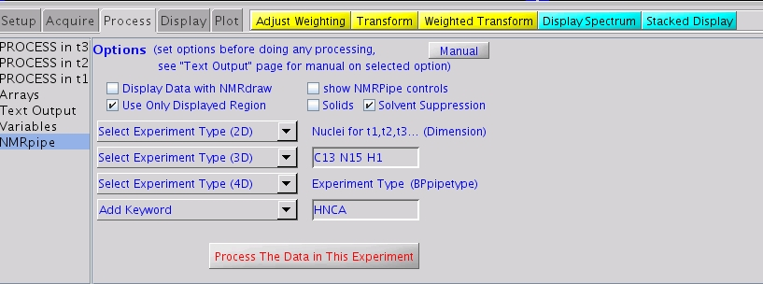
Figure 1. The NMRPipe interface panel. This is used for calling for automatic NMRPipe processing of data in the current “experiment” or “workspace”.

Figure 1 shows the interface for NMRPipe within VnmrJ 3.2. The Process folder now includes a page (NMRPipe) along with the other standard BioPack processing pages. All of the relevant operations are performed within the Parameter Panel. Experiment setup macros now include the automatic creation of variables needed by NMRPipe to do its automatic conversion of the VnmrJ data to NMRPipe format.

Parameter values are automatically set for each BioPack pulse sequence. The operator only needs to use a menu to select the class (e.g. “HNCO”) of experiment. The “dimension” parameter is automatically set, but can be changed prior to processing. This parameter specifies the order of evolution, by nucleus. The parameter “BPpipetype” is displayed and can be modified by adding keywords from the menu or by simple editing.

Several checkboxes are provided for user input. One checkbox is for specifying the relevant region of the observe dimension to be used for processing the indirect dimensions, thereby reducing the amount of data to be processed and speeding up the total time of processing. Another checkbox is for specifying whether NMRdraw or VnmrJ is to be used for displaying the data. A third checkbox specifies that BioSolids experiments are used and that the “Select Experiment Type” menus will be different. Finally, solvent suppression is under user option.

If VnmrJ is to be used for display, NMRPipe is used to process the data and then the resulting data is used by VnmrJ to display projection planes, 2D slices, etc. in the standard BioPack/VnmrJ manner. Users familiar with VnmrJ 2D or 3D display will use the same panels, buttons, menus, etc. as they have used in the past.

Processing parameters are automatically relevant to the acquisition times in each dimension before processing begins. Phasing in indirect dimensions can be first performed using standard VnmrJ displays. The phasing parameters determined for each dimension are then used by NMRPipe. Referencing is automatic. Processing is performed by a simple click of the “Process the Data in this Experiment” button. Display of the processed data follows automatically.

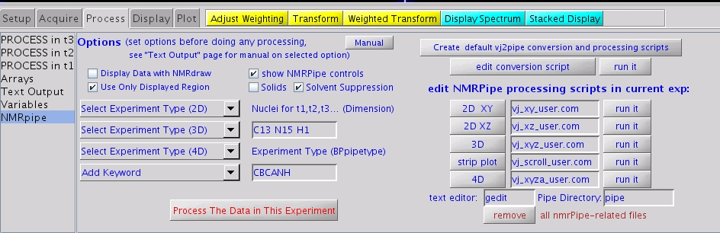

Figure 2. The expanded NMRPipe interface panel as used for advanced NMRPipe processing of data in the current “experiment” or “workspace”.

For more flexibility…
More options are available for the user, as shown in Figure 2, by activating the box “Show NMRPipe controls” in the interface. This adds expert tools for creating and editing conversion scripts and running specific types of NMRPipe processing. One can create, edit and run NMRpipe scripts by the click of a button. The text editor used for the script modifications can be chosen in the “text editor” entry. The directory in which all NMRPipe output files and scripts is specified by the Pipe Directory entry box. This directory lies within the current experiment. If desired, different data processing may be tried and the scripts and results stored in different directories by first changing the name of the Pipe Directory.

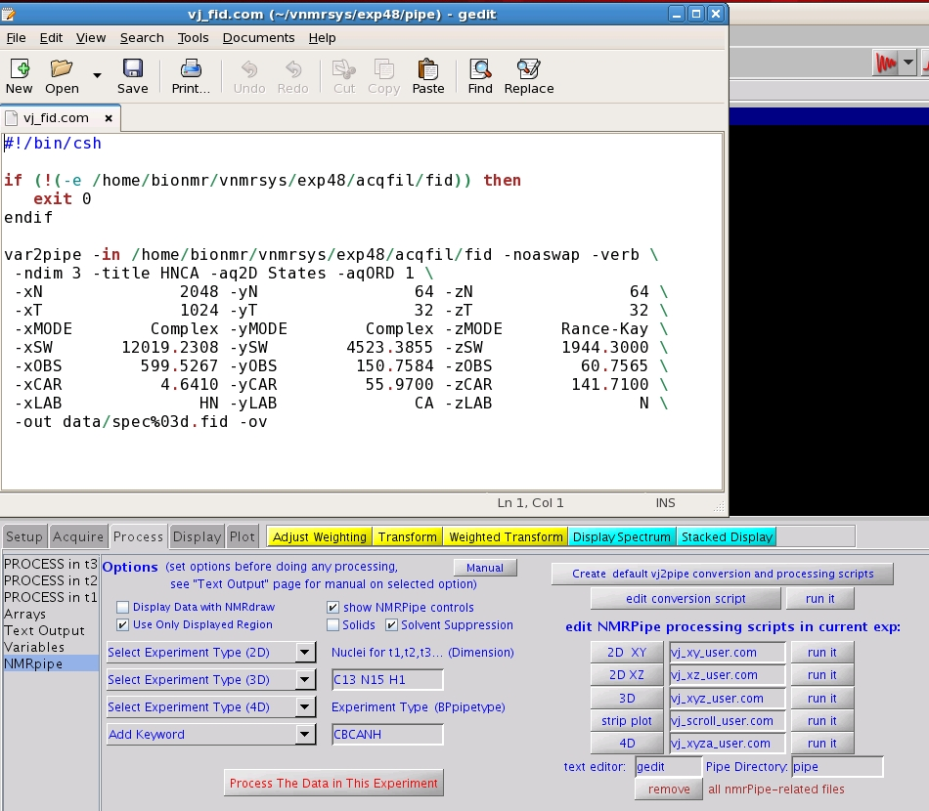

Figure 3. This popup appears when the button “Edit Conversion Script” is used.

Figure 3 shows the results of using the “edit conversion script” button in the lower right-hand section of the screen. A previously created VnmrJ to NMRPipe conversion script, “fid.com”, is opened in a text editor, ready for modifications.

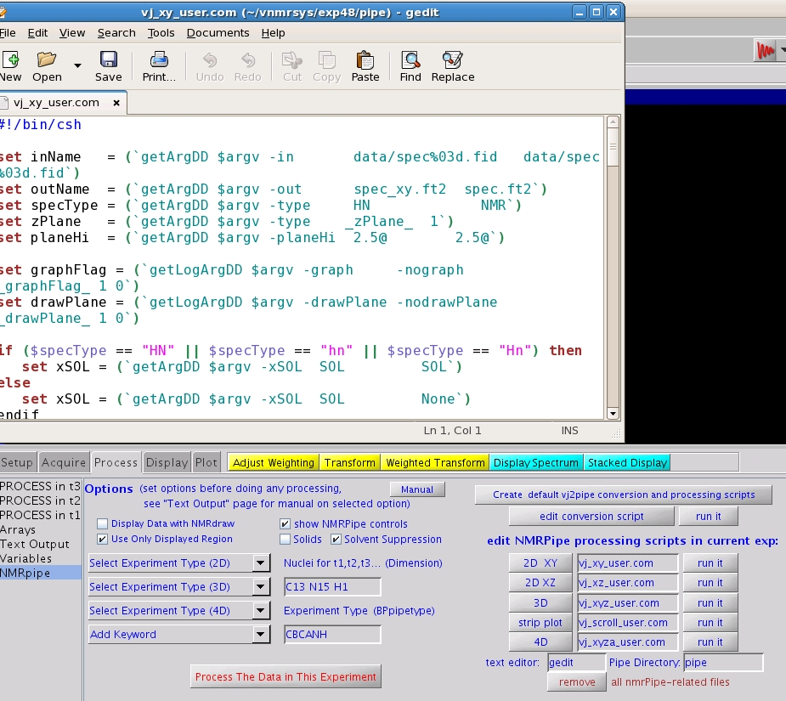

Figure 4. This popup appears when the button “2DXY” is used for editing the XY processing script.

Figure 4 shows the results generated by using the edit “2D XY” processing script button under the “edit NMRPipe processing scripts in current exp:” header on the lower right-hand side of the screen. Once edited, the script can be executed by the ”run it” button, producing data such as that in Figure 5.

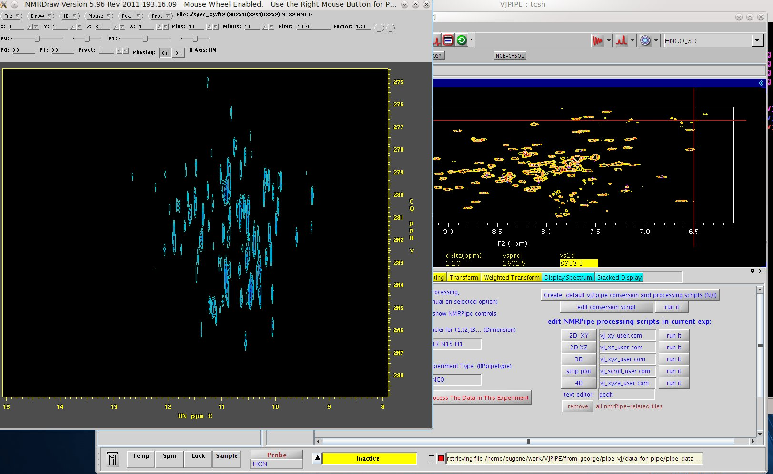

Figure 5. Using the “run it” button for the 2D XY case calls NMRPipe for processing and then uses NMRdraw to display the processed data.

Advanced displays such as “strip plots” are also selectable using the expert controls (see Figure 6).
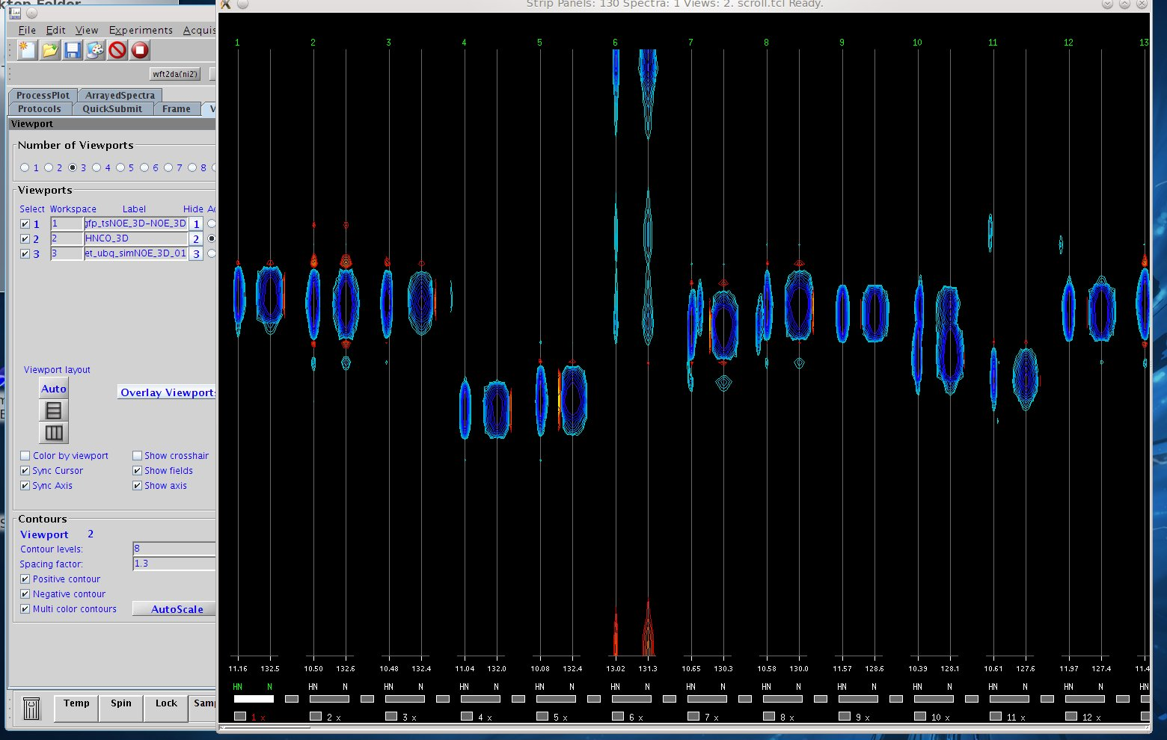
Figure 6. “Strip Displays” produced by NMRPipe processing.

NMRPipe now provides a means for processing 4D NMR data acquired on Agilent NMR spectrometers, as well as many other leading edge capabilities.

Tables

Table 1. Summary of NMRPipe features

Feature | Application | Feature | Application
Conversion of Agilent Spectral Data | Agilent spectral data can be imported for use with NMRPipe automatically, without the need to manually adjust parameters | Extensive Line-Shape fitting functions | Precise and convenient spectral quantification, including direct fitting of pseudo-3D data such as relaxation series or J-modulated series
Facilities to process, rephase and display multidimensional data | Sophisticated 3/4D data processing schemes using Maximum Entropy Reconstruction (MEM), Linear Prediction (LP), and Maximum Likelihood Frequency Maps (ML) | Analyze PDB | List H-bonds, secondary structure and turn classification, mass, volume, and surface area;  add Hydrogen atoms to a protein PDB file via simulated annealing
Facilities to manipulate and visualize dipolar couplings | Calculating residual dipolar couplings, including restrained fitting and cross-validation of tensor parameters | Predict protein backbone angles based on backbone chemical shifts; simulate and display protein backbone chemical shifts based on protein structure | Extracting restraints for structure calculations; help validate assignments and structure
NMR Homology Search | Identify structurally homologous fragments based on chemical shifts and dipolar couplings | Automated 1D and 2D batch processing and series analysis | Screening and process control

Details of the NMRPipe scripts.
vj2pipe is a system of scripts and software for seamless processing and visualization of data from Agilent NMR spectrometers. The system builds scripts to process and display data. This version of vj2pipe is configured for use with Agilent BioPack experiments for biomolecular data. The parameters and software have been enhanced specifically to support the most convenient and effective use of Agilent NMR data together with NMRPipe. The vj2pipe system can be used from within Agilent's VnmrJ software. And, like the tools of NMRPipe, vj2pipe can also be used directly from a C-shell command-line (within a terminal).
vj2pipe uses information from the Agilent spectral data (the fid file) and parameter file (the procpar file) to create and execute NMRPipe scripts which are then used to process and display the data. If processing parameters such as phase correction have already been selected, the processing and display can be entirely automated. Or, the scripts and data created by vj2pipe can be used interactively in the usual NMRPipe-style workflow.
As an initial step, vj2pipe reads the Agilent data parameters and builds a shell-script which converts the data from VnmrJ format to NMRPipe format. This script also establishes the chemical shift calibration information. Then, depending on the type of experiment, vj2pipe creates one or more additional scripts to process and display the spectral data. In the case of 3D experiments, these scripts will process and display the first XY and XZ 2D planes of the 3D data, as well as processing and displaying the entire 3D spectrum as a simple cube plot and in an interactive strip viewer.
Using vj2pipe within a terminal
The script vj2pipe.com can be used to run vj2pipe from a C-shell command-line in a terminal. By default, vj2pipe will read files and parameters from the current directory. So, it is usually used from the directory containing the fid and procpar files. In its simplest form, it can be used without any additional command-line options. When used this way, it will automatically convert and process the data according to parameters in the procpar file, and display the result. For example, the following commands would automatically convert, process, and display the given 3D data:

cd ghn_coca_cb_3D.fid
vj2pipe.com
In addition, vj2pipe can be used to list the options and parameters it determines for the current data, without creating or executing any scripts. This makes it possible to review the settings that will be used for the given data, and adjust these as desired via command-line options. The -info option is used to generate the informational display, for example:
cd ghn_coca_cb_3D.fid
vj2pipe.com -info

An example of the informational output produced for a 3D spectrum is given at the bottom of this document. Besides showing the parameter settings extracted from the current data, the informational display shows the name of the NMRPipe-style command-line option which can be used to adjust that parameter.

The NMRPipe.xml panel’s “expert” mode permits the generation, editing and running of these scripts.

vj2pipe performs the following steps in order:
- If an input data directory has been specified with the -cd option, change to that directory. Input for -procpar and -vjfid will be relative to this directory.

- If an output data directory has been specified with the -pipeDir option, create it if it does not exist, and change to that directory.

- Find the procpar file. If keyword Auto is used, vj2pipe will search for ./procpar acqfil/procpar and ../procpar in that order.

- Find the fid file. If keyword Auto is used, vj2pipe will search for ./fid acqfil/fid and ../fid in that order.

- Read the procpar file and extract all parameters in it.

- Replace or create procpar parameters with command-line values if any are given. This is done via the -pset option. Besides being one way to override values in procpar, this allows vj2pipe to be used with older Agilent data that might be missing specific vj2pipe parameters. For example, to set the value used in place of the procpar parameter BPpipetype:
vj2pipe.com -pset BPpipetype HNCA

- Interpret the procpar parameters to extract information about experiment type, data size, acquisition modes, storage details, axis labels, chemical shift calibration, and processing parameters. These are established as arguments for NMRPipe programs and scripts. Refer to the Big NMRPipe Reference Page and other NMRPipe documentation for more details.

- Replace any of the NMRPipe parameters with command-line values if any are given. This allows control of the details of conversion and processing. For example, to reset the NMRPipe conversion parameter for the X-Axis label of the data:
vj2pipe.com -xLAB HMeth

- Besides the predefined NMRPipe parameters such as aqORD xN xT xLAB etc., additional parameter names can be defined via the -sVar -lVar and -dVar command-line options. This provides a way to make new parameter names available for use in scripts.

- Create a script which converts the Agilent-format data to NMRPipe-format. This script uses the usual NMRPipe methods and arguments for format conversion, via the NMRPipe program var2pipe.

- Create one or more scripts for processing the spectral data. These are created from default script templates for particular tasks such as performing 3D Fourier processing. The default templates are stored in a directory of the NMRPipe installation ($NMRBASE/vj2pipe/com). These default scripts are available in the “expert” mode of the NMRPipe panel.

- New scripts are created by replacing text markers in the templates with the specific NMRPipe parameter settings for the given data. The text markers have the same names as the NMRPipe options, but begin and end with the underscore character. For example, the NMRPipe -xP0 parameter specifies the P0 (Zero Order Phase) value to apply when processing the X-Axis of the given data. So, the corresponding text marker for this option would be _xP0_ and this text marker will be replaced where ever it appears by the actual value for P0. For example, if a line from an input script template looked like this:
| nmrPipe -fn PS -p0 _xP0_ -p1 180.0 -di \
then the text _xP0_ would be replaced by the value for P0, for example:
| nmrPipe -fn PS -p0 43.0 -p1 180.0 -di \

- If requested, create additional scripts for displaying the processed spectral data.

- If additional template script names have been specified via the -subs command-line option, create new versions of these replacing text markers in the same way as for the default scripts.

- Execute the conversion script.

- Execute any processing and display scripts created from the default templates.
The auxiliary script vj_clean.com can be used to delete all processed data, and optionally all scripts created by vj2pipe in a given data directory.

vj2pipe General Command Options
Option | Default | Description
-procpar pName | procpar | Name of VNMRJ procpar Input, or Keyword Auto.
-vjfid fName | fid | Name of VNMRJ binary fid Input, or Keyword Auto.
-cd cdDir | . | Default Data Directory for Input.
-pipeDir | . | Default Data Directory for Output.
-outPrefix prefix | spec | File Name Prefix for Processed Results and Related Output Files.
-msgName mName | stderr | Output File for Status Messages, or Keyword stdout stderr None.
-vjDir vName | $NMRBASE/  vj2pipe | Directory of Auxiliary Files and Template Scripts used by vj2pipe.
-sVar sList | None | List of Additional User-Defined Single-Value Variables to Create.
-lVar lList | None | List of Additional User-Defined Multiple Value (List) Variables to Create.
-dVar dList | None | List of Additional User-Defined Dimension-Specific Variables to Create.
-subs sList | None | List of Additional User-Defined Template Scripts to Substitute.
-h2oM tSlope | -0.009552 | Slope of ppm/Degree K for Water, used in some calibration schemes.
-h2oB tInter | 5.011718 | PPM value for water at 273 degrees K, used in some calibration schemes.
-coThresh tPPM | 150.0000 | PPM threshold for identifying CO dimensions of 13C experiments.
-fidScript fidComPrefix | vj_fid | File Name Prefix for Conversion Script.
-ft1Script ft1ComPrefix | vj_ft1 | File Name Prefix for 1D Processing Script.
-ft2Script ft2ComPrefix | vj_ft2 | File Name Prefix for 2D Processing Script.
-xyScript xyComPrefix | vj_xy | File Name Prefix for Processing Script for 2D XY Plane of 3D.
-xzScript xzComPrefix | vj_xz | File Name Prefix for Processing Script for 2D XZ Plane of 3D.
-xyzScript xyzComPrefix | vj_xyz | File Name Prefix for 3D Processing Script.
-scrollScript scrComPrefix | vj_scroll | File Name Prefix for Strip Viewer Display Script for 3D Spectra.
-info |  | List All Parameters for the Current Data, then Exit.
-clean |  | Delete Previous Results and Scripts Before Proccessing.
-cleanOnly |  | Delete Previous Results and Scripts, then Exit.
-exec |  | Execute Conversion and Processing Scripts (Default).
-noexec |  | Create but Do Not Execute Conversion and Processing Scripts.
-graph |  | Display Spectral Graphics of the Results (Default).
-nograph |  | Do Not Display Spectral Graphics.
-drawPlane |  | Use NMRDraw to Display 2D Planes.
-nodrawPlane |  | Do Not Use NMRDraw to Display 2D Planes.
-drawCube |  | Draw 3D Contour Cube for 3D Data.
-nodrawCube |  | Do Not Draw 3D Contour Cube.
-drawStrips |  | Draw Strips for 3D Data.
-nodrawStrips |  | Draw 3D Strips.
-progress |  | Display a Progress Bar During Processing (Default).
-noprogress |  | Do Not Use Progress Bar Display.
-noskip |  | List Single-Point Dimensions, as for 3D experiments acquired as 2D.
-skip |  | Skip Listing of Single-Point Dimensions (Default).
-vjshow |  | List VJNMR-Specific Parameters.
-novjshow |  | Do Not List VJNMR-Specific Parameters.
-vjapod |  | Use VJNMR Window Function Values. Not yet implemented.
-novjapod |  | Use NMRPipe Window Function Values (Default).
-verb |  | Verbose Mode ON (Default).
-noverb |  | Verbose Mode OFF.
-help |  | List the Command-Line Options and Defaults.
-pset pName valList -- |  | Reset a procpar value. Can be used more than once. See below.
vj2pipe Data-Specific Command Options
The following options pertain to the parameters extracted specifically from the current data, and used to build conversion and processing schemes for the data. Options for specific parameters start with prefix -x -y -z etc ...
Option | Example | Related procpar | Description
-title | "hn(co)ca" | seqfil BPpipetype | The canonical title of the experiment.
-dimension | C13 N15 H1 | dimension | Specified which nuclei are associated with a given dimension
-type | HN | tn dn dn2 ... | The general experiment type. Keywords: HN HC HOMO NMR.
-ndim | 3 | np ni ni2 ... | Number of dimensions in the data.
-aq2D | States | array | The NMRPipe 2D plane mode. Keywords: States Magnitude.
-aqORD | 1 | array | The order of loops for real,imaginary detection in the indirect dimensions.
-planeHi | 2.50@ | BPpipedrawinfo | 2D Plane Contour Height, as Value, % or Fraction of Data @.
-hi | 2.50@ | BPpipedrawinfo | 2D Spectrum Contour Height, as Value, % or Fraction of Data @.
-cubeHi | 0.15@ | BPpipedrawinfo | 3D Cube Contour Height, as Value, % or Fraction of Data @.
-stripHi | 3.00@ | BPpipedrawinfo | 3D Strip Contour Height, as Value, % or Fraction of Data @.
-temperature | 298.00 | temp | Temperature, degrees K. Used in some PPM calibration schemes.
-xN | 2048 | np ni ni2 ... | Number of total points (real + imagimary) stored for the given dimension.
-xT | 1024 | array np ni ni2 ... | Number of valid time-domain points (complex) in the dimension.
-xMODE | Complex | array | Acquisition Mode for the dimension. Keywords: Complex Rance-Kay.
-xCHAN | 1 | dimension refsource... | Channel number the spectrometer associated with the dimension.
-xSW | 12019.2000 | sw sw1 sw2 ... | Spectral width, Hz.
-xAQTIME | 0.085197 | np ni ... sw sw1 ... | Effective acquisition time, Hz.
-xOBS | 599.8896 | sfrq dfrq dfrq2 ... | Observe Frequency at Zero ppm, MHz.
-xOBSMID | 599.8896 | sfrq dfrq dfrq2 ... | Observe Frequency at Center of Spectrum, MHz.
-xCAR | 4.6300 | obscenterppm h1ref... etc | PPM position of the center point of the spectrum (point N/2 + 1 of 1 to N).
-xCARSET | 0 | h1ref... etc | Indicates which procpar ref parameter (i.e. n15ref2) is set.
-xLAB | HN | BPpipetype tn dn ... | Axis label for the dimension.
-xNUC | H1 | dimension tn dn dn2 ... | Nucleus associated with the dimension. 1H 13C 15N.
-xGAMMA | 1.000000000 | dimension tn dn dn2 ... | Gamma value (gyromagnetic ratio).
-xP0 | -160.00 | rp rp1 rp2 ... | Zero-Order Phase, degrees.
-xP1 | -71.80 | lp lp1 lp2 ... | First-Order Phase, degrees.
-xAPOD | SP |  | NMRPipe Window Function Name
-xQ1 | 0.500 |  | Window Function Parameter 1.
-xQ2 | 0.950 |  | Window Function Parameter 2.
-xQ3 | 2.000 |  | Window Function Parameter 3.
-xELB | 0.000 |  | NMRPipe Window Function Exponential Broadening, Hz.
-xGLB | 0.000 |  | NMRPipe Window Function Gaussian Broadening, Hz.
-xGOFF | 0.000 |  | NMRPipe Window Function Gaussian Center, 0.0 (first point) to 1.0 (last point).
-xC1 | 1.000 | lp lp1 lp2 ... | First-Point Time Domain Scale. Usually 0.5 (when P1 phase is zero) or 1.0.
-xVJSB | -0.085 | sb sb1 sb2 ... | Original VnmrJ sb window value.
-xVJSBS | -0.085 | sbs sbs1 sbs2 ... | Original VnmrJ sbs window value.
-xVJLB | 5.000 | lb lb1 lb2 ... | Original VnmrJ lb window value.
-xVJGF | 0.022 | gf gf1 gf2 ... | Original VnmrJ gf window value.
-xVJGFS | 0.009 | gfs gfs1 gfs2 ... | Original VnmrJ gfs window value.
-xSOL | SOL |  | NMRPipe Solvent Filter Function to use.
-xZFARG | zf=1,auto | BPpipeprocinfo | NMRPipe Zero-Fill Options.
-xFTARG | None | BPpipeprocinfo | NMRPipe Fourier Transform Options.
-xEXTX1 | 9.952ppm | sp wp BPpiperegion | Start Coord of Processed Region to Extract. Units pts Hz ppm %.
-xEXTXN | 5.423ppm | sp wp BPpiperegion | End Coord of Processed Region to Extract. Units pts Hz ppm %.
-xLSTIME | 0 | lsfid lsfid1 lsfid2 ... | Shift to Apply in the Frequency Domain.
-xLSFREQ | 0 | lsfrq lsfrq1 lsfrq2 ... | Shift to Apply in the Frequency Domain.
-xBASEARG | None | BPpipeprocinfo | NMRPipe Baseline Correction Options.
Viewing and Setting vj2pipe Conversion and Processing Parameters
Using the command vj2pipe.com -info or vj2pipe.com -info -vjshow will generate a list of the default conversion and processing parameters for the data in the current directory. An example of this output is shown below. The values for any of these parameters can be reset at the command-line. For example, to change the default setting for the -title option:
vj2pipe.com -title HNCA

The NMRPipe.xml panel has buttons to display and edit these parameters.

As noted previously, it is also possible to adjust values from the procpar file before they are interpreted to generate NMRPipe parameters. This is done via the -pset option, followed by the name of the procpar parameter the corresponding value or value list, for example:

vj2pipe.com -pset BPpipetype HNCA

The -pset option can be used multiple times to reset more than one parameter. It can also be used with other options for adjusting parameters. In these cases, each use of the -pset option should be concluded by double-dashes -- for example:

vj2pipe.com -pset BPpipetype HNHA -- -pset h1ref3 4.55 -- -xLAB HN -yLAB HA

Example output from vj2pipe.com -info -vjshow follows:

-title "hn(co)ca" \
-dimension C13 N15 H1 \
-type HN \
-ndim 3 \
-aq2D States \
-aqORD 1 \
-temperature 298.00 \
-xN 2048 -yN 88 -zN 48 \
-xT 1024 -yT 44 -zT 24 \
-xMODE Complex -yMODE Complex -zMODE Rance-Kay \
-xCHAN 1 -yCHAN 2 -zCHAN 3 \
-xSW 12019.2000 -ySW 10558.9096 -zSW 1944.3000 \
-xAQTIME 0.085197 -yAQTIME 0.004167 -zAQTIME 0.012344 \
-xOBS 599.8896 -yOBS 150.8481 -zOBS 60.7933 \
-xOBSMID 599.8896 -yOBSMID 150.8481 -zOBSMID 60.7933 \
-xCAR 4.6300 -yCAR 40.2200 -zCAR 118.1500 \
-xCARSET 0 -yCARSET 1 -zCARSET 2 \
-xLAB HN -yLAB CA -zLAB N \
-xNUC H1 -yNUC C13 -zNUC N15 \
-xGAMMA 1.000000000 -yGAMMA 0.251449530 -zGAMMA 0.101329118 \
-xP0 -160.00 -yP0 0.00 -zP0 0.00 \
-xP1 -71.80 -yP1 0.00 -zP1 0.00 \
-xAPOD SP -yAPOD SP -zAPOD SP \
-xQ1 0.500 -yQ1 0.500 -zQ1 0.500 \
-xQ2 0.950 -yQ2 0.950 -zQ2 0.950 \
-xQ3 2.000 -yQ3 1.000 -zQ3 1.000 \
-xELB 0.000 -yELB 0.000 -zELB 0.000 \
-xGLB 0.000 -yGLB 0.000 -zGLB 0.000 \
-xGOFF 0.000 -yGOFF 0.000 -zGOFF 0.000 \
-xC1 1.000 -yC1 0.500 -zC1 0.500 \
-xVJSB -0.085 -yVJSB -0.015 -zVJSB 0.029 \
-xVJSBS -0.085 -yVJSBS -0.013 -zVJSBS -0.029 \
-xVJLB 5.000 -yVJLB 0.318 -zVJLB 1.000 \
-xVJGF 0.022 -yVJGF 0.006 -zVJGF 0.030 \
-xVJGFS 0.009 -yVJGFS 0.001 -zVJGFS 0.009 \
-xSOL SOL -ySOL None -zSOL None \
-xZFARG zf=1,auto -yZFARG zf=1,auto -zZFARG zf=1,auto \
-xFTARG None -yFTARG None -zFTARG None \
-xEXTX1 9.952ppm -yEXTX1 0% -zEXTX1 0% \
-xEXTXN 5.423ppm -yEXTXN 100% -zEXTXN 100% \
-xLSTIME 0 -yLSTIME 0 -zLSTIME 0 \
-xLSFREQ 0 -yLSFREQ 0 -zLSFREQ 0 \
-xBASEARG None -yBASEARG None -zBASEARG None \

References
- NMRPipe: a Comprehensive Software System for Multidimensional NMR Applications, http://www.nmrscience.com/nmrpipe.html.
- NMRPipe Spectral Processing and Analysis System Tutorial I: Introduction to Processing with NMRPipe, http://spin.niddk.nih.gov/NMRPipe/doc1/.

