78xx OZ Driver Installation & Usage
- Click “Oz.msi”
- Installation start. Follow procedure.
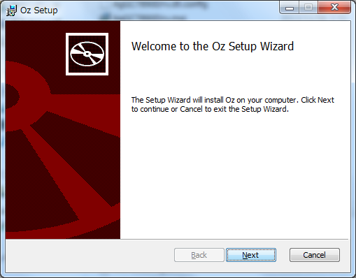
- In default, OZ driver is installed in C:\Program Files (x86)\Oz\
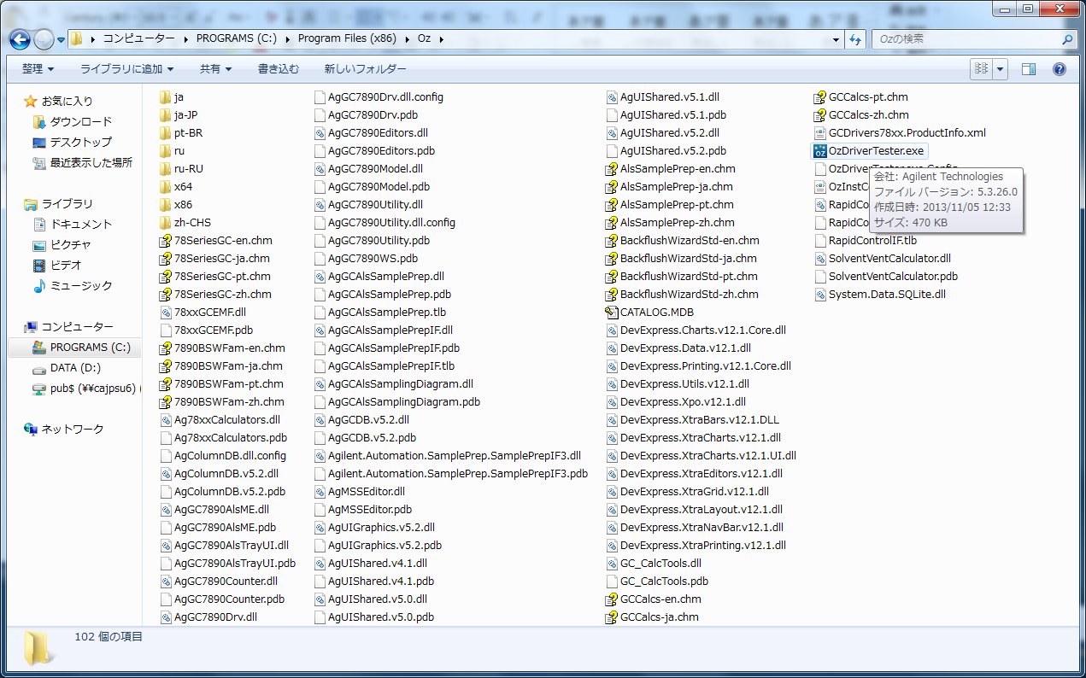
- Select “OzDriverTester.exe” to start OZ Driver
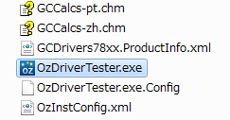
- OZ Driver UI, Click “Connect”
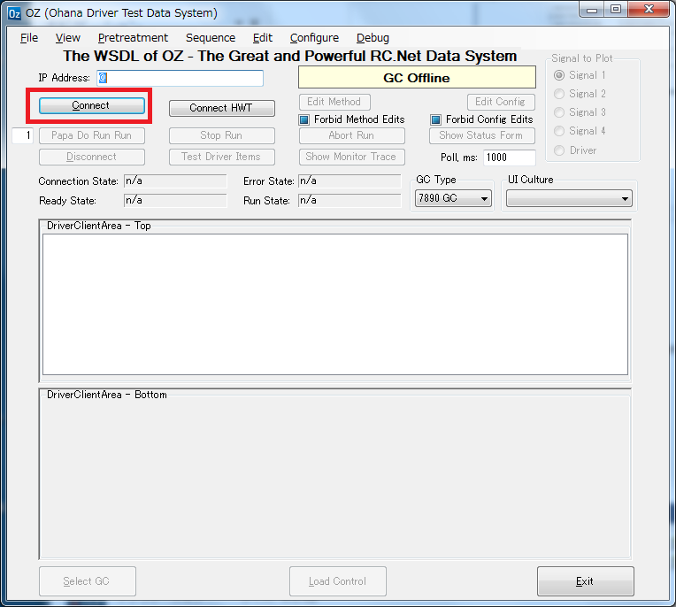
- You can configure Inlet, Detector etc. that you don’t have and you want to check UI.
e.g. I select; PCM & COC for Inlet: u ECD and NPD for detector
Click “As Specyfiled” button at the bottom left.
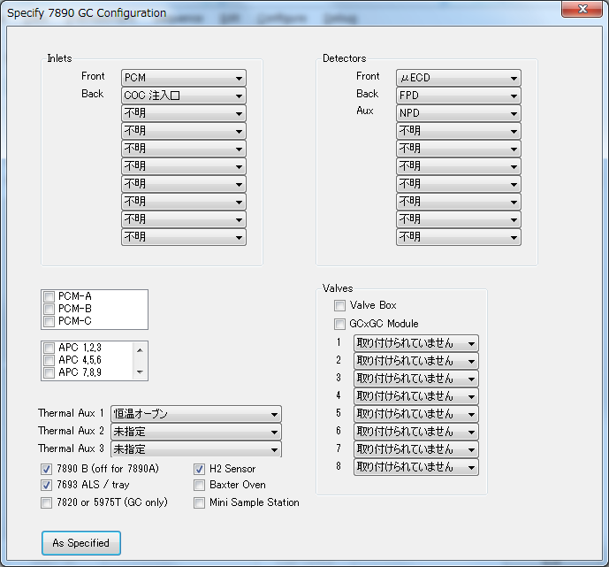
- The bellow is shown. Click “Edit Method”
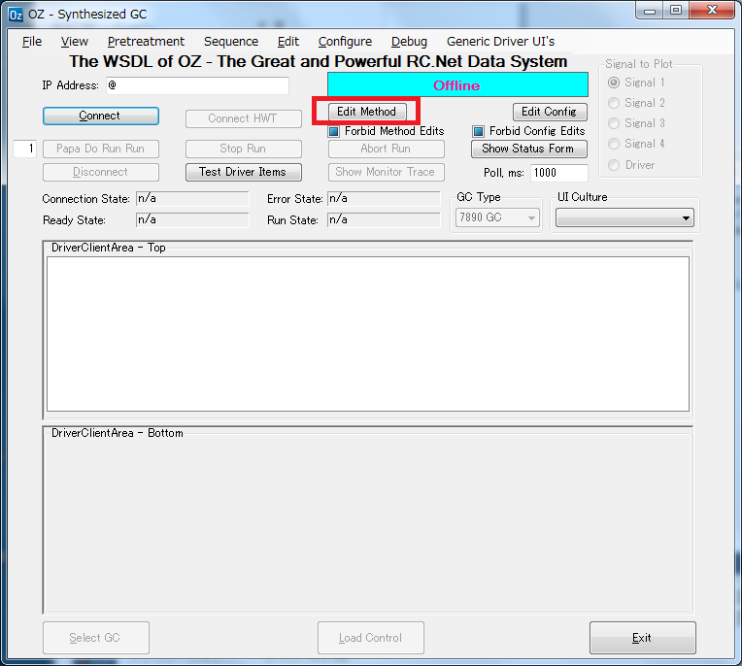
- You can verify the translated 78xx Dirver’s UI.
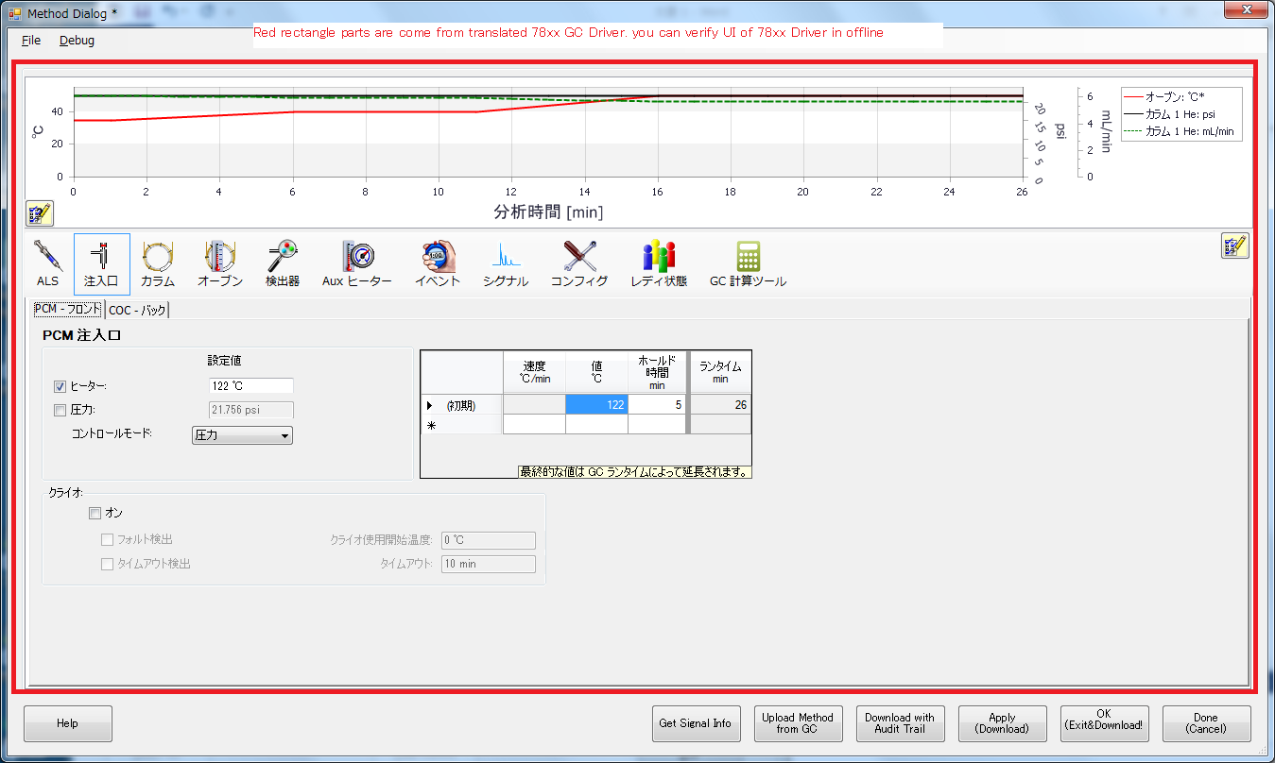
- If you want to check another module, you can change the setting. Repeat step 5 & 6.
- When you re-install OZ driver, please uninstall “OZ” from “Uninstall Program” first.
