Have you seen my twins???
call 203-300-2107 or taken32357@yahoo.com .

Because we were separated at birth

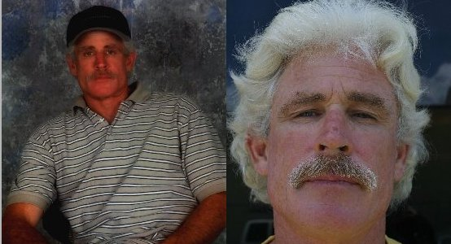

Hello:
My name is Kurt Miller and realizing that all my bad luck wasn't bad luck I researched my life and paid a lot of attention to the detail cuz that's where the answers are, boy was I floored. I've found out to start with that I have brothers and we were separated at birth, we are all identical looking. This was an experiment in the beginning and it has and is getting out of hand, 46 years later.

The deal was an ethical and moral type experiment, but down the line the doctors' changed the deal and got unethical along with breaking the law.

If you realized that you look like me please call. And any one else that believes they have seen me or someone that looks like me call 203-300-2107 or email: taken32357@yahoo.com .

I’m personally into construction and building homes, and know a little bit about electronics. I’m also aware that a couple of my brothers are also into these things.

Someone made a movie about me from someone who told the author about my life. The movie is “The Third Twin".

