1- ATM machine as usual ?
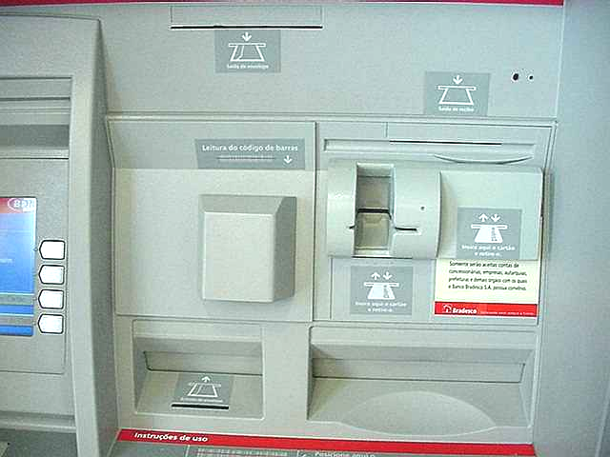

2- Is there an additional slot ?

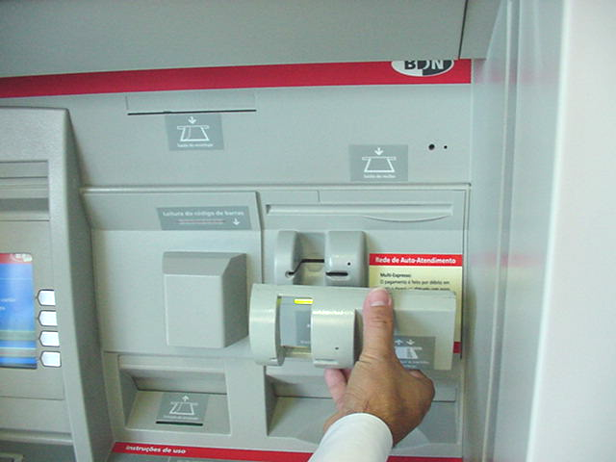
FALSE slot Fixed to the original card slot. (Same color and sticker ). Contains additional card reader to copy your card information ..and duplicate your card

3- A monitor and pamphlet holder at the side...nothing wrong
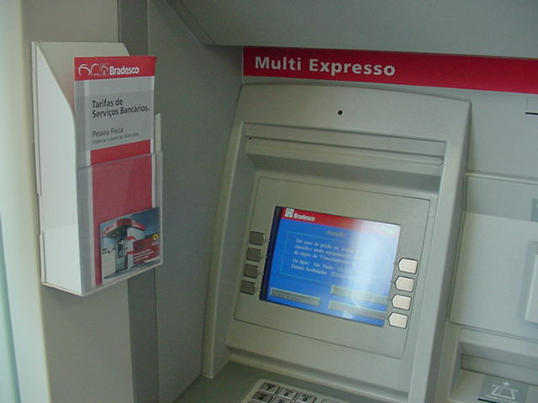

4- wait ..... Is it really a pamphlet holder ....

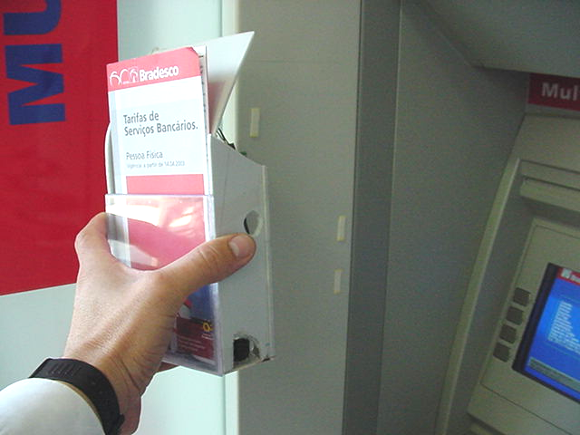
The side of box , facing the ATM screen has a reflective glassy hole ....thats a CAMERA !

5-False pamphlet box affixed to the ATM cubicle side

The micro camera at the side can view the KEYPAD and also the monitor to send wireless picture up to 200metres.

6-Inside the “pamphlet box”
”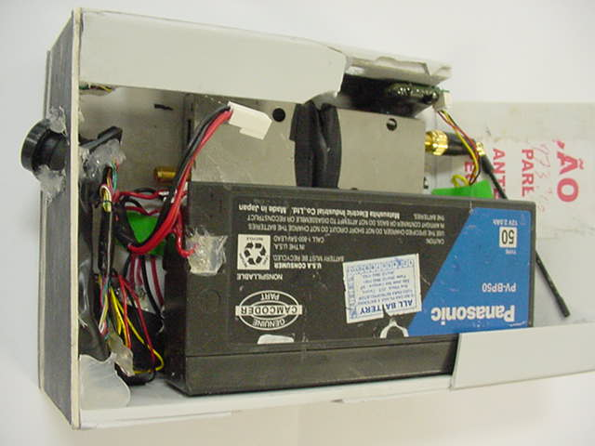
Camera positioned at correct angle to view keypad and monitor

Camera Battery;

Transmission Antenna

